Nature Communications
Approach for therapeutic drug monitoring within the clinical range using mid-infrared spectroscopy
Pin Dong¹, Kezheng Li¹, Dave D. Rowe², Ganapathy Senthil Murugan², Thomas F. Krauss¹ and Yue Wang¹
1. School of Physics Engineering and Technology, University of York, Heslington, York YO10 5DD, UK
2. Optoelectronics Research Centre, University of Southampton, Southampton, SO17 1BJ, UK
Abstract
Therapeutic drug monitoring (TDM), involving the measurement of drug levels in patients’ body fluids, is an important procedure in clinical practice. However, the analysis technique currently used, i.e. liquid chromatography–tandem mass spectrometry (LC-MS/MS), is laboratory-based, so does not offer the short response time that is often required by clinicians. We suggest that techniques based on Fourier Transform Infrared Spectroscopy (FTIR) offer a promising alternative for TDM. FTIR is rapid, highly specific and can be miniaturised for near patient applications. The challenge is, however, that FTIR for TDM is limited by the strong mid-IR absorption of endogenous serum constitutes. Here, we address this issue and introduce a versatile approach for removing the background of serum lipids, proteins and small-water soluble substances. Using phenytoin, an antiepileptic drug as an example, we show that our approach enables FTIR to precisely quantify drug molecules in human serum at clinically relevant levels, providing an efficient analysis method for TDM. Our study opens the door to an untapped integrable point-of-care modality based on mid-IR spectrometry for TDM.

Main
Therapeutic drug monitoring (TDM) is an important procedure in clinical practice. By measuring drug levels in patients` body fluids, most commonly serum or plasma, TDM is used to monitor and improve treatment outcomes, reduce drug toxicities, avoid the risk of developing drug resistance and optimize personalized drug therapy¹. For many drugs, however, the therapeutically effective concentration window (known as “therapeutic range”) can be very small. For example, phenytoin, a major first-line antiepileptic drug, has a narrow therapeutic range of 10-20 μg/ml, where small dosage adjustments can lead to severe adverse effects, such as seizures and coma². Similarly, vancomycin, a potent antibiotic for treating methicillin-resistant Staphylococcus aureus infections, has a trough serum concentration of 15-20 µg/mL³, exceeding this range can result in nephrotoxicity and ototoxicity. Therefore, monitoring drug levels within the therapeutic range is essential for enhancing clinical efficacy while minimizing toxicities^{1, 4}.
Currently, liquid chromatography-tandem mass spectrometry (LC-MS/MS) methods are extensively employed in clinical laboratories due to their exceptional selectivity and sensitivity. However, LC-MS is laboratory-based and typically analyses samples in batches, which inevitably incurs several hours` delay for routine tests⁵. Ideally, clinicians would prefer a much shorter turnaround time to make more informed decisions. Therefore, an assay that can provide results in minutes is highly desired. Commercially available kits based on immunoassays have also been used for clinical TDM for decades, offering advantages in respect to rapid turnaround time and ease of access. However, such immunoassays suffer from significant cross-reactivity, which can lead to false positives, limiting their utility⁶. Alternatively, surface-enhanced Raman spectroscopy (SERS) has been proposed for TDM due to its high sensitivity and the potential for hand-held devices for bedside measurements⁷. For example, SERS has been reported to detect anticancer drugs in human plasma down to a level of nanogram per millilitre⁸. However, as SERS relies on the overlap between the analyte and a nanoscale plasmonic hotspot, reproducibility and quantification are challenging⁹. We suggest that Fourier transform infrared (FTIR) spectroscopy provides a useful compromise between these methods. Similar to Raman, it directly measures molecular vibrations and generates a unique spectrochemical fingerprint but it also allows extraction of both quantitative and qualitative information¹⁰. Furthermore, FTIR-based techniques hold the potential to be used as miniaturised instruments¹¹. Among the various FTIR techniques, attenuated total reflection (ATR)-FTIR stands out for its high sensitivity, user-friendly operation and rapid data acquisition¹⁰. These attributes position ATR-FTIR as a promising TDM technique with the potential to streamline clinical decision-making processes.
The presence of water and proteins in human serum, however, limits the application of ATR-FTIR in TDM, as the absorption peaks of proteins in the range of 1700-1400 cm⁻¹ overlap with the fingerprint region of most drugs¹². Additionally, other endogenous substances such as sugars, lipids and peptides contribute to this background, making the quantitative analysis of small drug molecules even more challenging¹³. Studies have demonstrated the necessity of removing water and proteins to improve the limit of detection (LOD) of FTIR techniques¹³⁻¹⁶. For example, Wood et al.¹⁵ showed that by removing water through drying, ATR-FTIR could quantify glucose in the blood at a concentration of 300 μg/ml. Further removal of albumin by centrifugal filtration allowed ATR-FTIR to determine glucose in human serum at a ten-fold lower concentration of 30 μg/ml¹⁴. It should be noted, however, that centrifugal filtration also leads to significant drug loss, especially for highly-protein-bound drugs. For example, in human serum, more than 90% of phenytoin and warfarin, both on the TDM list¹⁷, hare bound to albumin^{4, 18}.
Even after removing the protein and water background, the LOD of ATR-FTIR is still not sufficient to assess many drugs that require clinical monitoring. This restriction is due to some endogenous serum substances, such as lipids and metabolites, that can interact with the drug of interest, thereby contributing to background noise and limiting the LOD. Therefore, there is a clear need for a new sample preparation method for human serum that enables the use of FTIR-based techniques in TDM. The method needs to remove proteins, lipids and other metabolites and be compatible with drying to remove the water background, while maintaining a relatively low drug loss.
Here, we introduce a new approach that meets these requirements. We demonstrate that our approach significantly improves the LOD of FTIR-based techniques by significantly reducing the serum background. As a result, we are able to demonstrate that FTIR spectroscopy is able to quantify drugs in human serum at clinically relevant levels.

Results
Verification of the FTIR-based techniques for TDM
We first investigated the LOD of ATR-FTIR for the chosen model drug, phenytoin (Figure 1a). Initially, we used phenytoin dissolved in ethyl acetate, followed by drying, to study the influence of water removal while excluding other factors. Figure 1b shows the ATR-FTIR spectrum of a dried spot of phenytoin at a concentration of 20 μg/ml. The two peaks at 1772 cm⁻¹ and 1726 cm⁻¹ correspond to the asymmetric and symmetric stretching, respectively, of the carbonyl group of the molecule. The green shading represents the threefold standard deviation (3σ) of the instrumental and atmospheric noise, the latter primarily caused by water vapour and carbon dioxide. We note that the two phenytoin peaks are nearly buried in the noise, indicating that the LOD of ATR-FTIR is not sufficient to meet the requirement for quantifying clinical samples with drug levels below 20 μg/ml.
To reduce the noise and improve the LOD, we pivoted to the method of polarization-modulation infrared reflection-absorption spectroscopy (PM-IRRAS). PM-IRRAS can eliminate atmospheric noise by simultaneously measuring the sample and the atmospheric background using p- and s- polarized light (Figure 1c) ¹⁹⁻²². As shown in Figure 1d, the improved spectral signal together with the reduced impact of atmospheric noise demonstrates that PM-IRRAS can minimise the interference of water vapour. We note that the peaks at 1772 cm⁻¹ and 1726 cm⁻¹ of a 5 μg/ml phenytoin dried spot (below the clinical range) are now well above the noise level, in fact, 20 times higher than the 3σ of the atmospheric noise, showing that PM-IRRAS can meet the quantification requirement for clinical samples. Consequently, we utilized PM-IRRAS for all subsequent investigations.

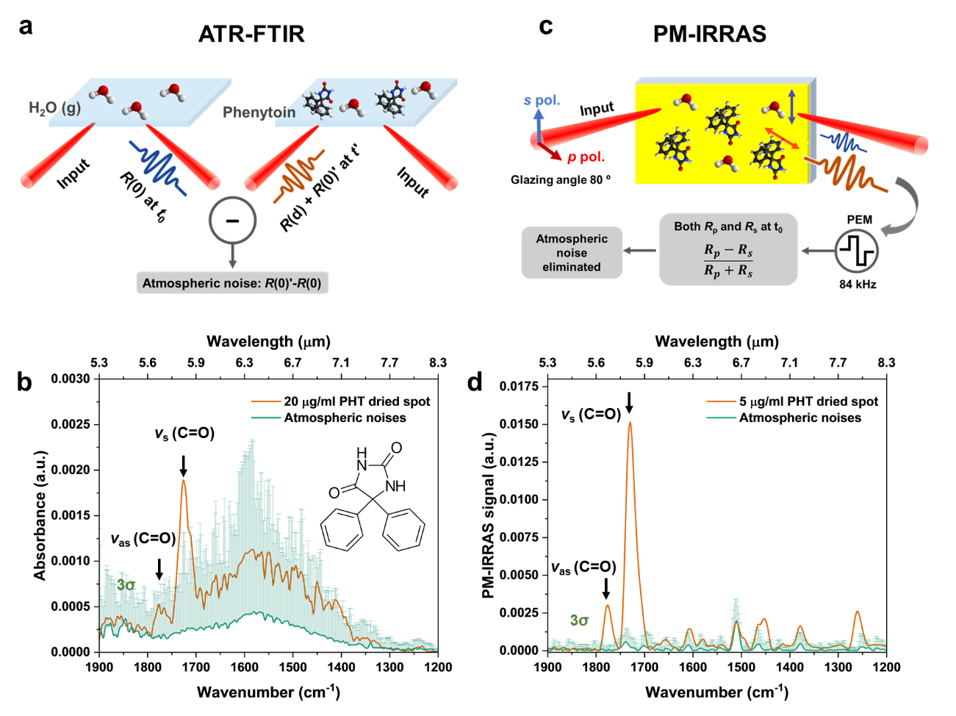
Figure1: LOD of ATR-FTIR and PM-IRRAS for dried phenytoin spots. (a) Schematic of the principles of ATR-FTIR; (b) ATR-FTIR spectrum of a dried spot of phenytoin dissolved in ethyl acetate at a concentration of 20 μg/ml, together with background noise. The inset shows the chemical structure of phenytoin. The two peaks at 1772 cm⁻¹ and 1726 cm⁻¹ (highlighted with the arrows) correspond to the asymmetric and symmetric stretching of the carbonyl group of the molecule, respectively; (c) Schematic of the principles of PM-IRRAS; (d) PM-IRRAS spectrum of a dried spot of phenytoin dissolved in ethyl acetate at a concentration of 5 μg/ml, alongside noise. The green shading in (b) and (d) represent the threefold standard deviation (3σ) of the measurement in the presence of atmospheric background.

Protein removal
Having discussed the need for serum protein removal without causing excessive drug loss, we now investigate the possible methodologies in more depth. There are two main methods: protein precipitation and liquid-liquid extraction. Protein precipitation, employing solvents such as acetonitrile and methanol, is commonly used in HPLC-MS analysis²³. For example, acetonitrile can effectively eliminate 97% of serum proteins while extracting the majority of the target drug molecules²⁴. When we applied the protein precipitation method to our serum samples, however, we only saw limited success. For example, we observed a significant remaining signature of the amide I (1700-1600 cm⁻¹) and II (1600-1500 cm⁻¹) bands as shown in Figure 2a, which likely originate from peptides of low molecular weight present in serum. Furthermore, we observed strong absorption at 1740 cm⁻¹, 1236 cm⁻¹and 1090 cm⁻¹, which we attribute to the stretching of C=C for neutral lipids of triglycerides, as well as the C=O and PO⁻² groups of phospholipids ^{25, 26}.
We then considered the liquid-liquid extraction method, which utilises a water-immiscible solvent such as ethyl acetate or chloroform to extract lipophilic drugs into the solvent while depleting serum proteins²⁷. The result is shown in Figure 2a. We note that ethyl acetate has already been employed in several studies for extracting phenytoin from human plasma²⁸⁻³⁰. We observe that, in contrast to protein precipitation, the serum background extracted by ethyl acetate exhibits no amide bands, indicating efficient removal of serum proteins. The intensity of the characteristic peak of lipids (1740 cm⁻¹) is also 5 times lower, suggesting a reduced amount of other serum substances. Therefore, it is clear that liquid-liquid extraction with ethyl acetate is the preferred method for removing serum proteins and water. Yet, the downside of the liquid-liquid extraction is that serum lipids are extracted together with the phenytoin due to the lack of specificity of ethyl acetate to the drug. This is apparent from Figure 2b, where we observe a number of absorption peaks (1740 cm⁻¹, 1465 cm⁻¹ and 1376 cm⁻¹) that are associated with lipids^{25, 26}. and that interfere with the phenytoin peaks. The exception is the peak at 1772 cm⁻¹ (highlighted with the arrow), This peak corresponds to the asymmetric stretching of the carbonyl group of the hydantoin ³¹ and because it exhibits the lowest background, we select it as the target peak for phenytoin quantification.

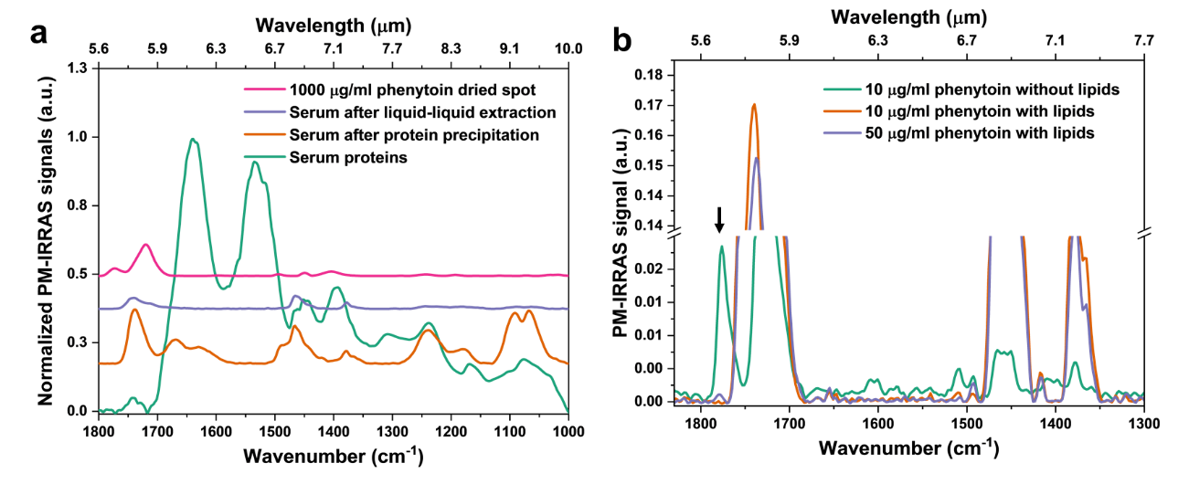
Figure 2: FTIR spectra after protein removal. (a) PM-IRRAS spectra following protein removal by protein precipitation (orange line) and liquid-liquid extraction (purple line), compared to dried serum proteins (green line) and pure phenytoin (pink line); The y axis values are offset for clarity. (b) PM-IRRAS spectra of dried spots of phenytoin with and without serum lipids at concentrations of 10 and 50 ug/ml. With the presence of serum lipids (orange and purple lines), the 1772 cm⁻¹ target peak is significantly diminished.

Lipid removal
With liquid-liquid extraction for protein removal, some nonpolar substances, such as serum lipids, were co-extracted with phenytoin. Although the serum background at the drug target peak of 1772 cm⁻¹ is low, we observe some interaction between this peak and the serum lipids. At a drug concentration of 10 μg/ml, as shown in Figure 2b, the target peak is barely discernible with serum lipids present, whereas it is prominent without serum lipids; in fact, we need to increase the drug concentration to 50 μg/ml to allow the peak stand out clearly. This happens because the molecular interaction between serum lipids and phenytoin broadens the target peak, reducing its intensity to a level that is too low to observe³². This highlights the importance of removing serum lipids to improve the LOD.
Cholesterol and triglycerides are the predominant types of serum lipids, most of which are bound to lipoproteins³³. They are commonly extracted with a chloroform-methanol mixture³⁴. Yet, using this method for lipids removal will leads to a big drug loss as phenytoin is soluble in these solvents. A combination of magnesium chloride and dextran sulphate sodium has been previously utilized to selectively precipitate lipoproteins³⁵. Consequently, we used this mixture to remove serum lipids, with the protocol shown in Figure 3a and the results in Figs 3b and 3c. In Figure 3b, we highlight the characteristic lipid peak at 1740 cm⁻¹, which decreases approximately threefold following lipoprotein precipitation, indicating a significant reduction in serum lipids.
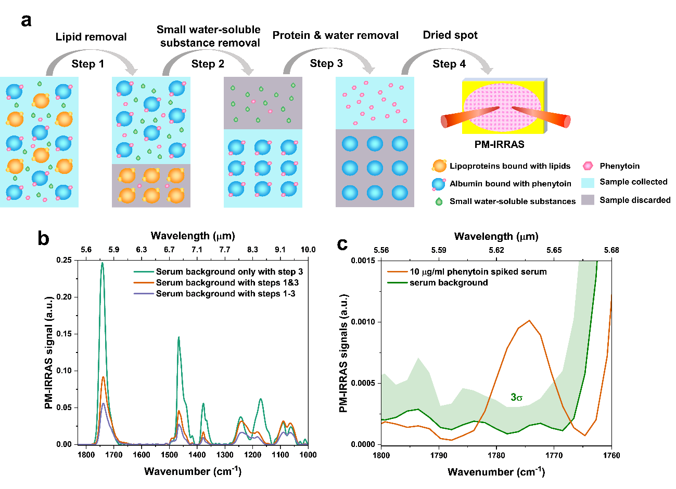
Figure 3. A new approach for human serum sample preparation to remove lipids, water-soluble substances and proteins. (a) Schematic diagram of serum sample preparation protocol. Step 1 of lipid removal: a mixture of MgCl₂-dextran sulphate sodium³⁵ is added to precipitate lipoproteins, to which serum lipids such as triglycerides and cholesterol bind. Step 2 of small water-soluble substances removal: saturated (NH₄)₂SO₄ is added to precipitate hydrophilic proteins such as albumin, to which the target drug phenytoin binds. The supernatant, involving small water-soluble molecules, is subsequently discarded. Step 3 of protein removal: the water-immiscible solvent ethyl acetate is used to extract phenytoin while removing serum proteins. The upper solvent layer is collected and dried on a gold-coated silicon substrate for PM-IRRAS measurements; (b) PM-IRRAS spectra highlighting the successive reduction of the serum background after the various steps used in the protocol; (c) A zoomed-in spectrum of the 1772 cm⁻¹ peak highlighting the successful conclusion of the protocol. A concentration of 10 μg/ml is clearly identifiable, well above the 3σ background (green shade).

Small water-soluble substances removal
The removal of both lipids and proteins enables PM-IRRAS to detect the lowest drug concentration of 15 μg/ml in serum (refer to Figure S2). This limitation arises from the presence of residual endogenous substances such as amino acids, hormones, and acetoacetate, which continue to interact with phenytoin and attenuate the target peak^{36, 37}. Thus, further removal of small water-soluble substances from the serum is necessary to improve the LOD of PM-IRRAS.
To achieve this, we used saturated ammonium to precipitate the albumin following lipid removal. Since more than 90% phenytoin binds to albumin, we collected the albumin precipitates and discarded the supernatant that contains most of the small water-soluble substances. As shown in Figure 3b, further removal of the small water-soluble substances reduced the serum background by another 1.5-fold, taking the peak intensity at 1740 cm⁻¹ as a reference. Lastly, the target drug molecules were extracted from the albumin precipitates. This refinement led to a further improvement in the LOD of PM-IRRAS. As shown in Figure 3c, the target peak significantly surpassed the 3σ threshold of the background signals, allowing PM-IRRAS to quantify phenytoin in serum concentration as low as 10 μg/ml. Despite the removal of lipids in the first step and small water-soluble substances in the second step resulting in a 15% drug loss at each step (refer to Figure S3), the overall reduction in serum background significantly increases the signal-to-noise ratio.

Absolute quantification of phenytoin in human serum
Finally, we applied our new protocol to a series of spiked serum samples. We added an internal standard to aid quantification, i.e. 4-hydroxybenzonitrile. This molecule exhibits a sharp C≡N stretching peak at 2221 cm⁻¹, where there is no serum background; the molecule also does not interfere with phenytoin (Figure 4). It is clear that the intensities of the 1772 cm⁻¹ target peak increase proportionally with drug concentration in the clinical range of 10 to 30 μg/ml, as illustrated in Figure 4a. The ratio of the peak height at 1772 cm⁻¹ and 2221 cm⁻¹ can then be used to establish the calibration curve. Figure 4b highlights the excellent linearity between the PM-IRRAS signals and the drug serum concentrations, with a correlation coefficient of 0.9993. We used HPLC as the validation method (refer to Figure S4 in supplementary material). We used two concentrations that represent the range of quantification in Fig. 4a, i.e. 13.2 and 28.7 μg/ml, respectively, and we note excellent agreement. Nevertheless, we note that the standard deviation of the PM-IRRAS measurements is larger than that of the HPLC analysis. We explain this larger deviation with the homogeneity issue of dried spots, which we discuss in more detail in the supplementary material (Figure S5). Overall Figure 4 provides clear evidence that PM-IRRAS, in conjunction with the multistage protocol we introduce here, is capable to quantify phenytoin in serum samples at the clinically relevant range.

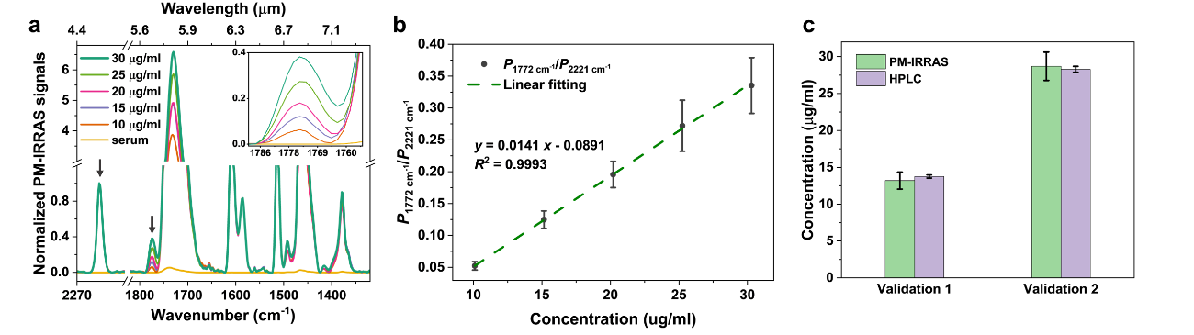
Figure 4. Calibration curve of PM-IRRAS FTIR and validation of serum samples. (a) PM-IRRAS FTIR spectra of phenytoin spiked samples at concentrations of 10, 15, 20, 25, 30 μg/ml, along with blank serum, following preparation with our new protocol. Each spectrum is normalized with the peak height of the internal standard at 2221 cm⁻¹. Inset: a zoom-in spectrum of the target peak at 1772 cm⁻¹; (b) Calibration curve of phenytoin spiked serum measured via PM-IRRAS. Six replicates are measured for each concentration; (c) Validation measurements of PM-IRRAS FTIR against HPLC for two concentrations spanning the range of (b).
Discussion and Conclusion
In summary, we introduce a practical and widely applicable approach for human serum sample preparation, enabling the FTIR spectroscopy-based technique to quantify drug serum concentrations at clinically relevant levels. Our study demonstrates the many advantages of FTIR-based techniques for therapeutic drug monitoring (TDM). It emphasizes the importance of removing serum lipids, small water-soluble substances and proteins to achieve the required performance. While our protocol is verified with phenytoin, it is broadly applicable to other poorly water-soluble and highly protein-bound drugs, such as warfarin, tacrolimus, and digitoxin, commonly monitored in clinical settings⁴. Beyond FTIR-based techniques, our serum preparation protocol can also be applied to improve the LOD of Raman-based techniques such as SERS, as protein and lipid background interreferences are major concerns for these techniques as well. Additionally, the approach opens up the utility of mid-IR based resonant sensing modalities to serum-based TDM, which are previously limited to laboratory media-based samples³⁸⁻⁴¹. Besides high sensitivity and specificity, our method can reduce the total time for both sample preparation and analysis to as little as 20 min, showing significant potential to optimize clinical workflows for efficient decision-making and better treatment.
Several aspects can be further investigated in future studies. Firstly, we measured the total serum concentration of the drug of interest based on the sample preparation approach rather than the free drugs, which are more directly related to efficacy. Nevertheless, the second step of our protocol for removing small water-soluble substances already separates free drugs, offering the possibility of quantifying free drug molecules in serum. Secondly, while the current approach is applicable to highly protein-bound drugs, it requires further adjustments for water-soluble drugs, based on the same principle of reducing most of the serum endogenous constituents. For example, vancomycin, typically less protein-bound, could benefit from nanoparticle absorption methods to selectively collect water-soluble drug molecules while removing other endogenous substances⁴². Lastly, the current protocol is a manual process. There are studies that have demonstrated the potential of employing microfluidics in removing lipoproteins⁴³ albumin proteins⁴⁴. Adapting our protocol to microfluidics could make it a rapid bedside modality for medical use. The approach paves the way for applying integrated mid-IR sensing to TDM in clinical settings.
In conclusion, we offer a versatile solution for serum sample preparation that markedly enhances the performance of mid-infrared spectroscopy for TDM. Importantly, it is transferable to various spectroscopic technologies. Our work contributes to the introduction of a low-cost, miniaturized on-site modality aimed at improving patients` quality of life.

Materials and methods
Phenytoin (5,5-Diphenylhydantoin, purity ≥98%) was commercially obtained from Cayman Chemical. 4-Hydroxybenzonitrile (purity ≥98%) was purchased from Thermo Scientific Chemicals. Ethyl acetate (anhydrous, 99.8%) for liquid-liquid extraction, dextran sulphate sodium salt (Mr~40,000), ammonium sulphate (≥99.0%) for albumin precipitation were purchased from Merck Life Science Limited. All other chemicals and reagents were of analytical grade. HPLC grade acetonitrile was supplied by Fisher Chemical (Loughborough, United Kingdom). Magnesium chloride hexahydrate (≥99.0%) was from Fluorochem Ltd, UK) of analytical grade and used without further purification. A mixture of magnesium chloride and dextran sulphate sodium solution is for lipoprotein precipitation. Blank human serum (male AB, USA origin, sterile-filtered) was acquired from Merck Life Science Limited and stored at −20 °C until analysis.
FTIR-based measurements
ATR-FTIR: A Fourier transform infrared spectrometer (VERTEX 70, Bruker) with a DTGS (deuterated triglycine sulphate) temperature-stabilised coated detector was used. This was equipped with a three-bounce ATR accessory with a diamond/ZnSe crystal (MIRACLE™, PIKE Technologies). Samples measured by ATR-FTIR are isoniazid dissolved in human serum and ethyl acetate with serum extracts, respectively. A drop of 100 ul of isoniazid serum samples was measured directly after recording the blank human serum as the background spectrum. A drop of 10 ul of isoniazid ethyl acetate samples was first dried on the ATR crystal and then measured after taking the atmosphere as the background spectrum.
PM-IRRAS: Measurements were performed using the same VERTEX 70 Fourier transform infrared spectrometer with an angle of incidence of 80° relative to the substrate surface normal. For p-polarisation of the IR light, an aluminium wire grid was used and modulated at 50 kHz with a ZnSe photoelastic modulator (PEM, Bruker PMA-50). Light reflected from the sample was focused with a ZnSe lens onto a cryogenic mercury cadmium telluride (MCT) detector. The optical path of the spectrometer was purged with dried air. All the Infrared spectra were collected using OPUS software (Bruker) with a spectral resolution of 4 cm^{–1} and the accumulation of 100 scans in the range of 4000-400 cm⁻¹. The data analysis was performed by Origin 2023b software.
HPLC
The HPLC system was an Agilent 1290 Infinity LC system with a photodiode array detector set to 220 nm (Agilent Technologies, USA). Chromatographic separation was carried out on a ZORBAX SB-C18 Column (4.6 x 150 mm, 5 µm, Agilent) and protected by SB-C18 Guard Cartridges (4.6x 12.5mm, 5 um, Agilent). The column oven temperature was set at 20 °C. An isocratic mobile phase consisted of 35% acetonitrile and 65% sodium acetate (0.02M, adjusted to pH 4.6 with acetic acid). Flow rate of the mobile phase and injection volume were 1.0 mL/min and 5 μl, respectively. The total run time was 12 min. A set of five samples, each of them in triplicate, containing 5, 10, 20, 30, 40 μg/ml (5, 10, 15, 20, 25, 30, 35, 40) of phenytoin was prepared in acetonitrile and was used as the calibration set (R² > 0.999).
Preparation of calibration standards and quality control samples
The stock solution was prepared by dissolving accurately weighed amounts of phenytoin in methanol to yield a 10 mg/mL drug concentration. The working solutions (150, 300, 450, 600 and 750 μg/ml) were prepared by further dilution of stock solution with methanol. The internal standard containing 1500 μg/ml 4-hydroxybenzonitrile was prepared in methanol.
The calibration standards were prepared by the addition of 10 μl of the working solutions and 10 ul of IS solution to 300 μl of blank serum aliquots, resulting in serum drug concentrations of 5, 10, 15, 20 and 25 μg/ml and 50 μg/ml of IS concentration, respectively. Simulated clinical samples were prepared independently at two concentration levels that are within and above the therapeutic window of phenytoin (10-20 μg/ml), i.e. 15 μg/ml and 25 μg/ml. Each spiked serum sample was processed as described in sample preparation.
Serum sample preparation
The serum samples (300 μl) were mixed with 10 μl of the 4-Hydroxybenzonitrile methanol solution with a concentration of 1500 μg/ml (internal standard) with the vortex for 2 min at 3000 rpm. Then 10 μL of a mixture of 3 mol/L magnesium chloride and 6% of dextran sulphate sodium salt was added, followed by a vortex for 1 min at 3000 rpm and centrifugation at 10,000 rpm (Eppendorf MiniSpin) for 3 min. The supernatant was transferred to 2 mL-centrifuge tubes. Subsequently, 1200 ul of saturated ammonium sulphate was added to the supernatant and vortexed for 1 min at 3000 rpm. After centrifugation for 2 min at 10,000 rpm, the upper layer was discarded and the precipitates were resuspended in 300 μl of distilled water. Next, 1 mL of ethyl acetate was added to each sample, followed by the vortex for 2 min at 3000 rpm and centrifugation at 10,000 rpm for 2 min. The organic (upper) layer was transferred to 2 mL centrifuge tubes. The extraction process was repeated, and the upper layers from the two extractions were combined and evaporated under a constant airflow at room temperature. The resulting dry residues were re-dissolved in 300 μl of either acetonitrile for HPLC analysis or ethyl acetate for PM-IRRAS measurements with the vertexing for 2 min at 3000 rpm. For PM- IRRAS measurements, 200 μl of the ethyl acetate sample was dried on a gold-coated silicon substrate with a size of 25 mm × 25 mm.

References

1. Ates, H.C. et al. On-Site Therapeutic Drug Monitoring. Trends in Biotechnology 38, 1262-1277 (2020).
2. Johannessen Landmark, C., Johannessen, S.I. & Patsalos, P.N. Therapeutic drug monitoring of antiepileptic drugs: current status and future prospects. Expert Opinion on Drug Metabolism & Toxicology 16, 227-238 (2020).
3. Rybak, M. et al. Therapeutic monitoring of vancomycin in adult patients: A consensus review of the American Society of Health-System Pharmacists, the Infectious Diseases Society of America, and the Society of Infectious Diseases Pharmacists. American Journal of Health-System Pharmacy 66, 82-98 (2009).
4. Overview of Therapeutic Drug Monitoring FAU - Kang, Ju-Seop FAU - Lee, Min-Ho. Korean J Intern Med 24, 1-10 (2009).
5. Xiao, Y., Xu, L., Qian, Y. & Xu, Y. Identification and characterization of critical values in therapeutic drug monitoring: a retrospective analysis. Scientific Reports 14, 11520 (2024).
6. Dasgupta, A. in Personalized Immunosuppression in Transplantation. (eds. M. Oellerich & A. Dasgupta) 29-56 (Elsevier, San Diego; 2016).
7. Li, C., Ye, Z., Xu, Y. & Bell, S.E.J. An overview of therapeutic anticancer drug monitoring based on surface enhanced (resonance) Raman spectroscopy (SE(R)RS). Analyst 145, 6211-6221 (2020).
8. Göksel, Y. et al. Quantification of Methotrexate in Human Serum Using Surface-Enhanced Raman Scattering—Toward Therapeutic Drug Monitoring. ACS Sensors 6, 2664-2673 (2021).
9. Jaworska, A., Fornasaro, S., Sergo, V. & Bonifacio, A. Potential of Surface Enhanced Raman Spectroscopy (SERS) in Therapeutic Drug Monitoring (TDM). A Critical Review. Biosensors 6, 47 (2016).
10. Naseer, K., Ali, S. & Qazi, J. ATR-FTIR spectroscopy as the future of diagnostics: a systematic review of the approach using bio-fluids. Applied Spectroscopy Reviews 56, 85-97 (2021).
11. Erfan, M. et al. On-Chip Micro–Electro–Mechanical System Fourier Transform Infrared (MEMS FT-IR) Spectrometer-Based Gas Sensing. Applied Spectroscopy 70, 897-904 (2016).
12. Baker, M.J. et al. Using Fourier transform IR spectroscopy to analyze biological materials. Nature Protocols 9, 1771-1791 (2014).
13. Byrne, H.J., Bonnier, F., McIntyre, J. & Parachalil, D.R. Quantitative analysis of human blood serum using vibrational spectroscopy. Clinical Spectroscopy 2, 100004 (2020).
14. Bonnier, F. et al. Ultra-filtration of human serum for improved quantitative analysis of low molecular weight biomarkers using ATR-IR spectroscopy. Analyst 142, 1285-1298 (2017).
15. Roy, S. et al. Simultaneous ATR-FTIR Based Determination of Malaria Parasitemia, Glucose and Urea in Whole Blood Dried onto a Glass Slide. Analytical Chemistry 89, 5238-5245 (2017).
16. Spalding, K. et al. Enabling quantification of protein concentration in human serum biopsies using attenuated total reflectance – Fourier transform infrared (ATR-FTIR) spectroscopy. Vibrational Spectroscopy 99, 50-58 (2018).
17. Dasgupta, A. in Therapeutic Drug Monitoring. (ed. A. Dasgupta) 1-29 (Academic Press, Boston; 2012).
18. Montgomery, M.C., Chou, J.W., McPharlin, T.O., Baird, G.S. & Anderson, G.D. Predicting Unbound Phenytoin Concentrations: Effects of Albumin Concentration and Kidney Dysfunction. Pharmacotherapy: The Journal of Human Pharmacology and Drug Therapy 39, 756-766 (2019).
19. Mendelsohn, R., Mao, G. & Flach, C.R. Infrared reflection–absorption spectroscopy: Principles and applications to lipid–protein interaction in Langmuir films. Biochimica et Biophysica Acta (BBA) - Biomembranes 1798, 788-800 (2010).
20. Muro, M., Itoh, Y. & Hasegawa, T. A Conformation and Orientation Model of the Carboxylic Group of Fatty Acids Dependent on Chain Length in a Langmuir Monolayer Film Studied by Polarization-Modulation Infrared Reflection Absorption Spectroscopy. The Journal of Physical Chemistry B 114, 11496-11501 (2010).
21. Islam, M.N., Ren, Y. & Kato, T. Polarization Modulation Infrared Reflection Absorption Spectroscopy of Gibbs Monolayer at the Air/Water Interface. Langmuir 18, 9422-9428 (2002).
22. Greenler, R.G. Infrared Study of Adsorbed Molecules on Metal Surfaces by Reflection Techniques. The Journal of Chemical Physics 44, 310-315 (1966).
23. Michopoulos, F., Lai, L., Gika, H., Theodoridis, G. & Wilson, I. UPLC-MS-Based Analysis of Human Plasma for Metabonomics Using Solvent Precipitation or Solid Phase Extraction. Journal of Proteome Research 8, 2114-2121 (2009).
24. Polson, C., Sarkar, P., Incledon, B., Raguvaran, V. & Grant, R. Optimization of protein precipitation based upon effectiveness of protein removal and ionization effect in liquid chromatography–tandem mass spectrometry. Journal of Chromatography B 785, 263-275 (2003).
25. Portaccio, M., Faramarzi, B. & Lepore, M. Probing Biochemical Differences in Lipid Components of Human Cells by Means of ATR-FTIR Spectroscopy. Biophysica 3, 524-538 (2023).
26. Pielesz, A., Biniaś, D., Waksmańska, W. & Bobiński, R. Lipid bands of approx. 1740 cm−1 as spectral biomarkers and image of tissue oxidative stress. Spectrochimica Acta Part A: Molecular and Biomolecular Spectroscopy 286, 121926 (2023).
27. Peng, S.X., Branch, T.M. & King, S.L. Fully Automated 96-Well Liquid−Liquid Extraction for Analysis of Biological Samples by Liquid Chromatography with Tandem Mass Spectrometry. Analytical Chemistry 73, 708-714 (2001).
28. Lin, P.-C., Hsieh, Y.-H., Liao, F.-F. & Chen, S.-H. Determination of free and total levels of phenytoin in human plasma from patients with epilepsy by MEKC: An adequate alternative to HPLC. ELECTROPHORESIS 31, 1572-1582 (2010).
29. Serralheiro, A., Alves, G., Fortuna, A., Rocha, M. & Falcão, A. First HPLC–UV method for rapid and simultaneous quantification of phenobarbital, primidone, phenytoin, carbamazepine, carbamazepine-10,11-epoxide, 10,11-trans-dihydroxy-10,11-dihydrocarbamazepine, lamotrigine, oxcarbazepine and licarbazepine in human plasma. Journal of Chromatography B 925, 1-9 (2013).
30. Tai, S.S.C., Yeh, C.-Y. & Phinney, K.W. Development and validation of a reference measurement procedure for certification of phenytoin, phenobarbital, lamotrigine, and topiramate in human serum using isotope-dilution liquid chromatography/tandem mass spectrometry. Analytical and Bioanalytical Chemistry 401, 1915-1922 (2011).
31. Dharani, S., Rahman, Z., Barakh Ali, S.F., Afrooz, H. & Khan, M.A. Quantitative estimation of phenytoin sodium disproportionation in the formulations using vibration spectroscopies and multivariate methodologies. International Journal of Pharmaceutics 539, 65-74 (2018).
32. Ting, J.M., Navale, T.S., Jones, S.D., Bates, F.S. & Reineke, T.M. Deconstructing HPMCAS: Excipient Design to Tailor Polymer–Drug Interactions for Oral Drug Delivery. ACS Biomaterials Science & Engineering 1, 978-990 (2015).
33. Quehenberger, O. & Dennis, E.A. The Human Plasma Lipidome. New England Journal of Medicine 365, 1812-1823 (2011).
34. Folch, J., Lees, M. & Stanley, G.H.S. A SIMPLE METHOD FOR THE ISOLATION AND PURIFICATION OF TOTAL LIPIDES FROM ANIMAL TISSUES. Journal of Biological Chemistry 226, 497-509 (1957).
35. Warnick, G.R., Nguyen, T. & Albers, A.A. Comparison of improved precipitation methods for quantification of high-density lipoprotein cholesterol. Clinical Chemistry 31, 217-222 (1985).
36. Akanji, A.O., Humphreys, S., Thursfield, V. & Hockaday, T.D.R. The relationship of plasma acetate with glucose and other blood intermediary metabolites in non-diabetic and diabetic subjects. Clinica Chimica Acta 185, 25-34 (1989).
37. Barth, A. Infrared spectroscopy of proteins. Biochimica et Biophysica Acta (BBA) - Bioenergetics 1767, 1073-1101 (2007).
38. Zhu, Y. et al. Optical conductivity-based ultrasensitive mid-infrared biosensing on a hybrid metasurface. Light: Science & Applications 7, 67 (2018).
39. John-Herpin, A., Tittl, A. & Altug, H. Quantifying the Limits of Detection of Surface-Enhanced Infrared Spectroscopy with Grating Order-Coupled Nanogap Antennas. ACS Photonics 5, 4117-4124 (2018).
40. Law, S., Podolskiy, V. & Wasserman, D. Towards nano-scale photonics with micro-scale photons: the opportunities and challenges of mid-infrared plasmonics. Nanophotonics 2, 103-130 (2013).
41. Peer Reviewed: Mid-IR Fiber-Optic Sensors. Analytical Chemistry 75, 258 A-267 A (2003).
42. Kaur, A., Preet, S., Kumar, V., Kumar, R. & Kumar, R. Synergetic effect of vancomycin loaded silver nanoparticles for enhanced antibacterial activity. Colloids and Surfaces B: Biointerfaces 176, 62-69 (2019).
43. Li, Z. et al. Cascaded microfluidic circuits for pulsatile filtration of extracellular vesicles from whole blood for early cancer diagnosis. Science Advances 9, eade2819 (2023).
44. Mei, N., Seale, B., Ng, A.H.C., Wheeler, A.R. & Oleschuk, R. Digital Microfluidic Platform for Human Plasma Protein Depletion. Analytical Chemistry 86, 8466-8472 (2014).

