Hybrid Integration of Quantum Cascade Lasers with Germanium on Silicon waveguides for Mid-Infrared Sensing Applications
Colin J. Mitchell,^{1,*} Longqi Zhou,² Ke Li,¹ Daniel Adeyemi, Ahmed Osman,¹ Milos Nedeljkovic,¹ Glenn Churchill,¹ James C. Gates,¹ Graham T. Reed¹, Kristian M. Groom,² Jon Heffernan,² Goran Mashanovich¹
¹ Optoelectronics Research Centre, University of Southampton, University Road, Southampton, Hampshire SO17 1BJ, UK
² Department of Electronic and Electrical Engineering, Sir Frederick Mappin Building, University of Sheffield, Mappin Street, Sheffield, S1 3JD, UK
*c.j.mitchell@soton.ac.uk
Abstract: The mid-infrared spectral region (2-20 µm) contains ‘fingerprint’ molecular absorptions, which are used for environmental, medical and security applications. The growing importance of this region for silicon photonics is reliant upon the integration of sources and detectors, operating at appropriate wavelengths with a mid-infrared sensing platform. Commercial devices need to be low cost, low power and have a small footprint for widespread use outside of the laboratory and are required to be mechanically robust and preferably manufactured within the existing silicon fabrication infrastructure. Such devices have been demonstrated for the near-infrared region, particularly at communication wavelengths, but much less work has been published in the mid-infrared. Here we report the first coupling data for hybrid flip-chip integration of a fully fabricated quantum cascade laser bar on a silicon photonics platform, in this case germanium-on-silicon. The passive alignment utilized here alongside CMOS compatible process flows will enable the development of fully integrated sensing chips across the mid-infrared spectrum with a clear manufacturing route.
- Introduction
The integration of lasers on to silicon is a key challenge for silicon photonics for the realization of compact practical devices. In order to achieve this goal several competing approaches have been proposed []. This is complicated by the indirect band gap of silicon, which prohibits production of high power lasers in the material. For this reason work on light sources for silicon has been focused on the integration of compound semiconductor lasers. The majority of this work has been performed at communication wavelengths where such techniques as wafer bonding and transfer printing [,,] and direct growth [,] have been demonstrated, along with flip-chip bonding of processed lasers. Considered here is the mid-infrared (MIR) region of the spectrum, where integration work is not as mature as near-infrared (NIR). Quantum cascade lasers (QCLs) [] are routinely used in this region of the spectrum, and the technical challenges have some differences such as thermal management of the QCLs and the larger mode sizes in the waveguides.
The increasing importance of the MIR field of silicon photonics is due to the molecular absorption lines found in this area, which allow for identification of a specific molecules based on individual chemical bonds, hence the term ‘fingerprint region’. Environmental monitoring and medical testing outside of a laboratory [] require the advantages that silicon photonic manufacture provides (footprint, weight, volume production and cost) and this is driving demand [], indeed applications for widespread use of medical sensors for either screening or monitoring of patients will rely on such technology. In addition, the measurement of greenhouse gases and pollutants in the air, land or the oceans would benefit, requiring extra mechanical strength and pose unique challenges from a harsh working environment. However, the integration approach itself will be similar across applications and wavelengths.
The operating wavelength demonstrated here, QCLs at 5.7 µm integrated to a germanium-on-silicon (GOS) waveguide platform, is for example applicable to important medical applications such as the therapeutic drug monitoring (TDM) of phenytoin used to control various types of seizures [, , ] as well as the determination of estrogen [], useful for the diagnosis of breast cancer []. However, the technique is transferable across the MIR for waveguide absorption spectroscopy. As a further example we envisage the integration of ICLs at shorter wavelengths for methane sensing [] at 3.8 µm for a submersible platform.
Heterogenious bonding of QCL gain material to MIR photonic integrated circuit (PIC) for evanescent coupling was first demonstrated on silicon [] at 4.7 µm using the silicon-on-nitride-on-insulator (SONOI) platform with outputs from a coupled waveguide around 31 mW in pulsed operation at 20ºC. Laser arrays of distributed feedback (DFB) and distributed Bragg-reflection (DBR) laser were subsequently demonstrated and combined with arrayed waveguide grating (AWG) multiplexers [] on a silicon-on-insulator (SOI) platform.
The direct growth of a QCL on silicon wafers was first demonstrated with output power up to 50 mW per laser facet [] emitting around 11 µm with up to 40 mW of power per facet. Further development has included interband cascade lasers (ICL) [] at lower wavelengths [, ] demonstrating CW output powers of 40 mW at room temperature at 3.3 µm. In the far infrared an InP-based QCL grown on silicon, 4º miscut toward [110], and an InP epitaxial template [] has demonstrated up to 4 W of output power from the laser facets at room temperature. These lasers do not demonstrate integration to waveguides or a GOS sensing platform, but clearly demonstrate promising routes to do so considering that at shorter MIR (2.25 µm) wavelengths GaSb lasers have been grown on to (001) miscut silicon [] and coupled to nitride waveguides [].
Most recently a system has demonstrated integration by flip-chip placement of a QCL(DFB) at 7.2 µm with sub-milliwatts of CW power [] coupled to a GOS waveguide. This system used a support structure and self-alignment by solder surface tension upon heating [, ] with the solder deposited by screen printing. The final position of the chip, and hence yield, is highly dependent upon several factors including: tolerances of volume of deposited material, edge definition of the bond pads and deposited material leading to bond pad wetting, size-friction, force ratios.
Described here is the first demonstration of coupling efficiency of fully processed flip-chip bonded QCL, laser bars, coupled to GOS waveguides for direct end-fire coupling. Previously we have demonstrated the first hybrid integration of QCL on a silicon photonics platform [,], where weak endfire coupling to a germanium waveguide was measured from output gratings downstream, and routes to improvements presented. Milliwatts of coupled power are achieved in this work, from this second generation of device. The alignment in this case is provided by the chip-chip bonding tool itself in conjunction with a support structure for the vertical alignment along with specific machine tooling []. This system exhibits the power required for absorption spectroscopy with a bonding technique that eliminates the issues of the interface associated with die/wafer bonded and monolithic grown structures. The gold-tin alloy bonded along the length of each individual laser to act both as an industrial standard contact solder and also as a heatsink from the QCL to the PIC substrate where thermal management is of critical importance for the laser.
Importantly, this approach allows for manufacturing of the GOS and QCL components using optimal fabrication for each component with minimal back-end processing. Processes and tooling allow mature manufacturing technology for passive alignment of lasers with the PIC.
The novel integration of laser bars (14.5 mm by 2.5 mm, with 24 lasers along the length) instead of a single laser is useful for two considerations, firstly the length of the bar helps with yaw angular alignment, but more importantly, this reduces the number of bonding alignments that required for multiple sources. For example, gain material bonded in bars can potentially be used simultaneously as a detector in one part and as an emitter in an adjacent ridge if coupling can be achieved. Additionally multiple lasers can be combined in the GOS circuit for either increased power or multiple wavelengths [17*AWG] selected within the gain spectra using DFB QCL arrays such demonstrated for free space absorption [].
- Chip design
When a QCL is flip-chip bonded to the GOS substrate the mode of the laser is aligned to the mode of the waveguide for endfire coupling between the two as shown in Figure 1. The measurement of facet-to-facet coupling (FTFC) at the interface of the QCL and the GOS requires a measurement or estimate of the power output of the laser facet in addition to the power in the waveguide. The QCL is a Fabry–Pérot (FP) laser and the outputs at either facet are assumed to be equal. Free-space measurements of both the uncoupled QCL facet and the waveguide output were taken. This was achieved by dicing the GOS chip to allow a very slight overhang of the QCL over the GOS, whilst a self-polished ductile diced facet [] was used to provide the facet quality for measuring the waveguide output.
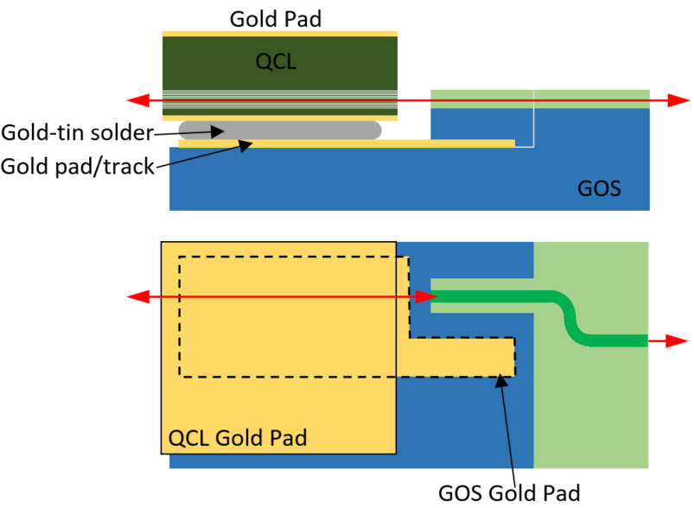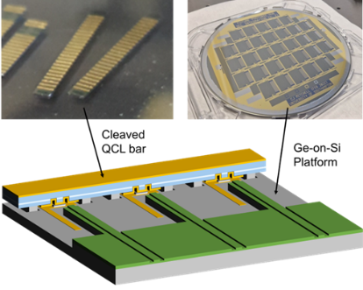
Fig. 1. (a) QCL flip-chip bonded to GOS. (b) QCL bars, GOS 6” wafer, for bonding.
The input for the germanium waveguide was a taper with an angled facet of 10º to reduce reflection back into the laser. The waveguide ran across the germanium top layer with two ninety degree bends to spatially separate the QCL output from the waveguide output. Figure 1 shows the contact pad for the growth side of the QCL extending outside of the QCL such that it could be contacted with probes. A flat surface for the contact pad level from under the QCL out to enable access for probes was achieved using two deep ICP-RIE etches. The first produced the top of the support structures, the second simultaneously formed the support structure mesa sides, the flat metallisation level and the waveguide facet, whilst maintaining quality of the facet (Fig. 2).
The chip design included a separate section for loss measurement structures to measure the propagation and bend losses in the waveguide and allow calculation of the interface FTFC.
- Flip-chip integration for MIR
The GOS platform is typically three micrometres thick [] to separate and reduce losses the threading dislocations at the interface and the silicon itself. In order to achieve coupling between the QCL and the waveguide the modes must overlap and to allow for misalignment in this design the width of the waveguide is tapered out from 3 µm single mode waveguides (TM-mode) to 11 µm wide. These tapers do not address the vertical mode size that is controlled by the thickness of the material. Considering the size of the mode from the QCL and the size of the mode in a tapered GOS waveguide there is a far better mode overlap than could be obtained from an SOI waveguide (typically ~200 nm overlay of silicon) at communications wavelengths where spot-size-converters or inverse tapers can be used to address this issue. In the MIR case, the mode overlap suggests that 3D spot size converters are not required in order to achieve reasonable coupling via tapered waveguides. However, this does increase the need for accurate vertical alignment in the approach employed.
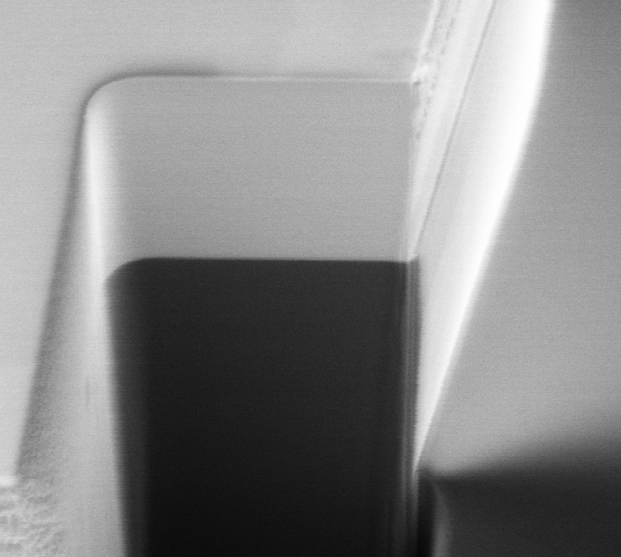
Ge (3 µm)

Si
Waveguide Facet
Fig. 2. FIB cross section of deep vertical ICP waveguide facet etch.
Flip-chip bonding tools produce very accurate placement in the plane of the chip interface. The FineTech Fineplacer® Lambda bonding tool used has demonstrated alignment accuracy of 0.5 µm and below. Automated tools with higher precision are available to the market demonstrating a route for scaling the process to industry. Alignment is made via an overlay image provided by the use of a beam splitter in this case. This gives the image of both the laser, and the target placement site on GOS.
The rotational alignment accuracy is particularly important for the laser bars used in this work. The alignment viewing optics can be moved across the beam splitter and in the long direction of the laser bar edge. This enables the extremes of the chip to be viewed and aligned for x-y in the same way as a photolithography tool and so accounts for any rotational misalignment.
The vertical alignment is provided by the use of an etched support structure in the germanium chip (Figure 3), which contacts with unprocessed laser surfaces on the laser bar. A single-axis gimballed placement tool provided rotation in the long direction of the laser bar, with the short dimension angle adjusted manually whilst viewing the interface with a camera. In this way the two chips are kept parallel.
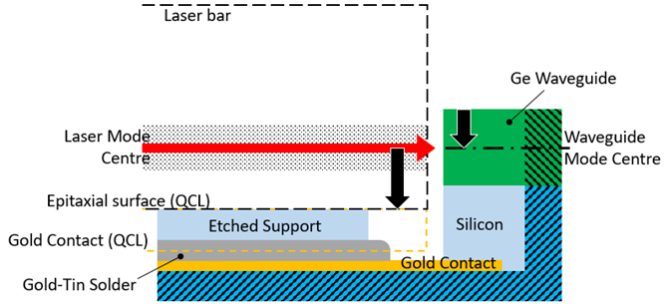
Fig. 3. Facet-to-facet alignment with support structure.
When in position, the gap for solder between the two sets of bond pads is defined by the etch depth to the contact level on the GOS and the thickness of the contact pads. Gold-tin solder thicker than this gap was e-beam evaporated and patterned with conventional lithography and lift-off. Using the solder in molten phase allowed for the flat placement of the QCL to the GOS support structure, whilst giving reliable Ohmic contacts. The gold-tin solder had a composition of 25 wt% tin giving a eutectic melting point of around 290ºC []. This elevated temperature will provide a thermal expansion mismatch between the components, which will be frozen in place as the solder solidifies adding strain to the laser and potential misalignment.
- QCL design
Longqi/Kris. Design and refs. No high divergent fast axis – helps with vertical alignment. CW operation with correct heat sink, bare epi for support structures as above, widths and single mode, depth of etch / etch profile, gold plating
- Power and length ,
- beam fast-slow axis divergence,

Maximum 1 page

- Coupling measurements
Initial indications of coupling were derived from imaging of a waveguide facet with the integrated QCL operating in pulse mode on a water cooled stage (Figure 4).
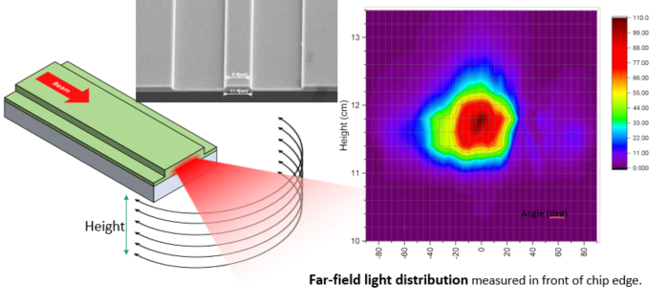
Fig. 4. Far-field image of light output from a diced facet.
To quantify the outputs from the device the QCL and waveguide facets were measured (Figure 5) using a high NA lens (Thorlabs C037TME-E) with anti-reflection coating (ARC) supplied by Thorlabs. This lens was mounted in a cage system with a Vigo MCT (electrically cooled) detector and a focusing lens with NA to match the detector acceptance angle (Thorlabs LA7477-E2). In the collimated section ThorLabs Neutral Density Filters (NDF) were used to prevent saturation of the detector. The attenuation of the NDFs with nominal OD = 0.3, 1.0, 2.0, were experimentally determined using the QCL as the source to correct for wavelength.
The QCL was driven in pulsed mode at 10ºC whilst mounted on a TEC cooled copper heatsink with thermal coupling matting between. The drive current was provided by an ILX Lightwave LDP-3830 operating with 400 ns pulses at 0.5% duty cycle. The ILX unit has a floating ground between the two ports with Tektronix TPP0100 passive probes used to measure the voltage. The LDP-3830 current monitor connection was used for measurement of the operating drive current.
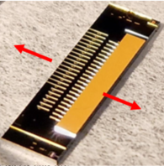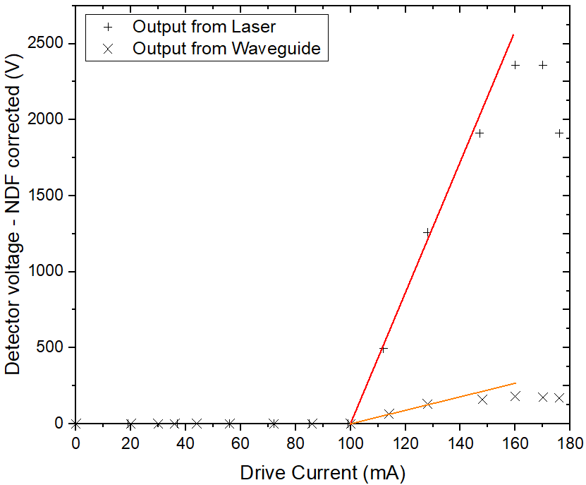
Fig. 5. (a) Integrated chip and outputs measured. (b) Light outputs from integrated chip.
The FTFC was calculated using a loss model shown in Figure 6 using the losses derived from the passive test structures, and a Fresnel reflection calculation using the effective index from simulating the taper structure, in conjunction with the QCL and waveguide outputs.

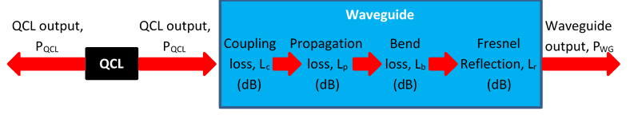
$$L_{c}= -10.\log_{10}\left(\frac{P_{WG}}{P_{QCL}}\right)- L_{p}- L_{b}-L_{r}$$
Fig. 6. FTFC calculation model.
The propagation loss was measured to be 8.6 dB/cm and the bend loss 9.8 dB/cm. These high values are thought to be from strain induced defects at the silicon-germanium interface accentuated by the thermal cycling involved in the deep ICP-RIE etch.
The peak outputs coupling (Table 1) was 12.9%, this produces a maximum value for FTFC of 44.8%. As rollover of the laser output sets in, FTFC falls to 26%. However, it must be noted that relatively small changes in measured output facet coupling produce a large change in the calculated interface FTFC when considering the large propagation losses in the waveguide. The measurement was repeated with longer pulses (600 ns) and this provided more stable interface coupling values with increasing current: the interface FTFC around 24 to 27%. This may suggest that the change in coupling with the shorter pulse (400 ns) could be due to heating effects of the QCL affecting alignment or the output wavelength with increased drive current. Thermal effects were noted around roll-over as the detector pulse profile changed with the apparent intensity peak shifting forward in time during the pulse as the output intensity fell with time.
Table 1. Output coupling variation with drive current.
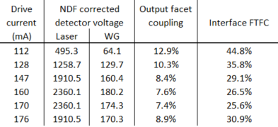
The data shown above is from the laser with the highest coupling efficiency from the bar, the eleventh of twenty-four, and located close to the middle of the bar. Along the bar were a mixture of endfire and grating coupled lasers, with measurements for grating couplers complicating the measurement of interface FTFC and not presented here. Comparing the seventeen endfire coupled lasers, sixteen of these were operational, and all of those sixteen coupled light. Away from the centre of the bat, and in both directions, the coupling efficiency fell indicating that this was not from rotation misalignment (yaw). The fall in efficiency, down to 3% at the edge of the laser bar, is most likely due to the thermal mismatch of the components. However, the tapered facets of the waveguides allowed for some misalignment, whilst still achieving coupling.

- Conclusions
In this paper, we have demonstrated a possible route to manufacture for integrated QCLs operating in the MIR coupled to a silicon photonics sensing platform using current CMOS compatible processes. The efficient co-design of the components opens up the possibility of scaling up production for widespread use outside of the laboratory for this mechanically strong system. Applications for medical, environmental and security sensing across the MIR become feasible, from desktop diagnosis in a medical setting through to harsh environments for ocean gas monitoring for example.
The hybrid flip-chip bonded approach using passive alignment of the components used an etched support structure in the GOS in contact with unprocessed sections of the QCL for repeatable vertical alignment. The flat placement of the QCL was achieved by combining this structure with gimballed placement tools and a molten gold-tin solder. QCL performance has been maintained for pulsed operation after integration and coupling demonstrated for milliwatts of power. Further gains could be made from the addition of heatsinking to the exposed substrate of the QCL, proven to dramatically improve performance to CW and high powers. If required active cooling could be included and integrated onto the chip.
The drop off in alignment that was noted was expected and due to thermal expansion coefficient mismatch. An interface FTFC of 3% was still achieved near the edge of the 14.5 mm wide laser bar. Coupling has been made possible by the tapered waveguide at the interface, whilst maintaining operation of the strained lasers. The potentially complex expansion mismatch (a function of tooling, components, and thermal gradients) will be experimentally measured on the chip and included in future designs increasing the potential for use of this system for long laser bars.
The novel use of laser bars has the potential for multiple sources, and the possibility of combining lasers for power or potentially at different wavelengths within the gain spectra of the lasers, all with a single alignment. With further developments such as active cooling for the QCL integrated on the GOS chip, portable low-cost, low power light sources on chip could be realized and become a common tool for tackling climate change and medical diagnosis.

Acknowledgements
Funding etc (MISSION)

References

Zhou, Z., Ou, X., Fang, Y. et al. Prospects and applications of on-chip lasers. eLight 3, 1 (2023). https://doi.org/10.1186/s43593-022-00027-x
Duan, G. H. et al. New Advances on Heterogeneous Integration of III–V on Silicon. IEEE J. Light. Technol. 33, 976–983, and references therein (2015).
G. Roelkens et al., "Micro-Transfer Printing for Heterogeneous Si Photonic Integrated Circuits," in IEEE Journal of Selected Topics in Quantum Electronics, vol. 29, no. 3: Photon. Elec. Co-Inte. and Adv. Trans. Print., pp. 1-14, May-June 2023, Art no. 8200414, doi: 10.1109/JSTQE.2022.3222686.
M. A. Tran, D. Huang, J. Guo, T. Komljenovic, P. A. Morton, and J. E. Bowers, “Ring-Resonator Based Widely-Tunable Narrow-Linewidth Si/InP Integrated Lasers” IEEE J. Sel. Top. Quantum Electron. 26(2), 1500514 (2020)
Wang, Z. et al. Room-temperature InP distributed feedback laser array directly grown on silicon. Nature Photon. 9, 837–842 (2015).? Anything more recent?
Y. Xue, J. Li, Y. Wang, K. Xu, Z. Xing, K. S. Wong, H. K. Tsang, K. M. Lau, In-Plane 1.5 µm Distributed Feedback Lasers Selectively Grown on (001) SOI. Laser Photonics Rev 2024, 18, 2300549. https://doi.org/10.1002/lpor.202300549
J. Faist, F. Capasso, D. L. Sivco, C. Sirtori et al., "Quantum cascade laser," Science, Article vol. 264, no. 5158, pp. 553-556, 1994.
Us APL Photonics
Soref, R. Mid-infrared photonics in silicon and germanium. Nature Photon 4, 495–497 (2010). https://doi.org/10.1038/nphoton.2010.171
Jang SH, Yan Z, Lazor JA. Therapeutic drug monitoring: A patient management tool for precision medicine. Clin Pharmacol Ther 2016; 99: 148–150; DOI: 10.1002/cpt.298
Hiemke C, Bergemann N, Clement HW, Conca A, Deckert J, Domschke K, Eckermann G, Egberts K, Gerlach M, Greiner C, Gründer G, Haen E, Havemann-Reinecke U, Hefner G, Helmer R, Janssen G, Jaquenoud E, Laux G, Messer T, Mössner R, Müller MJ, Paulzen M, Pfuhlmann B, Riederer P, Saria A, Schoppek B, Schoretsanitis G, Schwarz M, Gracia MS, Stegmann B, Steimer W, Stingl JC, Uhr M, Ulrich S, Unterecker S, Waschgler R, Zernig G, Zurek G, Baumann P. Consensus Guidelines for Therapeutic Drug Monitoring in Neuropsychopharmacology: Update 2017. Pharmacopsychiatry. 2018 Jan;51(1-02):9-62. doi: 10.1055/s-0043-116492. Epub 2017 Sep 14. Erratum in: Pharmacopsychiatry. 2018 Jan;51(1-02):e1. doi: 10.1055/s-0037-1600991. PMID: 28910830.
Kozer E, Parvez S, Minassian BA et al. How high can we go with phenytoin? Ther Drug Monit 2002; 24: 386–389
Zheng, B., Li, W., Li, H. et al. Separation and determination of estrogen in the water environment by high performance liquid chromatography-fourier transform infrared spectroscopy. Sci Rep 6, 32264 (2016). https://doi.org/10.1038/srep32264
Diamantopoulou, Z., Castro-Giner, F., Schwab, F.D. et al. The metastatic spread of breast cancer accelerates during sleep. Nature 607, 156–162 (2022). doi.org/10.1038/s41586-022-04875-y
Rand
A. Spott, J. Peters, M. Davenport, E. Stanton, C. Merritt, W. Bewley, I. Vurgaftman, C. Kim, J. Meyer, J. Kirch, L. Mawst, D. Botez, and J. Bowers, "Quantum cascade laser on silicon," Optica 3, 545-551 (2016).
Eric J. Stanton, Alexander Spott, Jon Peters, Michael L. Davenport, Aditya Malik, Nicolas Volet, Junqian Liu, Charles D. Merritt, Igor Vurgaftman, Chul Soo Kim, Jerry R. Meyer and John E. Bowers “Multi-Spectral Quantum Cascade Lasers on Silicon With Integrated Multiplexers” Photonics 2019, 6(1), 6; https://doi.org/10.3390/photonics6010006
Nguyen-Van, H., Baranov, A.N., Loghmari, Z. et al. Quantum cascade lasers grown on silicon. Sci Rep 8, 7206 (2018). https://doi.org/10.1038/s41598-018-24723-2
R. Q. Yang, "Infrared laser based on intersubband transitions in quantum wells," Superlattices and Microstructures, Article vol. 17, no. 1, pp. 77-83, 1995, doi: 10.1006/spmi.1995.1017.
A. Malik et al., "Integration of Mid-Infrared Light Sources on Silicon-Based Waveguide Platforms in 3.5–4.7 μm Wavelength Range," in IEEE Journal of Selected Topics in Quantum Electronics, vol. 25, no. 6, pp. 1-9, Nov.-Dec. 2019, Art no. 1502809, doi: 10.1109/JSTQE.2019.2949453.
Maeva Fagot, Daniel A. Díaz-Thomas, Audrey Gilbert, Gad Kombila, Michel Ramonda, Yves Rouillard, Alexei N. Baranov, Jean-Baptiste Rodriguez, Eric Tournié, and Laurent Cerutti, "Interband cascade lasers grown simultaneously on GaSb, GaAs and Si substrates," Opt. Express 32, 11057-11064 (2024)
S. Slivken and M. Razeghi, "High Power, Room Temperature InP-Based Quantum Cascade Laser Grown on Si," in IEEE Journal of Quantum Electronics, vol. 58, no. 6, pp. 1-6, Dec. 2022, Art no. 2300206, doi: 10.1109/JQE.2022.3212052
Andres Remis, Laura Monge-Bartolomé, Guilhem Boissier, Mounir Waguaf, Jean-Baptiste Rodriguez, Laurent Cerutti, Eric Tournié; Effect of dislocations on the performance of GaSb-based diode lasers grown on silicon. J. Appl. Phys. 7 March 2023; 133 (9): 093103. https://doi.org/10.1063/5.0135606
Remis, A., Monge-Bartolome, L., Paparella, M. et al. Unlocking the monolithic integration scenario: optical coupling between GaSb diode lasers epitaxially grown on patterned Si substrates and passive SiN waveguides. Light Sci Appl 12, 150 (2023). https://doi.org/10.1038/s41377-023-01185-4
Wang, D.; Kannojia, H.K.; Jouy, P.; Giraud, E.; Suter, K.; Maulini, R.; Gachet, D.; Hetier, L.; Van Steenberge, G.; Kuyken, B. “Innovative Integration of Dual Quantum Cascade Lasers on Silicon Photonics Platform.” Micromachines 2024, 15, 1055. doi.org/10.3390/mi15081055
Martin et al Proceedings of Electronic Components and Technology Conference (ECTC), 2019 IEEE 69th DOI 10.1109/ECTC.2019.00086
Martin et al Proceedings of Electronic Components and Technology Conference (ECTC), 2019 IEEE 69th DOI 10.1109/ECTC.2019.00166
Colin J. Mitchell, Ahmed Osman, Ke Li, Jordi S. Panadés, Milos Nedeljkovic, Longqi Zhou, Kristian M. Groom, Jon Heffernan, Goran Mashanovich, “Hybrid integration methodology for quantum cascade lasers with germanium waveguides in mid-IR” EPJ Web Conf. Volume 266, 2022, EOS Annual Meeting (EOSAM 2022), 01008, doi.org/10.1051/epjconf/202226601008
Colin J. Mitchell, Ahmed Osman, Ke Li, Jordi S. Panadés, Milos Nedeljkovic, Longqi Zhou, Kristian M. Groom, Jon Heffernan, Goran Mashanovich, “Hybrid laser integration in the mid-IR for silicon photonics sensing applications” Proceedings of SPIE - The International Society for Optical Engineering, Volume 124262023 Article number 1242608Silicon Photonics XVIII 2023; DOI: 10.1117/12.2650054
C. J. Mitchell et al., "Tooling and procedures for hybrid integration of lasers by flip-chip technology," 2020 IEEE 8th Electronics System-Integration Technology Conference (ESTC), Tønsberg, Norway, 2020, pp. 1-7, doi: 10.1109/ESTC48849.2020.9229661.
B. G. Lee et al., "DFB Quantum Cascade Laser Arrays," in IEEE Journal of Quantum Electronics, vol. 45, no. 5, pp. 554-565, May 2009, doi: 10.1109/JQE.2009.2013175
Gates/Glenn
M. Nedeljkovic, J. S. Penades, V. Mittal, G. S. Murugan et al., "Germanium-on-silicon waveguides operating at mid-infrared wavelengths up to 8.5 µm," Optics Express, vol. 25, no. 22, pp. 27431-27441, 2017/10/30 2017, doi: 10.1364/OE.25.027431.
J.W. Ronnie Teo, F.L. Ng , L.S. Kip Goi, Y.F. Sun, Z.F. Wang, X.Q. Shi, J. Wei, G.Y. Li, “Microstructure of eutectic 80Au/20Sn solder joint in laser diode package” Microelectronic Engineering, vol 85, issue 3, pp 512-517, March 2008

