Hybrid Integration of Quantum Cascade Lasers with Germanium on Silicon waveguides for Mid-Infrared Sensing Applications
Colin J. Mitchell,^{1,*} Longqi Zhou,² Ke Li,¹ Daniel Adeyemi, ¹ Ahmed Osman,¹ Milos Nedeljkovic,¹ Glenn Churchill,¹ James C. Gates,¹ Graham T. Reed¹, Kristian M. Groom,² Jon Heffernan,² Goran Mashanovich¹
¹ Optoelectronics Research Centre, University of Southampton, University Road, Southampton, Hampshire SO17 1BJ, UK
² Department of Electronic and Electrical Engineering, Sir Frederick Mappin Building, University of Sheffield, Mappin Street, Sheffield, S1 3JD, UK
*c.j.mitchell@soton.ac.uk
Abstract: We present a novel hybrid laser bar integration scheme for the mid-infrared spectral region (2–20 µm), which encompasses key molecular absorption features relevant to environmental monitoring, medical diagnostics, and security applications. Quantum cascade laser bars are flip-chip bonded onto a germanium-on-silicon target chip without active alignment, achieving end-fire coupling efficiencies of up to 45% (3.5 dB loss) in pulsed operation. Optical power estimates indicate 20–30 mW in the waveguide, with pulsed operation allowing increased current densities before the onset of thermal effects that reduce power. The passive alignment approach, combined with CMOS-compatible fabrication processes, offers a scalable pathway for fully integrated mid-infrared photonic sensing platforms.
- Introduction
The integration of lasers is a key challenge for silicon photonics for the realization of compact practical devices such as optical transceivers and sensor systems. This is primarily because the indirect band gap of silicon prohibits the demonstration of practical lasers in the material, which has led to the integration of compound semiconductor lasers becoming critical to the industry, with several competing approaches being proposed in order to achieve this goal [1]. The majority of this work has been performed at near-infrared (NIR) communication wavelengths where techniques such as wafer bonding, transfer printing [2-4] and direct growth [5-7] have been demonstrated, along with flip-chip bonding of processed lasers. However, laser integration within the mid-infrared (MIR) region of the spectrum (2-20 µm) has not been so widely addressed. Quantum cascade lasers (QCLs) are commonly used in the MIR because photons are emitted from intersubband transitions allowing access to MIR through design of the heterostructure as opposed to a conventional band-to-band transition [8]. Integrating lasers at MIR wavelengths gives rise to some key additional challenges, such as high QCL power consumption creating thermal management issues, absorption of the waveguide material and the larger mode sizes in the waveguides.
MIR silicon photonics has become increasingly important due to the molecular absorption lines found in this spectral region, which allow for identification of specific molecules based on individual chemical bonds, hence the term ‘fingerprint region’. Applications for widespread environmental monitoring, e.g. greenhouse gases and pollutants, security applications, and high-volume use of novel medical sensors for screening or monitoring of patients, requires low-cost compact systems. Developing such systems for use outside of a laboratory in MIR would benefit hugely from the advantages that silicon photonic integration provides [9], namely small footprint, light weight, mass production and low cost [10, 11]. Integrating the light sources on-chip will be crucial for most of the aforementioned applications with a flip-chip bonding method being conceptually similar across applications and MIR wavelengths.
Integration of a QCL with silicon photonic waveguides was first demonstrated on a silicon substrate [12] at 4.7 µm, by heterogeneously bonding a QCL gain material to a MIR photonic integrated circuit (PIC) using evanescent coupling to a silicon-on-nitride-on-insulator (SONOI) platform. Output powers of around 31 mW were reported in pulsed operation from a coupled waveguide at 20ºC. Laser arrays of distributed feedback (DFB) and distributed Bragg-reflection (DBR) lasers were subsequently demonstrated and integrated with arrayed waveguide grating (AWG) multiplexers [13] on a silicon-on-insulator (SOI) platform.
The direct growth of a QCL on silicon wafers was first demonstrated with output power up to 50 mW per laser facet [14], emitting at a wavelength around 11 µm. Silicon substrates (100) 6º miscut towards [110] were utilised to reduce defect formation (anti-phase domains). Further development has included ICLs [15] at shorter wavelengths [16, 17] demonstrating CW output powers of 40 mW at room temperature at 3.3 µm. In the far infrared, an InP-based QCL grown on silicon, 4º miscut toward [110], with an InP epitaxial template [18] has demonstrated up to 4 W of output power from the laser facets at room temperature. Whilst these reports do not demonstrate integration of lasers with waveguides or with a GOS sensing platform, they clearly demonstrate promising routes to doing so considering that at shorter MIR (2.25 µm) wavelengths GaSb lasers have been grown [19] directly upon (001) silicon substrates miscut 0.5° toward [110] and coupled to silicon nitride waveguides [20].
Recently, flip-chip placement of a DFB QCL at 7.2 µm has been demonstrated with a peak of 0.7 mW of CW output power [21] coupled to a GOS waveguide. This system used a support structure and self-alignment by solder surface tension upon heating [22, 23] with the solder deposited by screen printing. The final position of the chip, and hence yield, is highly dependent upon several factors including: tolerances of volume of deposited material, edge definition of the bond pads and deposited material leading to bond pad wetting, size-friction, and force ratios.
In this paper we present a novel approach for the integration of QCL bars with the GOS MIR waveguide platform. Our approach results in ~45% coupling efficiency and 20-30mW of optical power in the waveguide, which is crucial for sensitive mid-IR sensors. Our preliminary results, the first hybrid integration of a QCL on a silicon photonics platform presented in 2022 [24, 25], demonstrated only sub-milliwatt of output power. The new device presented in this paper incorporates parallel improvements and novel designs to the QCL and GOS circuit, enabling tens of milliwatts with coupling efficiencies ~45% measured, demonstrating a practical route for MIR silicon photonic sensing devices. Operating at 5.7 µm, this work is applicable to important medical applications such as the therapeutic drug monitoring (TDM) of phenytoin used to control various types of seizures [26-28] as well as the determination of oestrogen [29], useful for the diagnosis of breast cancer [30].
The novel integration of laser bars in this work is useful as this reduces the number of alignments required for multiple sources. Additionally, gain material bonded in bars can potentially be used simultaneously as a detector in one part and as an emitter in an adjacent ridge, or multiple lasers could be combined in circuit for increased power, or multiple wavelengths [13] selected using DFB QCL arrays such as for free space absorption measurements [31].

- Integration design
Hybrid flip-chip bonding of processed QCLs to GOS circuits allows for manufacture and optimization of the components at dedicated, separate sites for the group IV and compound semiconductors. However, this requires a co-design approach towards the components incorporating the integration mechanics and related challenges. Fig. 1 shows schematics illustrating the relative positioning of the QCL bar, waveguide, and contact pads to allow for alignment of the modes for end-fire coupling between the QCL and the GOS waveguide, whilst maintaining electrical contact. The GOS contact pad that connects to the QCL via a solder, extends outside of the QCL footprint to enable contacts with electrical probes or bond wires. The waveguide includes two 90º bends (0.2 mm radius) spatially separating the QCL input from the waveguide output, Fig. 1(b), to reduce emission from the laser facet interfering with the output measurement at the waveguide facet. Gold-tin was used for the solder, e-beam evaporated from an alloy source and patterned using conventional lithography and lift-off techniques. An excess of solder, larger than the designed gap (400 nm) between bond pads provided by the support structure, described later, allowed for variation of etch depth across the wafer of ~200 nm, whilst providing reliable Ohmic contacts. The gold-tin solder had a composition of 25 wt% tin, giving a eutectic melting point of around 290°C [32] and a soldering temperature of 320ºC.

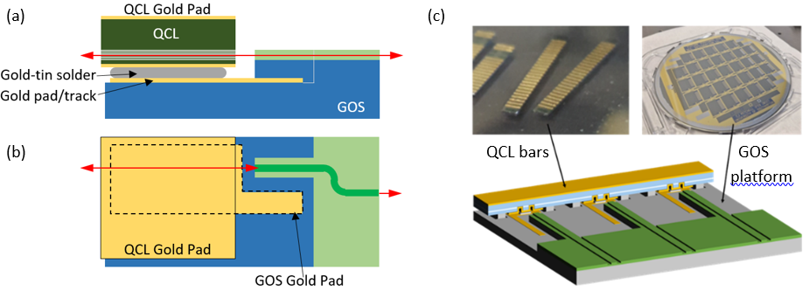
Fig. 1. (a) Side view of QCL flip-chip bonded to GOS showing coupling region. (b) Top view of bonded QCL to GOS with the GOS gold pad shown as a dashed line. (c) QCL bars (top-left), processed GOS 6” wafer (top-right) and a schematic of the bonded device (bottom).
To measure the coupling between the QCL and waveguide requires a measurement, or estimate, of the output power of the QCL towards the waveguide. As the QCLs are Fabry–Pérot (FP) lasers, the outputs from either facet are assumed to be equal, i.e. the power from the coupling facet to be equal to the uncoupled QCL facet. Hence, we designed the chip such that we could collect the light from the uncoupled QCL facet as an estimate of power to the waveguide from the QCL (Fig. 1). The GOS dies were diced using a self-polishing ductile dicing process [33, 34] with sufficient smoothness for measuring the waveguide output from the diced facet without additional polishing. Standard loss measurement structures, varying the number of bends or length, were included on each die to assess the losses in the waveguide.
The GOS platform used in this work incorporates a 3-µm-thick germanium layer grown by Reduced Pressure Chemical Vapour Deposition (RPCVD) on (100) silicon [33]. Single mode GOS rib waveguides were designed for TM polarization, with an etch depth of 2.1 µm and a width of 3 µm. The relatively thick waveguide layer, compared to SOI platforms, matches more closely the spot size of the laser and so alleviates the need for 3D spot size converters to achieve good mode overlaps for end-fire coupling. However, to allow for some misalignment the width of the waveguide is tapered from 3 µm to an 11 µm wide facet over a length of 1 mm. Additionally, the waveguide end facet was angled at 10º to reduce reflection back into the laser.
The two chips shown above were integrated and placed on top of one another, using a FineTech Fineplacer® Lambda flip-chip bonder, with an alignment accuracy < 0.5 µm in the plane of the interface of the two components. Automated bonders with higher precision are available, demonstrating a route for scaling the process. Vertical and angular alignment out of this plane is not as accurate, and so the design of the components requires a way to address this issue as an initial consideration. The method chosen was to use an etched support structure in the GOS to passively align the QCL to the waveguide plane using the unprocessed QCL top epitaxial layer as the other contact to minimize error from etch or deposition on the QCL. The etched support structure can be seen in Fig. 1(c), but is not shown in Fig. 1 (a/b) for schematic clarity. Parallel placement, where the GOS supports are in contact with the QCL along the whole length of the laser bar (14.5 mm by 2.0 mm bar, with 24 lasers along the length at a pitch of 500 nm), requires the use of a dedicated gimballed placement head and other tooling described elsewhere [35].
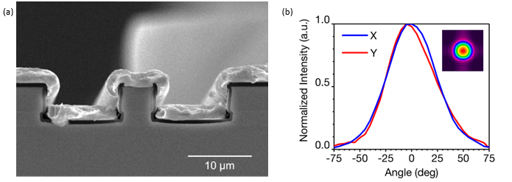
Au plate
Dielectric Active region
Fig. 2. (a) SEM image of a cross section in a 4.5µm wide double-trench QCL. (b) Measured X&Y-axis far-field beam profile. The inset 2D colour plot was measured using an Ophir Nano Scan pyroelectric scanning-slit beam profiler.
The MIR QCLs are based on a two-phonon resonance design [36] and were grown by metalorganic vapour-phase epitaxy (MOVPE) at the National Epitaxy Facility, Sheffield. The material was processed into double-trench ridge waveguide structures with ridge width of ~4.5 µm, which penetrate through the active region to a depth of 6 µm, as shown in Fig. 2(a). The double trench scheme allowed the unprocessed epitaxial surface in between the laser waveguide and metal to be in contact with the support structures on the GOS substrate. Uncoated FP lasers mounted with the epitaxial surface face-up on top of diamond substrates exhibit room temperature continuous-wave (RT-CW) operation, with threshold current ~130mA for a 3 mm long cavity, and maximum power >65 mW per facet at 15ºC. The measured optical far-field beam profile shown in Fig. 2(b) demonstrates a highly circular fundamental transverse mode, providing good beam quality and low divergence in the vertical plane, which is beneficial for effective waveguide coupling without 3D tapers. The FWHM fast- and slow-axis beam divergences are both around 55º.
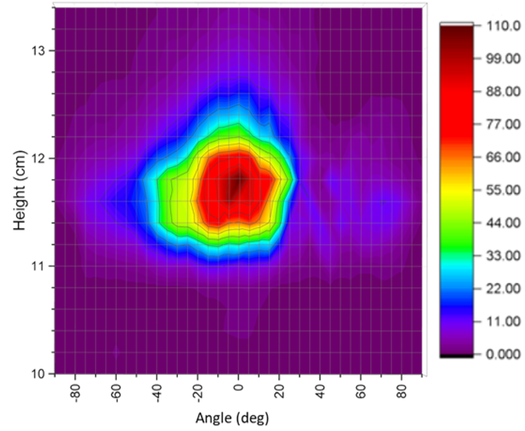
Fig. 3 Far-field image of light output from a ductile-diced waveguide facet measured using an Ophir Nano Scan pyroelectric scanning-slit beam profiler.
- Coupling measurements
Once the QCL had been flip-chip bonded to the GOS chip, initial characterization demonstrated consistent electrical connections along the QCL bar. In pulsed mode operation a far-field beam profile was measured from an output waveguide facet (Fig. 3), using the same approach as the as used in Fig. 2(b), indicating strong coupling between the QCL and waveguide. To quantify the outputs from the device, the QCL and waveguide facet outputs (Fig. 4) were collected and collimated using a NA=0.85 lens (Thorlabs C037TME-E) with anti-reflection coating and focused on to a thermoelectrically cooled (TEC) Vigo InAsSb superlattice detector (PVIA-4TE-10.6-1x1) via a lens (Thorlabs LA7477-E2) with NA selected to match the detector acceptance angle. In the collimated section between the lenses, Thorlabs neutral density filters (NDF) were used to prevent saturation of the detector. The attenuation of the NDFs with nominal OD = 0.3, 1.0, 2.0, were experimentally determined using an identical QCL as the source.
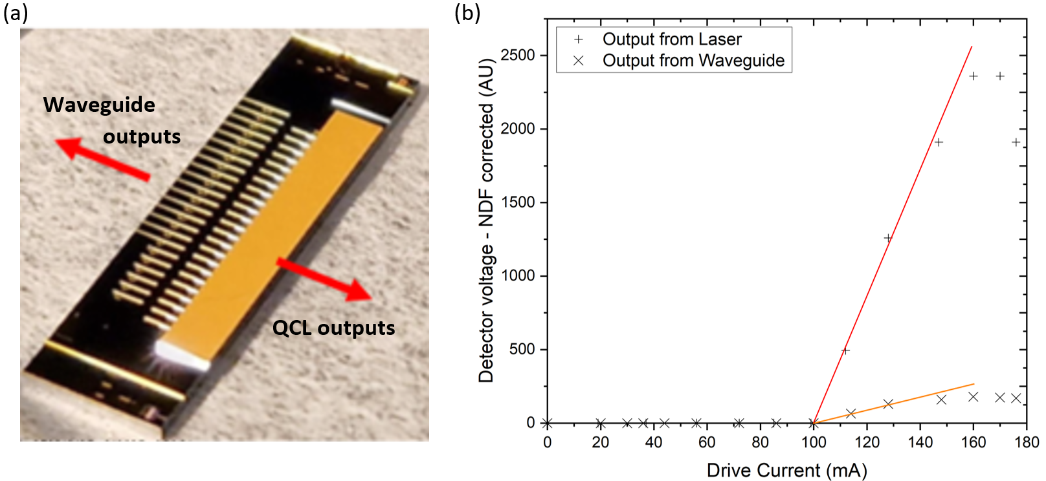
Fig. 4. (a) Integrated chip and measured outputs. (b) QCL and waveguide outputs from integrated chip with drive current.
The QCL was driven in pulsed mode mounted on a TEC cooled copper heatsink at 10ºC, using thermal conducting paste and matting. The drive current was provided by an ILX Lightwave LDP-3830 laser diode driver operating with 400 ns pulses at 0.5% duty cycle. The LDP-3830 current monitor connection was used for measurement of the operating drive current.
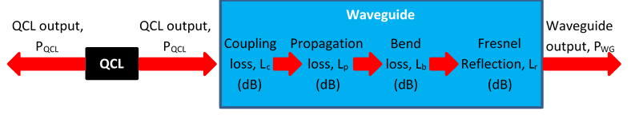
Fig. 5. Laser to waveguide optical coupling with losses.
$L_{c}= -10.\log_{10}\left(\frac{P_{WG}}{P_{QCL}}\right)- L_{p}- L_{b}-L_{r}$ (1)
The laser to waveguide optical coupling was calculated using Eq. (1), shown schematically in Fig. 5. Fresnel reflection loss (L_{f} = 1.89 dB) was calculated using the effective index (n_{eff} = 3.93) determined from simulation of the taper structure. Propagation and bend losses (L_{p} and L_{b} respectively) were derived from the passive test structures using the cut-back method. The propagation loss was calculated as 8.6 dB/cm and the bend loss 9.8 dB/cm (0.38 dB/90º bend). The high loss through the waveguide is thought to result from the presence of strain-induced defects at the silicon-germanium interface, accentuated by the thermal cycling involved in the deep ICP-RIE etch. This will be improved in future devices by cooler etch processes, which have been developed.
The data derived from this treatment is shown in Fig. 6 for the device with the highest coupling shown with two pulse lengths. The peak output coupling (output from integrated waveguide as a fraction of QCL output power) was 12.9% (8.9 dB loss). This produces a maximum value for laser to waveguide optical coupling of 45% (3.5 dB loss). As thermal rollover of the laser output begins, coupling falls to 26%. This reduction could be indicative of heating effects in terms of expansion or spectral changes in the FP cavity. The measurement was repeated with longer pulses (600 ns) and this provided more stable interface coupling values with increasing current, but with coupling limited to 20-27%. These values are similar to the values at 400 ns with higher current, again suggesting that the fall in efficiency for the shorter pulse could be due to heating effects, with increased drive current, that match those at the longer pulses as the laser reaches a steady thermal equilibrium. Of note here is that as the QCL reached roll-over, the output power profile on the oscilloscope changed. The intensity peak occurred earlier in the pulse, with a subsequent fall before the end of the pulse. This would occur with excess heating during the pulse.
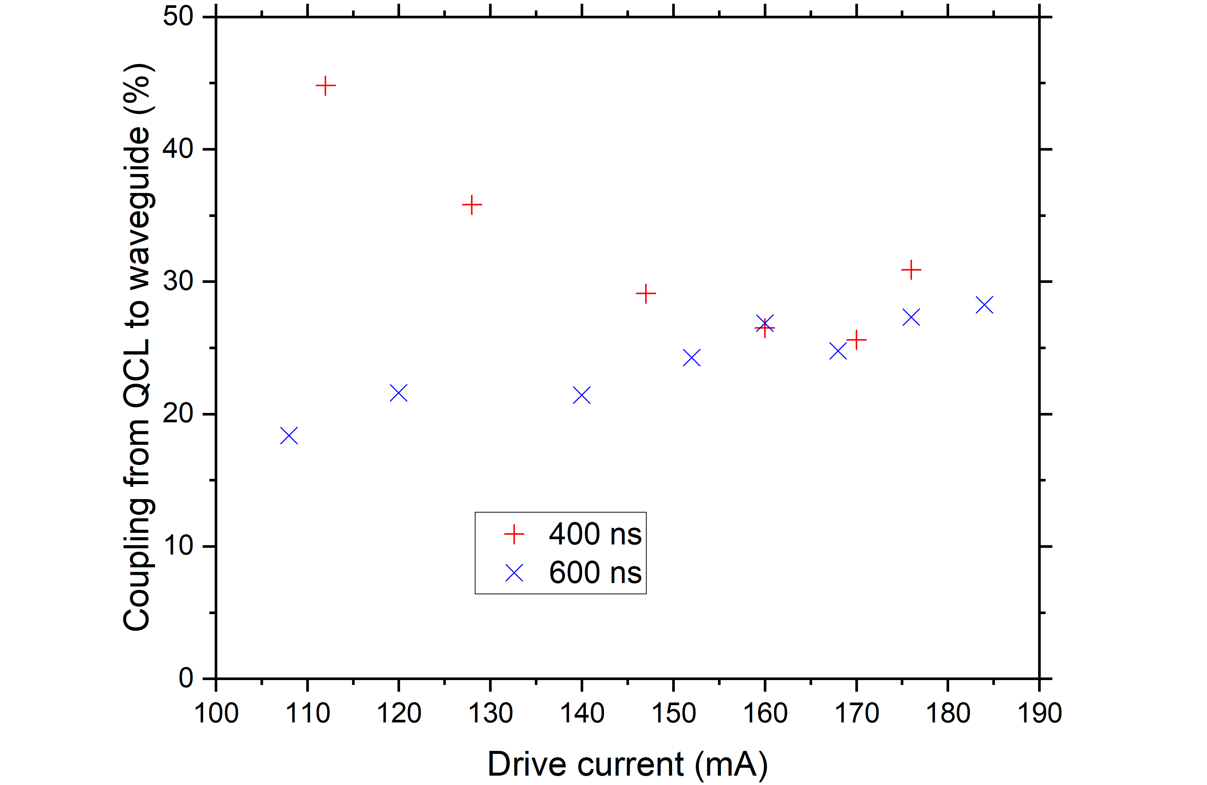
Fig. 6. Coupling efficiency of laser against current for two pulse widths
The data shown in Fig. 6 is from the QCL with the highest coupling efficiency on the bar, the eleventh of twenty-four, which was located close to the middle of the bar. Along the bar were a mixture of end-fire and grating outcoupled lasers. Seventeen QCLs were coupled to GOS waveguides with end-fire outcoupling, six QCLs were coupled to GOS waveguides with grating couplers at the output, and one had no waveguide interface by design. Grating couplers were not used for the calculation of the coupling between QCL and waveguide, due to a larger uncertainty in calculating the coupling efficiency by separating out grating coupler and fibre losses. Comparing the end-fire QCLs, one failed under initial electrical test, but all coupled light. Away from the centre of the bar, and in both directions, the coupling efficiency fell, indicating that this was not from rotational misalignment (yaw or roll). The fall in coupling efficiency, down to 3.5% at the edge of the laser bar (pulsed for 600 ns), is most likely due to the thermal expansion coefficient mismatch of the components at bonding (which took place at a temperature of 320ºC).
In order to obtain an estimate of the optical power in terms of mW, as opposed to detector voltages above, an identical QCL in a conventional laser driver unit was used. Firstly, the power was measured in CW mode and then compared to the values of detector voltage, using a standard chopper (simulating pulsed measurement). Quantifying the output of the QCL and using the coupling efficiency at peak power, this equates to 20-30 mW of power in the waveguide, demonstrating the potential use of this system for sensing.
- Conclusions
In this paper, we have demonstrated a novel route to integrate QCLs to a silicon photonics platform using CMOS-compatible processes. The efficient co-design of the components opens up the possibility of scaling up production for widespread use of this system for applications such as medical, environmental monitoring and security sensing across the MIR.
Flip-chip bonding eliminates the issues of the interface associated with die/wafer bonded and monolithically grown structures, whilst the gold-tin alloy bond along the length of each individual laser acts as an industrial standard contact solder, and as a critical heatsink for the QCL. Importantly, this approach allows for separate manufacture of the GOS and QCL components using optimal fabrication processes for each component with minimal back-end processing. Our hybrid approach using passive alignment of components, where the GOS contacts to unprocessed sections of the QCL, has demonstrated coupling into 11 µm wide waveguide facets along the length of a 14.5 mm laser bar. QCL performance has been demonstrated for pulsed operation after integration and demonstrating a coupling efficiency of 45%. Further gains could be made from additional heatsinking to the exposed substrate of the QCL, proven to dramatically improve performance, and possibly enable CW and high power operation. Additionally, active-cooling of the QCL to circuits on the GOS could be utilized if needed.
A drop off in coupling efficiency was noted away from the middle of the laser bar. This was expected and it is proposed that this is due to the mismatch in thermal expansion coefficients. A coupling efficiency between the laser and waveguide of 3.5% was still achieved close to the edge, representing an estimated ~1 mW in the waveguide. The potentially complex expansion mismatch (a function of tooling, components, and thermal gradients) can be experimentally measured and should be repeatable. Hence, this can be accounted for in future designs, improving the coupling efficiency of the lasers along the bar, and in conjunction with the use of tapered waveguide at the interface, as demonstrated here.
These developments open the path to multiple sources, and the possibility of combining lasers at different wavelengths within the gain spectra of the QCLs, or combining detectors, all with a single alignment. With further developments such as active cooling for the QCL integrated on the GOS chip, portable low-cost, low power light sources on chip could be realized and become a common tool for tackling climate change and medical diagnosis.

Funding. The authors gratefully acknowledge funding from the Engineering and Physical Sciences Research Council (EP/V047663/1, EP/W035995/1, EP/N00762X/1) and the Royal Academy of Engineering (RF201617/16/33).
Datasets. Data underlying the results presented in this paper are available with open access in …. [see library]
Disclosures. The authors declare no conflicts of interest.

References
1. Z. Zhou, et al., "Prospects and applications of on-chip lasers," eLight 3, 1 (2023).
2. G. H. Duan, et al., "New Advances on Heterogeneous Integration of III–V on Silicon," Journal of Lightwave Technology 33, 976-983 (2015).
3. G. Roelkens, et al., "Micro-Transfer Printing for Heterogeneous Si Photonic Integrated Circuits," IEEE Journal of Selected Topics in Quantum Electronics 29, 1-14 (2023).
4. M. A. Tran, et al., "Ring-Resonator Based Widely-Tunable Narrow-Linewidth Si/InP Integrated Lasers," IEEE Journal of Selected Topics in Quantum Electronics 26, 1-14 (2020).
5. Z. Wang, et al., "Room-temperature InP distributed feedback laser array directly grown on silicon," Nature Photonics 9, 837-842 (2015).
6. Y. Xue, et al., "In-Plane 1.5 µm Distributed Feedback Lasers Selectively Grown on (001) SOI," Laser & Photonics Reviews 18, 2300549 (2024).
7. Y. De Koninck, et al., "GaAs nano-ridge laser diodes fully fabricated in a 300-mm CMOS pilot line," Nature 637, 63-69 (2025).
8. J. Faist, et al., "Quantum Cascade Laser," Science 264, 553-556 (1994).
9. C. J. Mitchell, et al., "Mid-infrared silicon photonics: From benchtop to real-world applications," APL Photonics 9, 080901 (2024).
10. R. Soref, "Mid-infrared photonics in silicon and germanium," Nature Photonics 4, 495-497 (2010).
11. S. Shekhar, et al., "Roadmapping the next generation of silicon photonics," Nature Communications 15, 751 (2024).
12. A. Spott, et al., "Quantum cascade laser on silicon," Optica 3, 545-551 (2016).
13. E. J. Stanton, et al., "Multi-Spectral Quantum Cascade Lasers on Silicon With Integrated Multiplexers," Photonics 6, 6 (2019).
14. H. Nguyen-Van, et al., "Quantum cascade lasers grown on silicon," Scientific Reports 8, 7206 (2018).
15. R. Q. Yang, "Infrared laser based on intersubband transitions in quantum wells," Superlattices and Microstructures 17, 77-83 (1995).
16. A. Malik, et al., "Integration of Mid-Infrared Light Sources on Silicon-Based Waveguide Platforms in 3.5–4.7 μm Wavelength Range," IEEE Journal of Selected Topics in Quantum Electronics 25, 1-9 (2019).
17. M. Fagot, et al., "Interband cascade lasers grown simultaneously on GaSb, GaAs and Si substrates," Optics Express 32, 11057-11064 (2024).
18. S. Slivken and M. Razeghi, "High Power, Room Temperature InP-Based Quantum Cascade Laser Grown on Si," IEEE Journal of Quantum Electronics 58, 1-6 (2022).
19. A. Remis, et al., "Effect of dislocations on the performance of GaSb-based diode lasers grown on silicon," Journal of Applied Physics 133(2023).
20. A. Remis, et al., "Unlocking the monolithic integration scenario: optical coupling between GaSb diode lasers epitaxially grown on patterned Si substrates and passive SiN waveguides," Light: Science & Applications 12, 150 (2023).
21. D. Wang, et al., "Innovative Integration of Dual Quantum Cascade Lasers on Silicon Photonics Platform," Micromachines 15, 1055 (2024).
22. Y. Martin, et al., "Novel Solder Pads for Self-Aligned Flip-Chip Assembly," in 2019 IEEE 69th Electronic Components and Technology Conference (ECTC), 2019), 528-534.
23. Y. Martin, et al., "Flip-Chip III-V-to-Silicon Photonics Interfaces for Optical Sensor," in 2019 IEEE 69th Electronic Components and Technology Conference (ECTC), 2019), 1060-1066.
24. C. J. Mitchell, et al., "Hybrid integration methodology for quantum cascade lasers with germanium waveguides in mid-IR," EPJ Web Conf. 266, 01008 (2022).
25. C. J. Mitchell, et al., Hybrid laser integration in the mid-IR for silicon photonics sensing applications, SPIE OPTO (SPIE, 2023), Vol. 12426.
26. S. H. Jang, et al., "Therapeutic drug monitoring: A patient management tool for precision medicine," Clin Pharmacol Ther 99, 148-150 (2016).
27. C. Hiemke, et al., "Consensus Guidelines for Therapeutic Drug Monitoring in Neuropsychopharmacology: Update 2017," Pharmacopsychiatry 51, 9-62 (2018).
28. E. Kozer, et al., "How high can we go with phenytoin?," Ther Drug Monit 24, 386-389 (2002).
29. B. Zheng, et al., "Separation and determination of estrogen in the water environment by high performance liquid chromatography-fourier transform infrared spectroscopy," Scientific Reports 6, 32264 (2016).
30. Z. Diamantopoulou, et al., "The metastatic spread of breast cancer accelerates during sleep," Nature 607, 156-162 (2022).
31. B. G. Lee, et al., "DFB Quantum Cascade Laser Arrays," IEEE Journal of Quantum Electronics 45, 554-565 (2009).
32. J. W. Ronnie Teo, et al., "Microstructure of eutectic 80Au/20Sn solder joint in laser diode package," Microelectronic Engineering 85, 512-517 (2008).
33. M. Nedeljkovic, et al., "Germanium-on-silicon waveguides operating at mid-infrared wavelengths up to 8.5 μm," Optics Express 25, 27431-27441 (2017).
34. P. C. Gow, et al., "Mechanical dicing of optical quality facets and waveguides in a silicon nitride platform," Electronics Letters 60, e13138 (2024).
35. C. J. Mitchell, et al., "Tooling and procedures for hybrid integration of lasers by flip-chip technology," in 2020 IEEE 8th Electronics System-Integration Technology Conference (ESTC), 2020), 1-7.
36. I. I. Zasavitskii, et al., "A GaInAs/AlInAs quantum cascade laser with an emission wavelength of 5.6 μm," Quantum Electronics 48, 472 (2018).

