Mid-infrared germanium-on-silicon waveguide sensor for therapeutic drug monitoring of phenytoin
David J. Rowe*⁺, Siyu Chen⁺, Mihai-Adrian Panainte^, Callum J. Stirling⁺, Pin Dongº, Monika Bakalarz⁺, Hanuushah Vizabaskaran⁺, Glenn Churchill⁺, Weilin Jin⁺, Georgia Mourkioti⁺, Martin Ebert⁺, Graham T. Reed⁺, Saul N. Faust^, James S. Wilkinson⁺, Milos Nedeljkovic⁺, Daniel R. Owens^ and Goran Z. Mashanovich⁺.
⁺ Optoelectronics Research Centre, University of Southampton, Southampton SO17 1BJ, U.K. ^ Faculty of Medicine and Institute for Life Sciences, University of Southampton, Southampton SO16 6YD, and NIHR Southampton Clinical Research Facility and Biomedical Research Centre, University Hospital Southampton NHS Foundation Trust, Southampton SO16 6YD, U.K. º School of Physics Engineering and Technology, University of York, Heslington, York YO10 5DD, U.K.
KEYWORDS mid-infrared photonics, therapeutic drug monitoring, biosensing, infrared spectroscopy, tunable diode laser spectroscopy.

ABSTRACT We report the design, fabrication and characterization of evanescent mid-infrared germanium-on-silicon waveguide sensors for therapeutic drug monitoring (TDM). The sensors incorporate a passive microfluidic confinement structure to define the light-sample interaction length. Tunable diode laser absorption spectroscopy was used to analyze dried samples of the anti-seizure medication phenytoin in the spectral region of λ = 5.6 – 6.0 µm. A limit of detection of 2.20 mg/L was achieved for extracted samples, where phenytoin was first added to human serum and subsequently isolated using liquid-liquid extraction. This limit is significantly below the therapeutic window of 10 – 20 mg/L for phenytoin, enabling detection of sub‑therapeutic concentrations. At the same time, the sensor maintains a consistent dose‑dependent response up to 40 mg/L, demonstrating its capability to quantify concentrations across the therapeutic window and above the upper therapeutic limit. This validates the use of silicon photonics for biomedical infrared spectroscopy for patients undergoing drug therapy, whether the serum-drug concentration is either too high or too low.

INTRODUCTION Therapeutic drug monitoring (TDM) is the process of measuring the concentration of a medicine from the serum of a patient receiving the drug to ensure safe and effective dosing. It enables a clinician to alter the dose and timing of the drug depending on whether the level is too high or too low. This is particularly important for drugs with a narrow therapeutic window that cause toxicity such as the anti-seizure medication phenytoin, used for the management of epilepsy.
Conventional analytical methods for performing TDM generally use laboratory techniques such as chromatography and mass spectrometry. Such methods require centralized infrastructure and specialist personnel to process samples and operate equipment. These methods have high batch efficiency, where many samples can be processed simultaneously, but systematically introduce delays of several hours for routine tests¹. Immunoassay kits enable faster turnaround time by testing at the scale of individual patients but suffer from issues with specificity and cross-reactivity² while remaining inherent laboratory-based methods because of their microplate format. In contrast, a point-of-care method operable by the non-expert user would enable clinicians to obtain the relevant information directly in hospital, primary care or in the homes of patients. This need for locally delivered testing aligns with current UK governmentGovernment policy driving a shift in NHS services from hospital-based care toward community-centered provision, aimed at improving access and reducing reliance on acute facilities³.
Optical methods are suitable for point-of-care implementation because the light-sample interaction is more easily automated and miniaturized in comparison with chemical methods. Two such methods are surface-enhanced Raman spectroscopy (SERS) and mid-infrared (mid-IR) absorption spectroscopy.
SERS exploits the highly intense electromagnetic fields of localized surface plasmon resonances for a strong interaction with a target molecule for detection, resulting in low limits of detection in TDM applications⁴⁻⁶. However, the reproducibility required for TDM is significantly impacted by the need for the analyte to occupy a nanoscale plasmonic resonance amidst the complexity of a biological matrix⁵. Furthermore, this small overlap makes multiplexing difficult due to competitive adsorption of different drugs onto the sensor surface⁶.
Mid-IR absorption spectroscopy using evanescent waveguide sensors has been investigated for applications including protein sensing^{7, 8}, which could find application in cancer screening⁹, and illicit drug monitoring¹⁰. Cocaine was added to saliva and detected at 500 mg/L concentration using a single-wavelength measurement (λ = 5.8 μm) with a germanium-on-silicon (GoS) waveguide. This demonstrates that mid-IR photonics could be used for overdose detection in emergency medicine¹¹, although the relevant limits of detection are much higher than for TDM.
We have chosen to implement mid-IR spectroscopy for TDM using integrated photonics because the platform enables the light-sample interaction to be tuned for appropriate sensitivity while using an interaction volume much larger than that of SERS, thereby avoiding the issues of poor reproducibility and difficult multiplexing. The platform is mass producible due to the fabrication methods of the microelectronics industry, enabling single use transducers to be produced instead of requiring microwell plate-based pipelines associated with immunoassays. Such miniaturized sensors also avoid the need for centralized laboratory infrastructure required for the large and expensive equipment required for LC-MS.
One potential issue with mid-IR spectroscopy of biological fluids is interferents from the biological matrix, in particular water and protein, both of which have broad and intense absorptions in the mid-IR region¹². In this work, we use a previously-reported extraction method for extracting hydrophobic drugs¹³, which removes the water and protein content from the sample and isolates the analyte in a solvent with fewer interfering spectral features. Although the extraction is performed in a laboratory, work is underway to automate this workflow using a microfluidic platform.
TDM is helpful for doctors to maintain the concentration of drugs within a safe and effective treatment range that can be individualized to each patient. Phenytoin is a good example as it has a narrow range between minimum effective concentration and toxic levels. Individual variability, because of age, genetics, organ function or other medications, can lead to significant shifts in serum concentrations. If the level is too low, seizures might not be controlled; if too high, there is a significant risk of toxicity causing neurological symptoms such as slurred speech and confusion, cardiac arrhythmias and even death developing rapidly, especially in the elderly or critically ill¹⁴. TDM allows for early identification of ineffective or harmful drug levels before symptoms occur. The therapeutic window of phenytoin¹⁵ is 10 – 20 mg/L.

METHODS Rib waveguides were designed for the GoS material platform using simulations in Lumerical (Ansys, USA). A parameter sweep of the rib width was used to design the waveguide for single mode operation across the wavelength range of the tunable laser source, λ = 5.5 – 11 µm. Because a range of rib widths satisfied this condition, the maximum width of 3.0 µm was used to give the greatest modal confinement, which would reduce sidewall interaction and the corresponding propagation loss. The waveguide height was 3.2 μm and the etch depth was 1.8 μm. Tapered edge couplers and waveguide bends were also simulated in Lumerical. The taper design was optimized for minimal coupling loss, widening from the waveguide width to 16 µm at the facets with a taper length of 3 mm. For waveguide bends, excess propagation loss is inversely proportional to bend radius so a minimum bend radius of 300 µm was chosen as a compromise between the compactness of the circuit and a manageable excess bend loss. The simulated excess bend loss was 0.1 dB per 90° bend for TM polarization and 0.54 dB per 90° bend for TE polarization.
A 40 µm wide trench was etched into the germanium layer, matching the rib depth, to form the fluid‑confinement boundary. Each waveguide was created by etching two 20 µm wide trenches alongside the rib and the confinement trench was routed so that it intersected these waveguide trenches at right angles. The path of the confinement trench followed an obround loop measuring 6.5 mm by 2.5 mm, providing a physical barrier that pinned the droplet edge to prevent further spreading.
The photonic circuit was designed so that waveguides of various lengths traversed this confinement zone, enabling different optical interaction lengths while keeping the total device length constant. This ensured that propagation and coupling losses remained identical for all channels. A schematic diagram of the layout is shown in Figure 1.
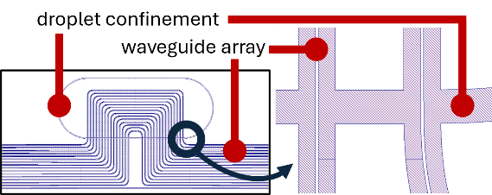
Figure 1: schematic of the photonic integrated circuit showing how the confinement trench extends perpendicularly from the waveguide trenches, which are etched either side of the rib waveguide core. The waveguide ribs and confinement trenches are etched by 1.8 μm.
Devices were fabricated using 200 mm GoS wafers as part of a CORNERSTONE multi-project wafer fabrication run at the University of Southampton. Features were patterned using deep UV lithography and etched using inductively coupled plasma-reactive ion etching. The etched wafers were diced into chips using ductile dicing, which yielded facets of sufficient flatness to enable end-fire coupling into the tapered couplers.
A schematic of the measurement setup used to perform absorption spectroscopy is shown in Figure 2. Absorption measurements were performed with a MIRcat tunable quantum cascade laser (Daylight Solutions, USA), operating in continuous-wave mode across the wavelength range 5.6 – 6.0 µm. This range was selected to be wide enough to cover the phenytoin absorption peaks of interest¹³ while including narrow zero-absorption regions on either side to enable reliable baseline correction. At the same time, the scan range was sufficiently narrow to allow rapid wavelength sweeping of the laser source. The average output power of the laser was around 450mW (Class 3R), which posed a potential risk of damaging both the detector and the FLIR Boson mid-IR camera (FLIR, USA). To mitigate this, wedged neutral density (ND) filters were placed after the laser to attenuate the optical power. The wedged geometry further helped suppress unwanted back-reflections within the optical system.
Since the rib waveguides were designed to operate under TM polarization for high surface interaction, a linear polarizer was placed after the ND filters to ensure high polarization purity of the incident beam. The beam was then focused onto the waveguide input taper using a reflective objective lens with 40× magnification and a numerical aperture (NA) of 0.5, providing a tightly focused spot and improved coupling efficiency into the waveguide. At the output side of the waveguide, a second reflective objective lens was used to collect the transmitted light and direct it to the mid-IR camera. The image from the mid-IR camera allows verification that the QCL laser excites the intended guided mode of the rib waveguide rather than undesired slab modes. Once correct mode excitation and alignment were confirmed, the transmitted beam was redirected to a HgCdTe photodetector (VIGO Photonics, Poland) via a foldable mirror, which exhibits a typical detectivity D* of ~4.0 × 10⁹ cm·Hz¹ᐟ²/W at its peak response, and the optical alignment was further optimized to maximize the detected power for spectral measurements.
All optical components were arranged in close proximity to avoid unnecessary beam propagation in air and so minimize the interaction length with environmental water vapour. This approach suppressed background absorption features to ensure that the measured spectrum was dominated by the waveguide-analyte interaction rather than environmental contributions. The total free space pathlength was approximately 120 cm.
For the spectral measurements, after the optimized alignment was found, the laser was swept linearly across the 5.6 – 6.0 µm wavelength range at a constant scan rate of 0.1 µm s⁻¹, resulting in a deterministic mapping between time and wavelength. Under this condition, the recorded detector signal represents a time-domain encoding of the optical absorption spectrum. To suppress high-frequency noise arising from electronic fluctuations and residual interference fringes while preserving the intrinsic absorption line shape, each individual wavelength scan was processed with a low-pass filter (LPF) procedure. The filter cut-off frequency was selected based on the narrowest absorption features of interest in this spectral region (on the order of 5 nm), corresponding to a characteristic temporal frequency of approximately 20 Hz at the applied scan rate. Accordingly, a cut-off frequency of 40 Hz was chosen to ensure full preservation of the absorption profile while reducing the high frequency noise. Filtering was implemented using a fifth-order Butterworth filter with zero-phase forward-backward processing to avoid phase distortion or artificial broadening of absorption features. To further improve the signal-to-noise ratio, the wavelength scan was repeated 100 times under identical experimental conditions. The filtered spectra from all scans were then averaged to reduce uncorrelated noise while maintaining reproducibility of the measured absorption features. The total insertion loss of the TDM chip was measured to be 16.2 dB.
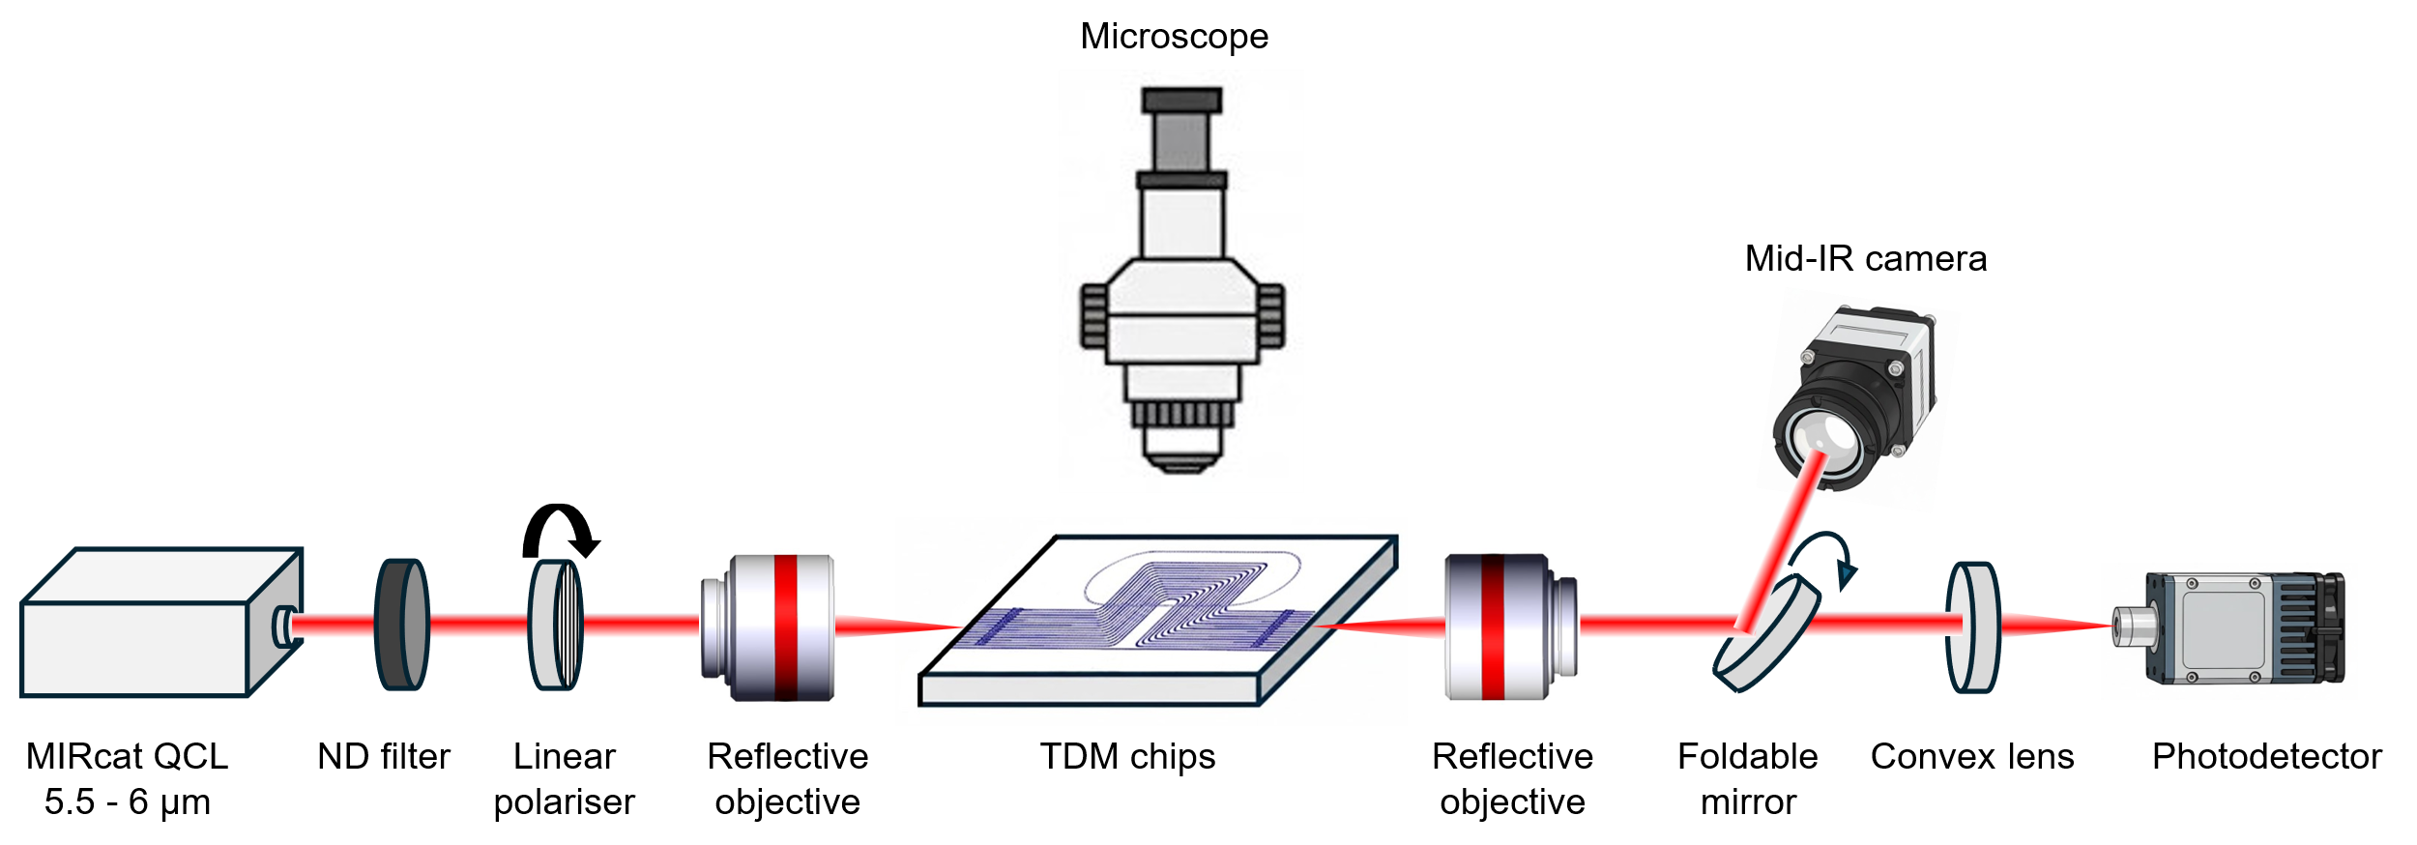
Figure 2: schematic of the measurement setup used to perform absorption spectroscopy. The TDM chips were mounted on a three-axis stage for alignment.
Phenytoin (≥ 98% purity; Cayman Chemical, US) was prepared in human serum (male AB plasma, USA origin, sterile-filtered; Merck, UK) at concentrations of 5, 10, 20, and 40 mg/L. The solutions were subsequently extracted into ethyl acetate following a previously published method¹³. A blank serum control underwent the same extraction procedure but without the addition of phenytoin.
The multistep extraction was used to remove major endogenous interferents from the serum solutions and can be summarized as follows. Lipoproteins were first precipitated by adding a magnesium chloride–dextran sulfate sodium solution, enabling removal of lipid-bound components. The supernatant was then treated with saturated ammonium sulfate to salt-out albumin, which retains the protein-bound phenytoin; the supernatant containing small water-soluble molecules was discarded. The albumin precipitate was resuspended in water and extracted twice with ethyl acetate to isolate phenytoin while removing remaining proteins. The organic extracts were combined and the solvent was evaporated, and the dried residue was reconstituted in ethyl acetate for subsequent analysis.
For each measurement, a reference spectrum was recorded by first measuring the power transmission spectrum of each waveguide. 0.5 μL of phenytoin sample was then pipetted onto the waveguide array and allowed to dry under ambient conditions. In practice, drying took several seconds. The waveguides were measured a second time in the same way to provide sample spectra. Absorbance was calculated as 10 log₁₀ of the ratio of the sample and reference spectra. All samples were measured in triplicate; that is, aliquots of each sample were pipetted onto three waveguide arrays and characterized individually. A new waveguide array was used to characterize each aliquot.
The noise of the system was estimated using the standard deviation of repeated measurements of the blank serum control. To achieve this, the entire measurement procedure, where 100 scans were filtered and averaged for a single spectrum, was repeated twenty times for each of three aliquots of the blank serum control for every waveguide.

RESULTS To explore the effect of interaction length on limit of detection (LoD) while efficiently using laboratory time, four waveguides were characterized for extracted phenytoin samples. Waveguide 6 had interaction length l = 3.44 mm, waveguide 8 l = 4.44 mm, waveguide 10 l = 5.44 mm and waveguide 12 l = 6.44 mm. Each waveguide had a total length of 11.79 mm.
Figure 3 shows the absorbance spectra for multiple concentrations of extracted phenytoin, measured using waveguides with different interaction lengths. The solid line represents the mean spectrum and the shaded areas represent ± one standard deviation, taken from the repeated measurements of each sample. Figure 4 shows the result of integrating the areas under the curves (AUC) in Figure 3 within the wavelength region 5.71 – 5.87 μm, covering the main phenytoin absorption peak, plotted with respect to concentration and again plotted for waveguides with different interaction lengths. Interference bands associated with water vapor from the free-space path of the experimental setup, shown as gray shaded regions in Figure 3, were excluded from the integration. For each subplot in Figure 4, the height of the shaded area represents the 3σ noise limit, calculated from the AUC from the repeated blank measurements, where three aliquots of the blank sample were measured 20 times each. The LoD was calculated as the concentration corresponding to this 3σ noise limit and is represented by the width of the shaded area.
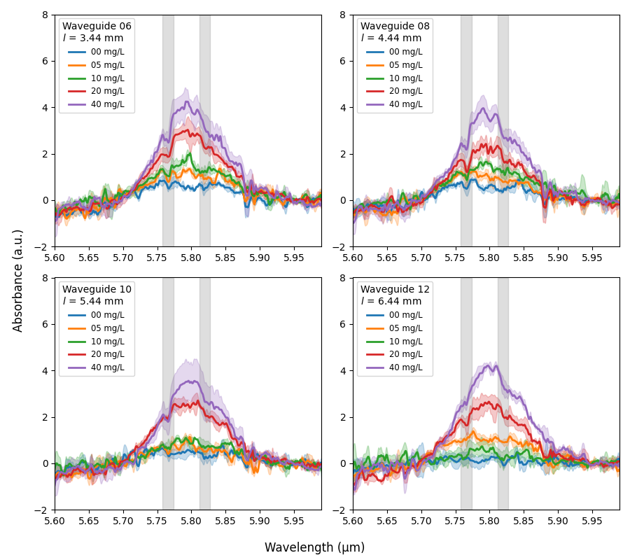
Figure 3: absorbance spectra for multiple concentrations of extracted phenytoin. Each subplot represents a different waveguide corresponding to a different interaction length l. Error bars represent ± one standard deviation from measurements of multiple aliquots. The zero-concentration trace represents blank measurements where the extraction protocol was applied to serum that had not had any phenytoin added. The gray shaded regions show interference from atmospheric water vapor and are excluded from the subsequent AUC calculation.
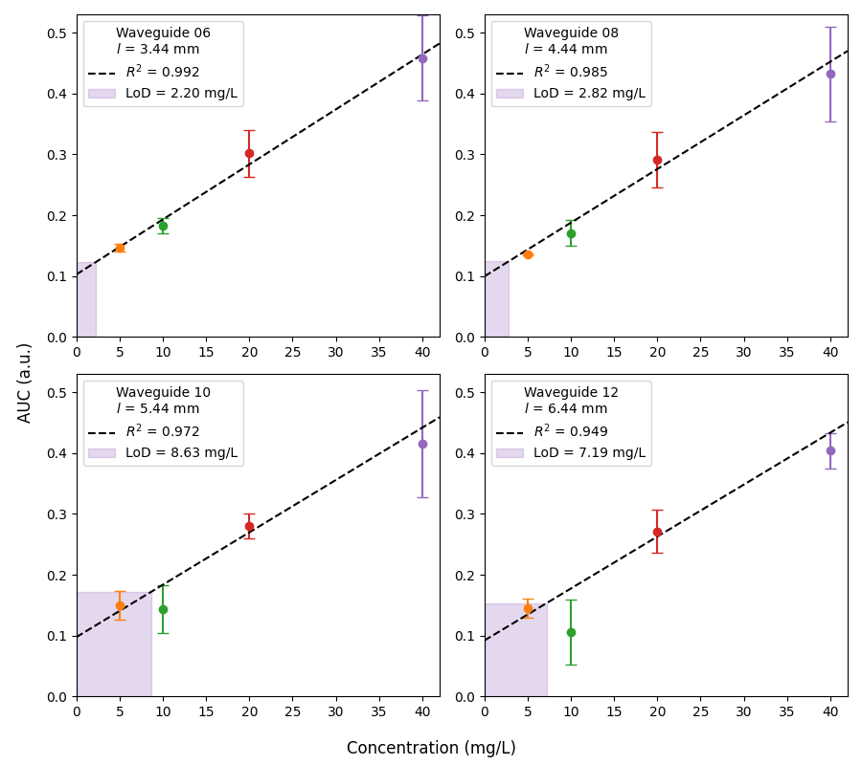
Figure 4: AUC with respect to concentration for extracted phenytoin. Each subplot represents a different waveguide corresponding to a different interaction length. Error bars represent ± one standard deviation from measurements of multiple aliquots. The shaded area represents the 3σ noise limit. The limit of detection (LoD; the width of the shaded area) is calculated as the concentration corresponding to an AUC equal to three times the standard deviation of the blank measurement (the height of the shaded area).
Figure 4 shows that the lowest observed limit of detection is 2.20 mg/L, which lies below the therapeutic range of 10–20 mg/L. Across the full tested range, no saturation of the AUC–concentration response is observed; concentrations above 20 mg/L continue to yield a clear, monotonic increase in AUC, supporting reliable quantification both throughout and above the therapeutic window as well.

DISCUSSION Figure 4 shows optimum performance for detecting extracted phenytoin using the shortest two interactions lengths (waveguides 6 and 8) in terms of limit of detection, sample error and measurement noise. The best LoD is 2.20 mg/L, which is significantly lower than the therapeutic window of 10 – 20 mg/L for phenytoin and suggests that this method would be appropriately sensitive for TDM in cases where a patient is underdosed, which is clinically more likely than the patient having too high a dose. While the low LoD is particularly relevant for identifying sub‑therapeutic concentrations, the maintained dose–response up to 40 mg/L also indicates that normal and supra‑therapeutic levels can also be quantified.
The sample error increases with concentration, which suggests that accuracy is a constant percentage of concentration. The gradient of the fit line is virtually identical for all waveguides, suggesting the interaction length is not varying where typically one would expect a larger gradient for an increased interaction length for a given concentration. This is likely due to imperfect fluid control by the confinement trench.
This aligns with experimental observations that the confinement trench is much less effective at controlling the spread of liquids with low contact angles such as ethyl acetate compared to those with higher contact angles such as water, where droplet pinning is much stronger. In particular, the confinement trench does not prevent solvents from wicking along the waveguides themselves. This would explain why the light-sample interaction appears the same between all the waveguides and suggests that more sophisticated sample control is required for low contact angle samples. Suitable solutions could be mid-IR transparent claddings, where a window could be etched in the cladding to expose the desired length of waveguide, or microfluidic integration where a flow cell is bonded on top of the photonic chip.
The 3σ measurement error, visually represented by the height of the shaded area in Figure 4, and the R² value for the fit lines both increase with waveguide length. This suggests there is greater variation in interaction length for the longer waveguides, particularly waveguide 12, where the error bars of two of the measurement points do not overlap with the fit line. The fact that the LoD is lower for waveguide 12 compared to waveguide 10 is an artefact of the fit line being skewed by the 10 and 40 mg/L measurements.
The increase in measurement variation with interaction length can be understood by considering how the droplet dries within the nested waveguide layout. When the sample is pipetted in the center of the confinement trench, it spreads to fill the sensing region. During this process, the droplet encounters several waveguides, which guide its flow and create slight variations in how the sample distributes. As the ethyl acetate evaporates, the analyte is deposited for measurement and characteristic drying phenomena such as the coffee‑ring effect shape its final distribution. The shorter interaction length waveguides near the center of the nested array benefit most from this geometry, showing the lowest variation.
Importantly, these observations highlight clear opportunities for further improvement. For example, replacing the nested geometry with straight waveguides, where the droplet could spread along rather than across each waveguide, would support more uniform deposition. Introducing a mid-IR transparent cladding material to define a dedicated fluid cavity would mean the sample boundary is precisely set by design rather than by droplet shape. Completely flooding such a cavity would naturally enhance sample uniformity because it would introduce pinning at the cavity edge, suppressing radial capillary flow and making evaporative flux more uniform. Together, these refinements offer a straightforward route to improved measurement repeatability.
The main factor limiting the LoD is interaction length: generally, the longer the interaction length for a given mode profile, the larger the measured absorbance. Longer interaction lengths would increase the gradient of the AUC-concentration response and so increase the LoD for given noise performance. Future work should include a longer range of interaction lengths, together with a cavity for liquid confinement, which would enable the interaction length to be optimized for LoD empirically. The measurements are not close to the noise floor of the detector so they are not limited by detectivity. Reflections are not a significant issue because there are not pronounced ripples in the spectrum, which would arise from Fabry-Perot resonances.
The effect of fluctuations in the output power of the laser was reduced by averaging 100 scans per measurement but the laser performance will always be different between the reference and sample measurements because they are measured one after the other. A more sophisticated strategy where they are measured simultaneously would be beneficial. The most effective way to do this would be to use an on-chip splitter to divide the input into separate sensing and referencing waveguides. These could either be measured simultaneously using two balanced detectors or measured sequentially using a single detector by recombining into a single waveguide and switching between the two. The simultaneous measurements of the first method would enable cancellation of fluctuations in the laser output power but would be more challenging experimentally because of the need to have two optically isolated detectors close to each other. Using a single detector would be simpler experimentally but would require fast modulation between the two paths for effective cancellation to occur.
A third option would be to use a beam splitter before coupling to the TDM chip to measure the laser power directly. This was attempted using our setup but proved ineffective because waveguide coupling was heavily influenced by small variations in beam pointing from the QCL and this information could not be captured using a power meter or detector.
Here we have demonstrated that mid-IR silicon photonics has appropriate sensitivity for TDM of a single drug. In clinical practice, it is likely that a patient would not receive phenytoin alone. For example, they could also receive analgesics for pain relief or other anti-convulsants for seizure management, which would have different therapeutic windows and would be metabolized at different rates. This would require the sensor to operate over a wider spectral range to identify the characteristic peaks of each drug, which is important for quantification in situations where the peaks overlap. This is significant for future work using patient-derived samples rather than spiked samples because metabolites of the TDM target are likely to demonstrate overlapping spectral features with the analyte.
Polypharmacy will require further adaptation of the sample pre-processing. Ethyl acetate will dissolve many but not all hydrophobic drugs and it cannot dissolve hydrophilic molecules, including common drugs such as paracetamol or beta-lactam antibiotics. If TDM were necessary for these other targets, a different extraction process would be required, although if TDM were not necessary for the other drugs then the extraction process could be favorable by excluding them from the analyzed material.

CONCLUSION This work reports the design and validation of evanescent GoS waveguide sensors for TDM of phenytoin using spiked serum samples. The limit of detection was 2.20 mg/L, which is lower than the therapeutic window of 10 – 20 mg/L to enable identification of sub‑therapeutic concentrations. At the same time, the concentration‑dependent response remains consistent up to 40 mg/L, demonstrating that the platform can also quantify supra‑therapeutic levels and is suitable for monitoring across the full clinically relevant range.
The confinement trench proved ineffective for controlling the spread of low contact angle samples and the nested waveguide design appears to cause some issues with sample homogeneity. Straight waveguides with cladding to define interaction length would rectify these effects. Future work will focus on validating mid-IR GoS sensors for TDM using a wider wavelength range for patient-derived samples containing metabolites and other drugs.

AUTHOR INFORMATION
Corresponding Author
* Correspondence should be addressed to Dr David J. Rowe at d.rowe@soton.ac.uk.
Author Contributions
The manuscript was written through contributions of all authors. All authors have given approval to the final version of the manuscript.
ACKNOWLEDGMENT
The authors acknowledge funding from the Engineering and Physical Sciences Research Council (grant no. EP/V047663/1).
ABBREVIATIONS
QCL, quantum cascade laser; ATR-FTIR, attenuated total reflection-Fourier transform infrared.
REFERENCES
(1) Xiao, Y.; Xu, L.; Qian, Y.; Xu, Y. Identification and characterization of critical values in therapeutic drug monitoring: a retrospective analysis. Scientific Reports 2024, 14 (1), 11520. DOI: 10.1038/s41598-024-62402-7.
(2) Sotnikov, D. V.; Zherdev, A. V.; Zvereva, E. A.; Eremin, S. A.; Dzantiev, B. B. Changing Cross-Reactivity for Different Immunoassays Using the Same Antibodies: Theoretical Description and Experimental Confirmation. In Applied Sciences, 2021; Vol. 11, p 6581.
(3) Anderson, M.; Pitchforth, E.; McGuire, A.; Mossialos, E. The NHS 10-year plan: between aspiration and implementation. Lancet. DOI: 10.1016/S0140-6736(26)00035-8.
(4) Göksel, Y.; Zor, K.; Rindzevicius, T.; Thorhauge Als-Nielsen, B. E.; Schmiegelow, K.; Boisen, A. Quantification of Methotrexate in Human Serum Using Surface-Enhanced Raman Scattering—Toward Therapeutic Drug Monitoring. ACS Sensors 2021, 6 (7), 2664-2673. DOI: 10.1021/acssensors.1c00643.
(5) Jaworska, A.; Fornasaro, S.; Sergo, V.; Bonifacio, A. Potential of Surface Enhanced Raman Spectroscopy (SERS) in Therapeutic Drug Monitoring (TDM). A Critical Review. In Biosensors, 2016; Vol. 6, p 47.
(6) Li, C.; Ye, Z.; Xu, Y.; Bell, S. E. J. An overview of therapeutic anticancer drug monitoring based on surface enhanced (resonance) Raman spectroscopy (SE(R)RS). Analyst 2020, 145 (19), 6211-6221, 10.1039/D0AN00891E. DOI: 10.1039/D0AN00891E.
(7) Mittal, V.; Devitt, G.; Nedeljkovic, M.; Carpenter, L. G.; Chong, H. M. H.; Wilkinson, J. S.; Mahajan, S.; Mashanovich, G. Z. Ge on Si waveguide mid-infrared absorption spectroscopy of proteins and their aggregates. Biomed. Opt. Express 2020, 11 (8), 4714-4722. DOI: 10.1364/BOE.398013.
(8) Mittal, V.; Nedeljkovic, M.; Carpenter, L. G.; Khokhar, A. Z.; Chong, H. M. H.; Mashanovich, G. Z.; Bartlett, P. N.; Wilkinson, J. S. Waveguide absorption spectroscopy of bovine serum albumin in the mid-infrared fingerprint region. ACS Sensors 2019, 4 (7), 1749-1753, Article. DOI: 10.1021/acssensors.9b00215 Scopus.
(9) Mitchell, C. J.; Hu, T.; Sun, S.; Stirling, C. J.; Nedeljkovic, M.; Peacock, A. C.; Reed, G. T.; Mashanovich, G. Z.; Rowe, D. J. Mid-infrared silicon photonics: From benchtop to real-world applications. APL Photonics 2024, 9 (8), 080901. DOI: 10.1063/5.0222890 (acccessed 12/17/2025).
(10) Chang, Y.-C.; Wägli, P.; Paeder, V.; Homsy, A.; Hvozdara, L.; van der Wal, P.; Di Francesco, J.; de Rooij, N. F.; Peter Herzig, H. Cocaine detection by a mid-infrared waveguide integrated with a microfluidic chip. Lab on a Chip 2012, 12 (17), 3020-3023, 10.1039/C2LC40601B. DOI: 10.1039/C2LC40601B.
(11) Wägli, P.; Chang, Y. C.; Homsy, A.; Hvozdara, L.; Herzig, H. P.; De Rooij, N. F. Microfluidic droplet-based liquid-liquid extraction and on-chip IR spectroscopy detection of cocaine in human saliva. Analytical Chemistry 2013, 85 (15), 7558-7565, Article. DOI: 10.1021/ac401606p Scopus.
(12) Rowe, D. J.; Smith, D.; Wilkinson, J. S. Complex refractive index spectra of whole blood and aqueous solutions of anticoagulants, analgesics and buffers in the mid-infrared. Scientific Reports 2017, 7, 7356.
(13) Dong, P.; Li, K.; Rowe, D. J.; Krauss, T. F.; Wang, Y. Protocol for Therapeutic Drug Monitoring Within the Clinical Range Using Mid-infrared Spectroscopy. Analytical Chemistry 2024, 96 (48), 19021-19028. DOI: 10.1021/acs.analchem.4c03864.
(14) Al-Roubaie, Z.; Guadagno, E.; Ramanakumar, A. V.; Khan, A. Q.; Myers, K. A. Clinical utility of therapeutic drug monitoring of antiepileptic drugs: Systematic review. Neurology Clinical Practice 2020, 10 (4), 344-355. DOI: 10.1212/cpj.0000000000000722 From NLM.
(15) Johannessen Landmark, C.; Johannessen, S. I.; Patsalos, P. N. Therapeutic drug monitoring of antiepileptic drugs: current status and future prospects. Expert Opinion on Drug Metabolism & Toxicology 2020, 16 (3), 227-238. DOI: 10.1080/17425255.2020.1724956.

