Liquid biopsy for lung cancer detection in a high-risk cohort using machine learning-assisted ATR-FTIR spectroscopy

David J Rowe,^{a,*} Samuel L Hill,^{b,c} Victoria M Goss,^{d} Alexander Hicks,^{e} Philip AJ Crosbie,^{f} Matthew EJ Callister,^{g} Peter WM Johnson,^{d} Goran Z Mashanovichª
a University of Southampton, Optoelectronics Research Centre, Southampton, UK
b University of Southampton, School of Cancer Sciences, Southampton, UK
c University Hospital Southampton, Medical Oncology, Southampton, UK
d University of Southampton, Southampton Clinical Trials Unit, Southampton, UK
e Portsmouth Hospitals University NHS Trust, Portsmouth, UK
f University of Manchester, Division of Immunology, Immunity to Infection and Respiratory Medicine, Manchester, UK
g Leeds Teaching Hospitals NHS Trust, Leeds, UK

Abstract
Significance: This work applies machine learning-assisted attenuated total reflectance-Fourier transform infrared (ATR-FTIR) spectroscopy to distinguish individuals with and without lung cancer within a high‑risk population resembling those referred for urgent suspected lung cancer assessment. This builds on previous work by using a control cohort that is more similar to the positive case cohort, which is more challenging from an analytical perspective and more realistic from a primary care perspective.
Aim: The aim was to evaluate the classification performance of machine learning-assisted FTIR spectroscopy for liquid biopsy of lung cancer and assess its potential as a minimally invasive triage tool within the urgent suspected lung cancer diagnostic pathway.
Approach: Serum samples were obtained from participants without a prior lung cancer diagnosis undergoing low dose computed tomography (LDCT) scans, who also completed a medical questionnaire including their smoking history. Participants with lung cancer confirmed by the LDCT scan (n = 47) were matched to controls without lung cancer (n = 47, N = 94) according to their age, sex, current smoking status and cumulative smoking exposure. Serum samples were characterised using ATR-FTIR spectroscopy. Serum was measured in its wet and dry states. The machine learning methods of random forests, artificial neural networks and support vector machines were applied to the spectral measurement data and participant responses to the medical questionnaire in order to classify participants by cancer status. The algorithms were optimised in order to maximise the accuracy of sample classification. Different data fusion methods were investigated for further performance improvements
Results: Similar performance was obtained by combining classifications of wet and dried data using decision-level fusion (area under receiver operator characteristic AUROC = 0.75). Maximum specificity = 88% was obtained for a cut-off value of sensitivity = 45%. Maximum sensitivity = 82% was obtained for a cut-off value of specificity = 45%. Optimised classification for wet samples gave AUROC = 0.74, with maximum specificity = 86% at sensitivity = 45% and maximum sensitivity = 83% at specificity = 45%. Optimised classification for dried samples gave AUROC = 0.74, with maximum specificity = 86% at sensitivity = 45% and maximum sensitivity = 84% at specificity = 45%.
Conclusions: These findings indicate that ATR‑FTIR liquid biopsy shows promise for supporting triage within the urgent suspected lung cancer pathway. Wet and dried serum samples demonstrated similar classification performance, indicating that ATR‑FTIR spectroscopy can be applied flexibly without substantial loss of diagnostic accuracy. Combining wet and dried data through decision‑level fusion offered only marginal improvements, suggesting that a streamlined workflow based on a single sample preparation method may be sufficient for clinical implementation. Further work with larger cohorts will be required to refine model performance and ensure clinical utility.

Keywords: Liquid biopsy, Fourier transform infrared (FTIR) spectroscopy, machine learning, cancer diagnostics.

*David J Rowe, E-mail: d.rowe@soton.ac.uk

Introduction
Early detection of cancer is essential to improving outcomes. The degree of spread of a cancer at diagnosis, its clinical stage, is linked to the likelihood of cure and long-term survival in most cancers. This is particularly relevant in lung cancer, where 5-year survival for those diagnosed at the earliest stage (Stage I) was 67.8% (66.2-69.4 with 95% confidence interval) compared to 8.8% (8.4-9.2%) for those with the highest stage (Stage IV) in England between 2016 – 2020 [1].

The UK National Health Service (NHS) is in the process of expanding access to targeted lung health checks in current or previous smokers over the age of 55, assessments which include low dose computed tomography (LDCT) scans, with a view to establishing its fourth national cancer screening program. While this is proving effective at identifying cancers at an early stage in at risk individuals, there are issues to this approach including a risk of ionising radiation leading to future malignancies. and the high volume of referrals generated by symptoms common among smokers places substantial pressure on diagnostic pathways. Including minimally invasive testing early in diagnostic pathways could enhance risk-stratification of patients, helping to better target LDCT to those most likely to benefit and thereby increase the positive predictive value of the program.

The concept of using blood sampling to detect cancer, a so-called liquid biopsy, is an appealing one and the subject of much interest. Various approaches have been assessed, with circulating tumour DNA (ctDNA) detection the most advanced, whereby nucleic acid material derived from tumours is identified and sequenced [2-4]. This technique has reached routine clinical practice, particularly for identifying targetable mutations [5] and increasingly for assessing treatment response [6, 7], but has not yet been proven reliable enough, and cost effective enough to be used as diagnostic screening tool [8, 9]. Current estimates of the cost of ctDNA tests vary but it is currently too expensive to be widely accepted and adopted as a screening test.

Attenuated total reflection-Fourier transform infrared (ATR-FTIR) spectroscopy is a method that measures the absorption spectrum of a sample using the evanescent field of an internally reflected infrared beam. This greatly reduces the pathlength of light in the sample and thereby reduces the effect of water, which is highly absorbing in the mid-infrared spectral region [10, 11], and enables the identification of less absorbing biochemical species. Figure 1 shows example spectra of serum in its wet and dried states and highlights the different spectral regions corresponding to the different biochemical species [12] found in serum. ATR‑FTIR liquid biopsy relies on the principle that cancer alters the biomolecular fingerprint of serum and that machine learning models can be trained to identify these subtle changes even in the presence of substantial physiological variability between individuals.
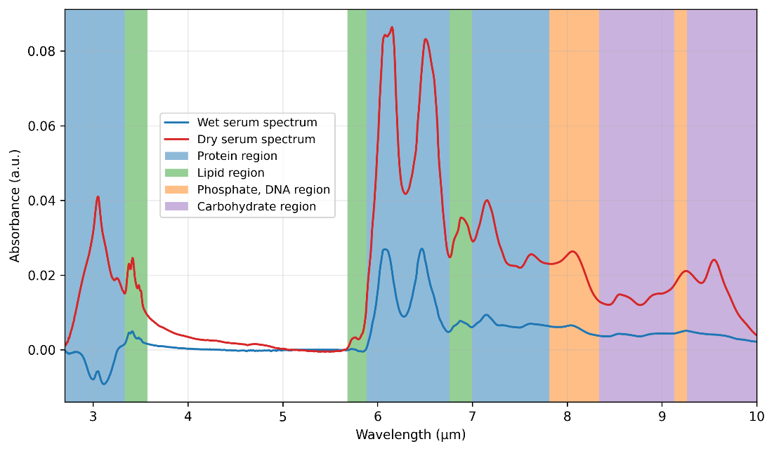
Figure 1: ATR-FTIR absorbance spectrum of wet and dried serum samples. The highlighted spectral regions indicate the absorbance features corresponding to biochemical species found in serum.

The application of ATR-FTIR for liquid biopsy has been the subject of much research in recent years. Numerous groups have investigated different cancers [13-16] including lung cancer [17, 18]. Different control cohorts have been used for the lung cancer studies, including asymptomatic participants and participants with non-specific symptomatic and chronic obstructive pulmonary disorder (COPD). However, smoking status, which is a major risk factor for lung cancer and cause of systemic inflammation, has not been controlled for. In this study we investigate the use of a risk-based cohort which matches cancer-positive to cancer-negative participants using the criteria of age, sex, current smoking status and the number of years smoked.

The iDx Lung study provided an opportunity to evaluate ATR‑FTIR spectroscopy in a high‑risk population with characteristics similar to those commonly referred for urgent suspected lung cancer assessment. The study collected blood and nasal epithelial samples from patients attending mobile CT-scanner units for lung health checks, to test whether adding blood or tissue biomarkers assessment to LDCT scanning can improve diagnostic performance. With a proportion of study participants subsequently being diagnosed with early-stage lung cancer and a control population who remain cancer-free, serum blood samples collected within iDx represented an ideal resource for assessing the ability of ATR-FTIR to detect spectral signatures of cancer in an asymptomatic population. By matching participants with and without lung cancer by age, sex, smoking status and cumulative smoking exposure, this study aimed to assess whether ATR‑FTIR–derived spectral signatures, combined with machine learning, could support triage decisions within real‑world diagnostic pathways.

Liquid biopsy is particularly useful as a triage method because it is minimally invasive. Rapid analysis methods such as ATR-FTIR spectroscopy require minimal sample processing and have the potential for fast laboratory turnaround times.. Liquid biopsy methods such as this are not posited to replace gold standard diagnostic methods, such as cross-sectional imaging with CT or MRI scans followed by histological assessment of a biopsy specimen, but rather offer potential to improve screening and diagnostic processes by triaging high risk individuals for rapid onward assessment. In the context of brain cancer, a retrospective economic study of providing a diagnosis one month earlier using ATR-FTIR liquid biopsy has been shown to improve patient outcomes in terms of mortality risk, expected inpatient days and risk of new or worsened neurological deficit [19].

Considering the large number of patients referred via urgent suspected lung cancer pathways each year, and the substantial proportion who ultimately do not have cancer, there is a clear need for tools that can support more efficient triage. Liquid biopsy approaches such as ATR‑FTIR spectroscopy could serve as an adjunct to urgent suspected lung cancer referrals by helping to identify individuals with a low likelihood of malignancy who may not require immediate advanced imaging, thereby improving resource allocation within the diagnostic pathway. By selecting a cohort that reflects the risk‑profile of patients typically referred with new symptoms, this study aims to evaluate the usefulness of ATR‑FTIR‑based liquid biopsy as a triage tool in this setting.

This study also investigates the impact of the hydration status of the sample by comparing the classification of wet and dried serum measurements, and the viability of data fusion of both sample preparation methods to further improve classification performance. Similar research was recently published for endometrial cancer, which found broadly similar classification performance for wet and dried sample measurements [20]. Data fusion was performed for wet sample measurements using ATR-FTIR and Raman spectroscopies, which provided a marked improvement in classification accuracy from 82% using Raman and 78% using ATR-FTIR to 86% combined. Data fusion was not investigated for the different sample preparation methods. The present study does not investigate Raman spectroscopy but rather investigates data fusion of spectra from a single measurement technique, ATR-FTIR spectroscopy, using different sample preparation methods. This will be used to investigate whether classification performance can be improved using a single workflow, given that a dried sample must initially be delivered in a wet state.

Methods

Participant recruitment
This comparative analysis utilised blood samples collected at the time of low-dose CT screening for lung cancer as part of the iDX lung study. The investigation included 52 individuals diagnosed with lung cancer, matched with another 52 participants without evidence of lung cancer, ensuring parity in age, gender, and current smoking status. These paired samples were analysed using ATR-FTIR spectroscopy to explore differences in molecular profiles between cases and controls. Data on established risk factors for lung cancer, particularly smoking history and prior lung disease, was gathered to facilitate the identification of appropriate control subjects for each case.

Exclusion criteria
Participants were excluded when the clinical questionnaire was incomplete and due to the presence of non-lung malignancy. Ten participants were excluded leaving a total of 94 participants, comprised of 47 with cancer and 47 without.

Sample preparation
Blood was collected from each patient in serum tubes, then centrifuged to extract serum and frozen at -80 °C within 24 hours. Samples were thawed at room temperature for 30 minutes, aliquotted into appropriate volumes for analysis and immediately refrozen. Samples were thawed a second time in the same way prior to analysis. For wet serum analysis, 9 μL samples were pipetted onto the spectrometer for analysis without any further processing. For dried serum analysis, 1 μL samples were pipetted onto the spectrometer and immediately enclosed within a drying chamber, as shown in Figure 2.
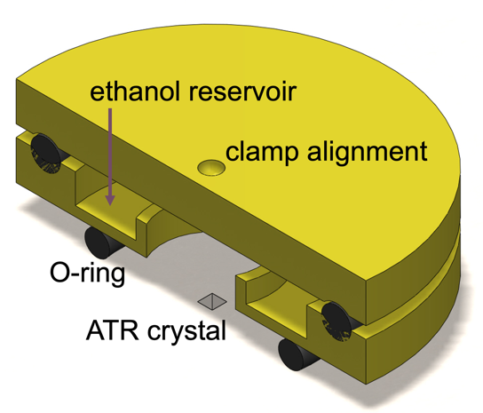
Figure 2: cross-sectional view of the drying chamber, which uses an ethanol vapour to slow water evaporation from serum samples to maintain sample homogeneity during drying.

Pressure is applied to the top of the sample chamber via a small recess, which is centrally positioned to align the drying chamber to the sample. An O-ring forms a gas-tight seal where the chamber meets the spectrometer. The facet of the ATR-FTIR crystal that provides the sample interface is a 1 mm square diamond crystal. In order to ensure sample homogeneity across the area of the crystal, the drying chamber was used to slow the evaporation rate of water from serum and minimise the coffee-ring effect (CRE), thereby improving the repeatability of ATR-FTIR measurements of biological matrices [21]. The CRE is a commonly observed phenomenon that determines the redistribution of solutes as the solvent evaporates from a droplet of solution on a surface, which in this instance is water evaporating from serum. The drying chamber mitigates the evaporation of water because it provides a saturated ethanol vapour immediately surrounding the serum sample, which limits the evaporation of water into the enclosed volume while promoting redistribution of solutes within the droplet by Marangoni flow [22]. Preparatory work showed that 1 μL of serum would dry after 50 minutes using the drying chamber, as opposed to approximately one minute without. Therefore, each aliquot was measured after one hour of drying.

ATR-FTIR spectroscopy
Measurements were performed using an Alpha II FTIR spectrometer (Bruker, Germany) with a single bounce diamond ATR attachment. 24 scans were averaged per measurement at a resolution of 4 cm⁻¹ in the wavenumber range of 400 – 4,000 cm⁻¹. Three aliquots were measured from each donated sample and ten measurements were recorded per aliquot for a total of 30 measured spectra. This process was repeated for wet and dried serum samples, meaning that each participant had 30 spectra taken for wet samples and 30 spectra taken for dried samples. For wet sample measurements, a reference measurement of deionised (DI) water was taken first. DI water was used as it is the single main component of the infrared absorption of serum. For dried sample measurements, a measurement of the ambient atmosphere was taken as the reference measurement. The measurement routine was otherwise the same for both wet and dried samples. Measured spectra then had baseline correction and vector normalisation applied.

Machine learning
For ML, each measured point in the spectrum and each questionnaire response was treated as an individual feature. The data were classified as numeric, nominal or ordinal. Numeric data included absorbance spectra, age and BMI. Nominal data, which are classified into categories which do not have inherent order or rank, included sex and current smoking status. Ordinal data have an inherent order or rank, such as education level and family history of lung cancer, which was ranked according to none, late onset and early onset. The data were then concatenated so that each observation included spectral data plus the relevant clinical information for that participant. The same process was applied to wet and dried data, which were treated as separate datasets during initial ML for comparison.

ML was performed using the scikit-learn package in Python. For all datasets and methods, the figure of merit for optimisation was to maximise the area under the receiver operating characteristic (AUROC). Three algorithms were investigated for classifying the wet and dried datasets: support vector machines, artificial neural networks and random forests. For the first two methods, it was necessary to scale to unit variance to prevent large individual features from dominating the learning procedure while also dramatically improving algorithm efficiency. In contrast and in common with all tree methods, random forests do not require scaling because its decision tree is based upon thresholds for individual features rather than distances between them so remains unaffected by scale.

Hyperparameter optimisation was performed in a nested configuration of cross validation (CV) loops. The purpose of CV is to reduce overfitting; hyperparameter optimisation is applied to the training set only in order to prevent data leakage between the training and test sets. First, the dataset was split into 80% training and 20% test data. Participants were aggregated so that all thirty observations per participant were either entirely within the training set or entirely within the test set. The test set remained untouched during model training and hyperparameter tuning. Second, the inner fivefold CV loop was applied to the 80% training set to find the optimal hyperparameters by maximising AUROC. These optimal hyperparameters were fixed for the outer CV iteration. Third, the model was trained using the outer CV with the optimised hyperparameters on the entire 80% training set. Performance was assessed by using the trained model to classify the test set and then taking the consensus (majority vote) per participant. This process was then repeated for all five iterations of the outer CV loop. Each iteration used a different train-test split and the metrics were then aggregated by taking the mean performance across the five outer CV loops.

During consensus voting, the classifier produced a predicted probability of cancer for each of the 30 measurements per participant. These probabilities were first converted into binary outcomes using a predefined threshold and an overall classification for each classifier was obtained using majority voting across the 30 decisions. If the classifier produced equal numbers of positive and negative predictions, the tie was resolved by comparing their mean predicted probabilities, with the higher average determining the final outcome.

This entire process was then applied to different spectral windows. Sweeps were performed such that up to four regions of the spectrum were used during ML. At maximum, this included the whole spectrum except the zero region between the functional and fingerprint regions, which is 1800 – 2700 cm⁻¹. At minimum there were three 30 cm⁻¹ windows outside of the zero region. All combinations of windows were tested. These spectral sweeps were used to prevent overfitting, for example to noisy parts of the spectrum which could otherwise show spurious correlation with cancer status owing to the relatively small size of the cohort.

Mean receiver operating characteristics (ROCs) were used to compare the performance of the ML methods for both sample types after cross validation, using the optimised hyperparameters and spectral windows in each instance. The contributions of each feature, which includes spectral and questionnaire data, to the classifier can be visualised using feature importance scores.

Data fusion
Different levels of data fusion were investigated to examine whether the combination of wet and dried data would yield better classification, in conjunction with the clinical data, in comparison with either one of the sample types alone. Data fusion can be divided into two main categories: data-level or decision-level. Data-level fusion is a low-level operation where multiple sources of information, in this case the wet and dried spectra, are concatenated and provided together as inputs to a single classifier. Decision-level fusion is a high-level operation where the outputs of multiple classifiers, in this case the optimised wet and dried classifiers, are subsequently combined to give a global decision.

In decision‑level fusion, each classifier produces a predicted probability of cancer for each of the 30 measurements per participant to obtain a majority vote across the 30 decisions, as above. If the two classifiers disagree, the classifier with the larger majority margin determines the fused decision, reflecting the stronger internal consensus. Only in the rare situation where both classifiers produce an identical majority margin is the tie resolved by comparing their mean predicted probabilities, with the higher average determining the final outcome. This approach prioritises threshold‑based classification and majority consensus for their interpretability and robustness, using probability‑based comparison only as a secondary step when classifier outcomes conflict.

Data-level fusion requires a new classifier because it uses a different input dataset compared with the individual classifiers for wet and dried samples, meaning that it would generate a new set of feature importance scores. Conversely, decision-level fusion is based upon the aggregation of decisions from the separate classifiers, meaning that a new classifier is not required so a new set of feature importances would not be generated.

Results
ATR-FTIR measurement data is shown in Figure 3(a) for a wet sample and (b) for a dried sample. These spectra have had baseline correction and vector normalisation applied. A single spectrum is shown for each sample type for clarity because the hundreds of other measurements all have a similar appearance. These data were used to train three types of machine learning classifier (random forest, artificial neural network and support vector machine) as described in the Methods section. In each case, hyperparameter optimisation and spectral windowing were applied to find the best classification performance by maximising AUROC for both wet and dried samples.

Spectral feature importances are also shown in Figure 3. Feature importance is used to evaluate the contribution of each datum to the classification decision, and each feature can be a measured absorbance or a piece of clinical information obtained from the questionnaire. A higher score indicates the feature contributes more strongly to classification. The features shown here are those from the optimised machine learning classifier that gave the best classification performance for each sample type. The feature importances also visually represent the result of the wavelength optimisation as the presence of blue bars in some spectral regions indicates that those parts of the spectrum contribute to classification whereas the regions without blue bars do not contribute to classification.

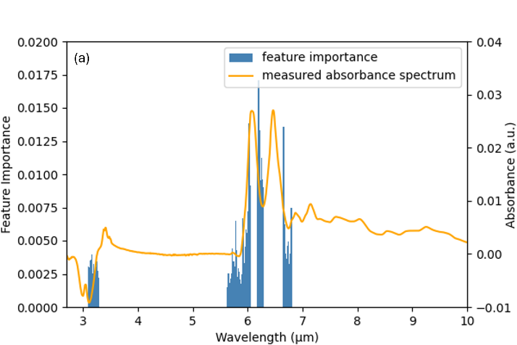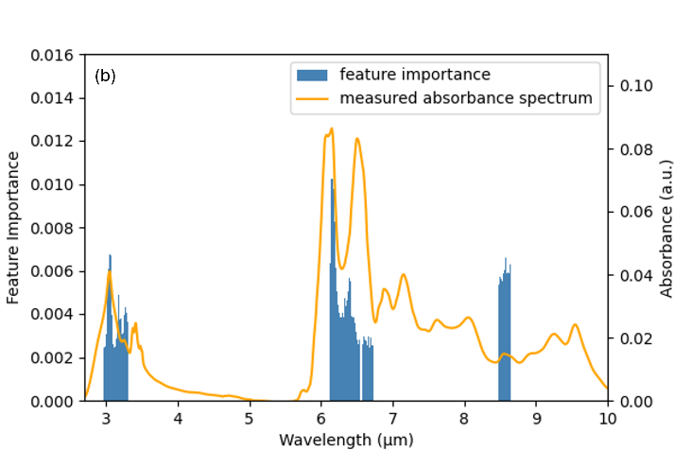
Figure 3: spectral feature importance for (a) wet and (b) dried sample classifiers. The orange traces represent a typical spectrum for each sample type, which has had baseline correction and vector normalisation applied.

Feature importance from the optimised classifiers for clinical data are shown in Figure 4. Multiple parameters collected in the questionnaire, including ethnicity and history of emphysema, made a negligible contribution to classification so are excluded for brevity.

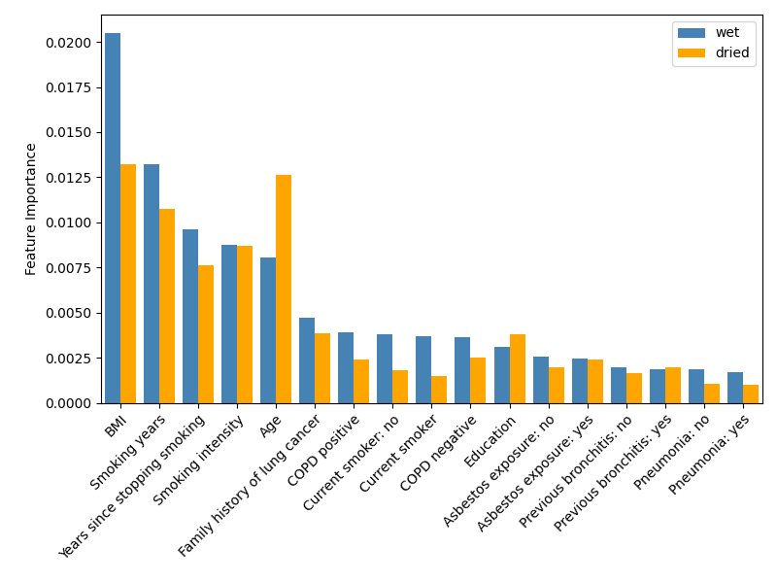
Figure 4: feature importance scores from the optimised classifiers for clinical data. Scores for the wet sample classifier are shown in blue and scores for the dried sample classifier are shown in orange.

For both wet and dried samples, the random forest method was found to give superior performance (AUROC_{wet} = AUROC_{dried} = 0.74) to artificial neural networks (AUROC_{wet} = 0.69, AUROC_{dried} = 0.73) and support vector machines (AUROC_{wet} = 0.61, AUROC_{dried} = 0.70). This is likely due to its decision tree structure, which makes it more robust in the presence of noise and outliers because they can be retained in individual trees that do not subsequently contribute strongly to overall classification. The decision tree structure also enables a random forest to model nonlinear relationships in the data. In contrast, support vector machines are sensitive to noise and can perform poorly when applied to unseen data owing to their susceptibility to overfitting. Support vector machines can also be significantly impaired when fitting large numbers of features per sample, as used in this study. Artificial neural networks can model nonlinear relationships between features but their complexity can make them prone to overfitting and therefore overly sensitive to noise [21].

Decision-level fusion using the outputs of the separate wet and dried sample random forest classifiers was found to give superior performance (AUROC = 0.75) compared to data-level fusion (AUROC < 0.65), which performed worse than using either of the sample types individually. For this reason, only decision-level fusion results are presented here. Note that decision-level fusion does not generate importance scores because this form of data fusion does not generate a new ML model; instead it recombines the output of the two ML models shown above. None of the participants yielded a tied decision so all classifications were made using the threshold-based approach described in the methods section.

The mean ROCs for wet samples, dried samples and their combination using decision-level fusion (DLF) are shown in Figure 5.
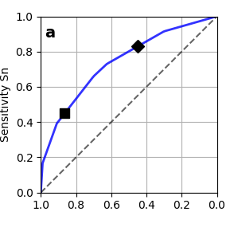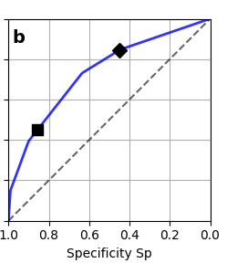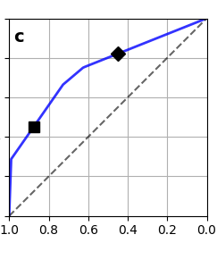
Figure 5: mean ROC for optimised classification by cancer status using data from (a) wet serum samples, (b) dried serum samples and (c) decision-level fusion. Diamond markers show optimised sensitivity at specificity = 0.45 for each classifier; likewise the square markers show optimised specificity at sensitivity = 0.45.

The AUROC is 0.74 for both wet and dried samples and 0.75 for DLF. Tuning along the ROC by varying the probability threshold enables sensitivity (Sn) and specificity (Sp) to be optimised depending on the chosen clinical application. These are tabulated in Table 1. The probability threshold is the cutoff point used to decide whether a predicted probability should be classified as a positive or negative outcome. Adjusting the threshold makes the model more or less sensitive; generally, increasing sensitivity will lower specificity, and vice versa.

Table 1: tuned Sn and Sp for classifiers built using wet sample data, dried sample data and DLF.
Classifier | AUROC | Sn (Sp = 0.45) | Sp (Sn = 0.45)
Wet | 0.74 | 0.83 | 0.86
Dried | 0.74 | 0.84 | 0.86
DLF | 0.75 | 0.82 | 0.88

Discussion
We describe the first assessment of ATR-FTIR spectroscopy as a screening tool using a risk-based cohort for lung cancer, a disease where despite improvement in systemic treatments, outcomes in patients with advanced disease remain poor, and early-stage detection is paramount in improving survival.

The results show that there is not a significant difference in classification performance between the wet and dried samples in terms of AUROC or for tuned sensitivity and specificity. This shows that sample preparation could potentially be simplified: using a wet sample means that it does not have additional heterogeneity introduced by drying, which reduces the specification of the analytical equipment: for example, the surface of the transducer would not need to be patterned to minimise CRE.

Data‑level fusion, performed by concatenating the wet and dried spectral inputs for classification, resulted in substantially lower performance than either classifier alone. This is likely due to the combined feature space being considerably larger and more heterogeneous than that of either dataset individually. Wet and dried spectra emphasise different biochemical and noise characteristics so concatenating them at the input stage increases dimensionality without adding new independent participants. This increases model variance and makes it more difficult for classifiers to identify reproducible structure, leading to poorer generalisation performance.

In contrast, decision‑level fusion avoids these issues by allowing the wet and dried classifiers to operate independently in their respective, more homogeneous feature spaces. Their outputs are combined at the final decision stage, which reduces the impact of noise and limits the risk of overfitting. However, the improvement offered by decision‑level fusion in this study was modest, with performance closely matching that of the individual wet and dried classifiers. This suggests that while decision‑level fusion is a more stable strategy than data‑level fusion, the information contained in the wet and dried spectra is already highly correlated. As a result, combining their outputs yields only small gains.

Serum must be wet before it is dried on a sensor surface, which means that in principle it would be straightforward to measure a sample twice: while wet and once dried. However, the data presented here do not justify the additional complexity in the classification procedure. In contrast, the endometrial cancer study cited in the introduction obtains a ~ 6% improvement in classification performance from data fusion, which is likely due to the fact that the fused data comes from different spectroscopic methods, ATR-FTIR and Raman spectroscopies [20]. In that case, fusion adds genuinely new biochemical contrast, whereas in the present study the wet and dried measurements remain too closely related for fusion to provide substantial additional discriminatory power.

Tuning along the ROC allows sensitivity and specificity to be tuned for a specific application. High sensitivity is typically used in screening programmes, where large numbers of participants are tested for a rare but dangerous condition. In this situation a high true positive rate is preferred at the expense of the true negative rate because every instance of the condition should be captured due to its severity, which are potentially much greater than the risk of false positive classification. This method could also have a role in monitoring patients for early disease recurrence where a high sensitivity blood test could minimise the need for repeat scanning and exposure to ionising radiation.

High specificity is particularly valuable in the context of the urgent suspected lung cancer pathway, where many patients present with symptoms that warrant referral but ultimately do not have cancer. In this setting, a triage test that reliably identifies individuals at low risk could reduce unnecessary downstream investigations without compromising patient safety. For example, a long‑term smoker presenting with a new persistent cough will often be referred regardless of supporting evidence; however, a high‑specificity liquid biopsy could provide additional reassurance when the likelihood of cancer is low, allowing clinicians to defer immediate imaging in selected cases. This aligns closely with the intended clinical use‑case of the ATR‑FTIR approach described here, as an adjunctive tool to support decision‑making within the urgent suspected lung cancer diagnostic pathway.

To compare with other studies that investigated ATR-FTIR liquid biopsy for lung cancer, it is useful to calculate the balanced-accuracy sensitivity Sn_{BA} and specificity Sp_{BA}, which occur at a probability threshold = 0.5. For DLF classification these results were Sn_{BA} = 78% and Sp_{BA} = 71%. This makes comparison possible because we do not have the threshold data required to calculate sensitivity and specificity at other points on the ROCs reported by earlier studies. The other studies reported Sn_{BA} = 93% and Sp_{BA} = 78% for dried samples [17] and Sn_{BA} = 86% and Sp_{BA} = 79% for wet samples [18]. Differences in the composition of control groups likely influenced the outcomes. Cameron et al. included healthy participants or those with generic symptoms like headaches or strokes [17], which likely contributed to better predictive performance compared to disease-specific controls. Conversely, Huber et al. utilised both non-symptomatic controls and symptomatic COPD references, with the latter yielding reduced performance with Sn_{BA} = 67% and Sn_{BA} = 71% [18]. It is possible that controlling by smoking status instead of COPD status gives more accurate classification for serum based ATR-FTIR liquid biopsy, although other factors will contribute. For example, the classification method used by Huber et al. was a support vector machine [18], which we found less effective than random forests or neural networks; the machine learning method used by Cameron et al. was proprietary [17]. The accuracy of the technique used to confirm the presence of cancer, such as imaging as used here or histopathology as in [17], could also affect the selection of positive and control groups and thereby affect classification performance.

Cameron et al. also tuned sensitivity and specificity to allow performance to be optimised for a given clinical scenario. For lung cancer, this gave a maximum sensitivity = 1.00 (specificity = 0.4) and a maximum specificity of 0.95 (sensitivity = 0.47). These are excellent results and future large-scale research work could benefit from the inclusion of a control cohort matched by smoking status.

While ML techniques do not immediately yield physical interpretations of their findings, such as the individual biomolecular species associated with a cancer classification, the spectral regions contributing most strongly to cancer classification can be identified using the feature importance spectra in Figure 3. For both wet and dry samples, the regions that contribute most strongly are around 1530 cm⁻¹, which is the amide II absorption associated with proteins, and C-H and N-H stretching vibrations in the region 3000 – 3300 cm⁻¹, which are also associated with protein content. The wet response also includes the weak 1700 – 1720 cm⁻¹ region associated with lipid content and the stronger 1600 – 1700 cm⁻¹ amide I band associated with protein content. The dried response also shows important features for asymmetric phosphate stretching vibrations around 1170 cm⁻¹. This is likely to contribute less strongly in the wet spectra because of the relatively weak absorbance compared to the aqueous background. These agree with the response for lung cancer versus non-specific symptomatic controls reported previously, and more generally share a heavily proteinaceous response in common with other cancers [17].

﻿﻿Wavelength optimisation restricts the bandwidth of data used for classification, resulting in narrow spectral contributions compared to a full FTIR spectrum. This would allow the use of multiple tunable narrowband lasers instead of a single broadband source. Such an approach allows for miniaturised, integrated optical technologies that offer cost-effective solutions compared to traditional benchtop spectrometers based on free-space optics, which are typically large, fragile, and expensive. This greatly expands the opportunity space for commercial development of infrared tools for liquid biopsy.

This work marks an encouraging first step toward incorporating ATR‑FTIR liquid biopsy into a diagnostic pathway that remains dependent on CT scanning and vulnerable to misclassification and radiation‑related risks. While the present sensitivity and specificity reflect the constraints of a pilot‑scale dataset, they nonetheless demonstrate clear potential and it is expected that performance would be improved upon in future by using a larger and more diverse study population. Increasing the number of samples analysed should capture more heterogeneity from lung cancer, which could enable better out-of-sample predictive performance.

Given its speed, low cost and potential for simple deployment, ATR‑FTIR liquid biopsy is well suited to integration into the urgent suspected lung cancer pathway. In this context, the test would not replace existing diagnostic investigations but could support clinical decision‑making for patients whose pre‑test probability of cancer is borderline, such as individuals with common but non‑specific symptoms in a high‑risk group. Applying the test to this higher‑prevalence population could estimate the post‑test probability of cancer for each patient, helping determine whether immediate imaging is warranted or whether further invasive investigation can be safely deferred. With further refinement, particularly improvements in specificity, this approach could meaningfully reduce avoidable imaging and streamline workflows while maintaining focus on those most likely to benefit from rapid assessment.

Amid sustained pressure on health services from an ageing population with complex needs, there is a clear requirement for minimally invasive tools that enhance the efficiency of symptomatic diagnostic pathways. As an adjunct to the urgent suspected lung cancer pathway, ATR‑FTIR liquid biopsy can provide a minimally invasive triage step to support decisions about immediate imaging, helping to reduce avoidable investigations while focusing resources on higher‑risk patients.

Conclusion
This study demonstrates that ATR‑FTIR spectroscopy, combined with machine learning, shows promise in distinguishing individuals who will and will not go on to receive a lung cancer diagnosis within a high‑risk population. Using a cohort matched by smoking status and cumulative smoking exposure, classification performance was evaluated and the clinical applicability of this approach within real-world diagnostic pathways was assessed. The intended use of this technology is as an adjunct within the urgent suspected lung cancer diagnostic pathway, where a minimally invasive triage test could help identify patients with a sufficiently low probability of cancer to avoid immediate advanced imaging. These results represent an important early step and further work in larger cohorts will be essential to improve predictive performance, refine spectral biomarkers and ensure suitability for clinical deployment.

Disclosures

Code, Data, and Materials
The data presented in this article are publicly available in [repository name] at [DOI link].

Acknowledgments

The authors acknowledge funding from the Engineering and Physical Sciences Research Council (grant no. EP/V047663/1), Innovate UK (grant no. 42012) with additional support from Cancer Research UK. The Leeds Lung health check samples were provided through Yorkshire Cancer Research (grant no. L403). The authors acknowledge the use of the Faculty of Medicine Tissue Bank, the IRIDIS High Performance Computing Facility and associated support services at the University of Southampton in the completion of this work. The authors thank Dr Ben Mills for advice on machine learning. The authors thank Professor James S. Wilkinson and Dr Sam Wilding for valuable feedback on the manuscript.

Biographies
David J Rowe is Senior Research Fellow at the University of Southampton. He received his BEng (Hons) and PhD in Electronic Engineering from Cardiff University in 2009 and 2013, respectively. He is the author of more than 30 journal and conference papers. His current research interests include medical applications of silicon photonics and microfluidic-photonic integration. He is a member of SPIE.

Caption List
Figure 2: cross-sectional view of the drying chamber, which uses an ethanol vapour to slow water evaporation from serum samples to maintain sample homogeneity during drying.
Figure 3: spectral feature importance for (a) wet and (b) dried sample classifiers. The orange traces represent a typical spectrum for each sample type, which has had baseline correction and vector normalisation applied.
Figure 4: feature importance scores from the optimised classifiers for clinical data. Scores for the wet sample classifier are shown in blue and scores for the dried sample classifier are shown in orange.
Figure 5: mean ROC for optimised classification by cancer status using data from (a) wet serum samples, (b) dried serum samples and (c) decision-level fusion.

Bibliography
[1] "Cancer Survival in England, cancers diagnosed 2016 to 2020, followed up to 2021," NHS Digital, 2023.
[2] C. Bettegowda et al., "Detection of circulating tumor DNA in early- and late-stage human malignancies," Science Translational Medicine, Article vol. 6, no. 224, 2014, Art no. 224ra24, doi: 10.1126/scitranslmed.3007094.
[3] E. Crowley, F. Di Nicolantonio, F. Loupakis, and A. Bardelli, "Liquid biopsy: Monitoring cancer-genetics in the blood," Nature Reviews Clinical Oncology, Review vol. 10, no. 8, pp. 472-484, 2013, doi: 10.1038/nrclinonc.2013.110.
[4] J. W. P. Bracht, C. Mayo-de-las-Casas, J. Berenguer, N. Karachaliou, and R. Rosell, "The Present and Future of Liquid Biopsies in Non-Small Cell Lung Cancer: Combining Four Biosources for Diagnosis, Prognosis, Prediction, and Disease Monitoring," Current Oncology Reports, Review vol. 20, no. 9, 2018, Art no. 70, doi: 10.1007/s11912-018-0720-z.
[5] P. van der Leest et al., "Detection of actionable mutations in circulating tumor DNA for non-small cell lung cancer patients," Communications Medicine, Article vol. 5, no. 1, 2025, Art no. 204, doi: 10.1038/s43856-025-00921-8.
[6] F. Diehl et al., "Circulating mutant DNA to assess tumor dynamics," Nature Medicine, Article vol. 14, no. 9, pp. 985-990, 2008, doi: 10.1038/nm.1789.
[7] P. Jonnalagadda, V. Arnold, and B. A. Weinberg, "A Review of Circulating Tumor DNA (ctDNA) in Pancreatic Cancer: Ready for the Clinic?," Journal of Gastrointestinal Cancer, Review vol. 56, no. 1, 2025, Art no. 50, doi: 10.1007/s12029-024-01151-2.
[8] N. Soda, B. H. A. Rehm, P. Sonar, N. T. Nguyen, and M. J. A. Shiddiky, "Advanced liquid biopsy technologies for circulating biomarker detection," Journal of Materials Chemistry B, Review vol. 7, no. 43, pp. 6670-6704, 2019, doi: 10.1039/c9tb01490j.
[9] A. K. Ghosh, K. R. Stephens, P. A. Kandiah, R. T. Hurt, and E. A. Gilman, "Multicancer Detection (MCD) Testing in Gastrointestinal Cancers: An Evolving Tool for Early Diagnosis," Current Gastroenterology Reports, Article vol. 27, no. 1, 2025, Art no. 19, doi: 10.1007/s11894-025-00970-y.
[10] N. J. Harrick, Internal Reflection Spectroscopy. Interscience, 1967.
[11] D. J. Rowe, D. Smith, and J. S. Wilkinson, "Complex refractive index spectra of whole blood and aqueous solutions of anticoagulants, analgesics and buffers in the mid-infrared," Scientific Reports, vol. 7, p. 7356, 2017.
[12] Z. Movasaghi, S. Rehman, and D. I. ur Rehman, "Fourier Transform Infrared (FTIR) Spectroscopy of Biological Tissues," Applied Spectroscopy Reviews, vol. 43, no. 2, pp. 134-179, 2008/02/01 2008, doi: 10.1080/05704920701829043.
[13] A. Sala et al., "Liquid Biopsy for Pancreatic Cancer Detection Using Infrared Spectroscopy," Cancers, vol. 14, no. 13, doi: 10.3390/cancers14133048.
[14] H. J. Butler et al., "Development of high-throughput ATR-FTIR technology for rapid triage of brain cancer," Nature Communications, vol. 10, no. 1, p. 4501, 2019/10/08 2019, doi: 10.1038/s41467-019-12527-5.
[15] M. Huber et al., "Stability of person-specific blood-based infrared molecular fingerprints opens up prospects for health monitoring," Nature Communications, vol. 12, no. 1, p. 1511, 2021/03/08 2021, doi: 10.1038/s41467-021-21668-5.
[16] L. Voronina et al., "Molecular Origin of Blood-Based Infrared Spectroscopic Fingerprints," (in English), Angew Chem Int Edit, vol. 60, no. 31, pp. 17060-17069, Jul 26 2021, doi: 10.1002/anie.202103272.
[17] J. M. Cameron et al., "A spectroscopic liquid biopsy for the earlier detection of multiple cancer types," British Journal of Cancer, vol. 129, no. 10, pp. 1658-1666, 2023/11/01 2023, doi: 10.1038/s41416-023-02423-7.
[18] M. Huber et al., "Infrared molecular fingerprinting of blood-based liquid biopsies for the detection of cancer," eLife, vol. 10, p. e68758, 2021/10/26 2021, doi: 10.7554/eLife.68758.
[19] H. Butler et al., "Earlier brain tumor detection: Assessing the impact on survival, recurrence, inpatient length of stay and neurological deficit," Journal of Clinical Oncology, vol. 43, no. 16_suppl, pp. e23268-e23268, 2025/06/01 2025, doi: 10.1200/JCO.2025.43.16_suppl.e23268.
[20] R. Schiemer et al., "Infrared and Raman spectroscopy of blood plasma for rapid endometrial cancer detection," British Journal of Cancer, vol. 133, no. 2, pp. 194-207, 2025/08/01 2025, doi: 10.1038/s41416-025-03050-0.
[21] S. S. Nazeer, R. K. Venkataraman, R. S. Jayasree, and J. Bayry, "Infrared Spectroscopy for Rapid Triage of Cancer Using Blood Derivatives: A Reality Check," Analytical Chemistry, vol. 96, no. 3, pp. 957-965, 2024/01/23 2024, doi: 10.1021/acs.analchem.3c02590.
[22] M. Majumder et al., "Overcoming the “Coffee-Stain” Effect by Compositional Marangoni-Flow-Assisted Drop-Drying," The Journal of Physical Chemistry B, vol. 116, no. 22, pp. 6536-6542, 2012/06/07 2012, doi: 10.1021/jp3009628.

