Metasurface-Enhanced Molecular Absorption at Mid-Infrared Wavelengths for Therapeutic Drug Monitoring
Kezheng Li^{1,*}, Pin Dong¹, Aneesh Vincent Veluthandath², Soheila Kharratian¹, Augusto Martins¹, Ganapathy Senthil Murugan², Yue Wang^{1,*} and Thomas F. Krauss¹
¹ School of Physics, Engineering and Technology, University of York, York, U.K.
²Optoelectronics Research Centre, University of Southampton, Southampton, U.K.
*Email: kezheng.li@york.ac.uk; yue.wang@york.ac.uk

Abstract
Therapeutic drug monitoring (TDM) is the clinical practice of measuring specific drugs at designated intervals to maintain a constant concentration in a patient's bloodstream. However, detecting clinically relevant levels (typically in the μg/ml range) remains challenging outside the laboratory, as current analytical methods use elaborate sample preparation protocols and complicated measurement procedures. Here, we present a metasurface-assisted FTIR approach using dried samples that enhances molecular absorption by aligning their vibrational modes with the metasurface resonance; the metasurface supports a guided-mode resonance that hybridises with the vibrational frequency of the drug molecule, thereby increasing the effective absorbance significantly. The metasurface topology also promotes ordered drug crystallisation in regions with the strongest light-matter interaction, further contributing to the absorption enhancement. Using this design, we are able to consistently detect phenytoin in serum below the therapeutic range of 10-20 µg/ml by achieving a limit of detection (LoD) of 1.4 μg/ml, which is limited by the drying process. This demonstration of TDM at concentrations in the sub µg/ml level highlights the significant potential for metasurface-enhanced spectroscopy and offers a path toward compact, high-performance infrared sensors for healthcare applications.

Introduction
Therapeutic drug monitoring (TDM) is a branch of clinical analytical chemistry and clinical pharmacology that specializes in the measurement of medication levels in blood. The main focus of TDM is on drugs with a narrow therapeutic range, i.e. drugs that can easily be under or over dosed¹. For example, phenytoin is an anti-epileptic drug with a therapeutic range between 10-20 μg/ml, whereby concentrations below 10 µg/ml may be ineffective while concentrations above 20 µg/ml can lead to toxicity². Accurate and rapid quantification of drug concentration at these levels within a patient’s bloodstream is therefore critical for effective treatment.
Chromatographic methods, such as Liquid Chromatography-Tandem Mass Spectrometry (LCMS) or the enzyme-linked immunosorbent assay (ELISA), remain the clinical gold standard for TDM³; however, widespread adoption of these methods is hindered by their confinement to laboratory settings, i.e. expensive instrumentation and the need for skilled personnel, which leads to a long turnaround time⁴. All of these prevent real-time and point-of-care monitoring. While electrochemical sensors have been explored as alternatives⁵, they suffer from drift, electrode fouling, and poor reproducibility, which limit their reliability for long-term monitoring.
In contrast, benchtop Fourier-transform infrared (FTIR) spectroscopy offers a truly label-free and on-site analytical alternative. FTIR provides molecular fingerprint information, enabling high specificity for identifying relevant drug molecules. However, especially for blood or serum samples, the strong water absorption and overlapping protein bands often obscure weak drug signals, complicating direct detection and quantification. The Attenuated Total Reflectance (ATR) FTIR configuration conducted on dried samples partially addresses this challenge by extending the effective interaction path length through evanescent field coupling, improving the sensitivity over conventional transmission or reflection setups. Nevertheless, even ATR-FTIR typically lacks the sensitivity required to detect drug concentrations in the required low μg/ml range essential for TDM.
More advanced optical methods, such as Polarization-Modulated Infrared Reflection–Absorption Spectroscopy (PM-IRRAS)⁶, can further improve the detection limit by suppressing the background absorption using a polarization-based differential measurement, which results in an enhanced signal-to-noise ratio. However, PM-IRRAS relies on grazing-incidence optics with a single-pass absorption geometry and is limited to probing surface-confined or monolayer species, which is inadequate for bulk biological samples such as serum or blood. Therefore, it is not suitable for routine or bedside monitoring applications.
Overall, the primary limitation of these methods is their insufficient sensitivity. To address this limitation, the sensitivity can be significantly enhanced by strengthening the light–matter interactions via approaches such as surface-enhanced Raman spectroscopy (SERS) or surface-enhanced infrared absorption spectroscopy (SEIRA)^{7,8,9,10,11}. For example, SEIRA samples usually exploit a localised field, which can enhance molecular absorption by coupling and hybridising photonic resonances with molecular vibrational modes. When the vibrational mode of a molecule is coherently coupled to the resonant mode of a photonic structure, the light–matter interaction is significantly amplified, leading to enhanced absorption effects that are measurable as resonance dips. To evaluate the performance of such structures, a practical figure of merit (FOM) is the absorption enhancement, which quantifies how much the molecular absorptance is amplified. This FOM inherently reflects the effects of local field enhancement, mode overlap, the resonance’s quality factor Q, and effective interaction volume and coupling efficiency, making it a direct metric for comparison. For example, Adato et al.⁹ have demonstrated a plasmonic antenna to enhance the absorption of a protein monolayer 10-fold compared to IRRAS-FTIR. Tittl et al. ⁷ reported that quasi-BIC dielectric metasurfaces achieved more than one order-of-magnitude enhancement in molecular absorption for physiosorbed monolayers, relative to IRRAS. Using a comparable geometry, Leitis et al.¹⁰ further exploited angular sensitivity to demonstrate a 50-fold enhancement in the absorption of PMMA thin films compared with IRRAS, while Kharratian et al.¹¹ showed that dielectric hole arrays achieve more than an order-of-magnitude enhancement in molecular absorption in solution relative to ATR-FTIR. Numerous other studies have also been reported without specifying exact absorption enhancement factors^{9, 12}, yet they clearly demonstrate the growing attention in this field. These examples illustrate the potential of resonantly enhanced mid-IR spectroscopy to detect low concentrations of molecules. Nevertheless, none of these structures has yet been applied to the important problem of TDM. For bedside TDM, several practical requirements must be met: the enhancement should not be confined to highly localized hotspots; the effective sensing area must be sufficiently large to match the FTIR beam size; and the system must be tolerant to angle and alignment variations while enabling rapid measurement and short sample turnaround times. Existing SERS and SEIRA platforms do not simultaneously satisfy all of these requirements.
Since compact FTIR systems are already being used in research and pharmaceutical settings¹³, and are beginning to find applications in clinical environments¹⁴, we propose a new dielectric metasurface design that can be readily integrated with compact FTIR systems to enhance sensitivity and improve the limit of detection (LoD). The key novelty in our approach is the choice of an angle-tolerant metasurface design, which is essential for ensuring compatibility with the focussed beam of an FTIR system. Our approach offers the real possibility of moving TDM from the laboratory to the bedside. As a proof-of-concept, we target phenytoin (PHT), a widely prescribed antiepileptic drug, and show that we are able to detect sub-clinically relevant concentrations. The sub-clinical concentration we demonstrate allows to accommodate the tolerances and reproducibility issues of a system that may actually be used in clinical practise.
Main
Our metasurface consists of a patterned 400 nm thick germanium (Ge) layer on a bulk calcium fluoride (CaF₂) substrate. It is designed to have high reflectivity in the spectral range of 5 - 9 μm (Fig. S1, section 1 in Supplementary Information) and is illustrated in Fig. 1a. The periodical structure is a two-dimensional array of a tetramer unit cell that supports a guided mode resonance. The design is inspired by the bound state in the continuum (BIC) phenomenon with intentionally broken symmetry to allow coupling to the guided mode¹⁵. When this resonance mode is tuned to coincide with the molecular vibrational mode in wavelength, the two modes hybridise, which enhances the light-matter interaction and amplifies molecular absorption¹⁶. This results in a pronounced absorption dip in the reflection spectrum of the sample (Fig. 1e).
The geometric parameters of our metasurface (see Fig. 1b) are chosen by considering both the resonance amplitude and the Q factor¹⁷ while tuning the resonance to the target wavelength (full details are provided in Fig. S2, section 2 in the SI). With $a=2 μm$, $b=1.5 μm$, $w=1 μm$ and the period of $5.4 μm$, the structure supports a mode aligned with the absorption peak of Phenytoin (PHT) at 5.62 μm (1778 cm⁻¹) as shown in the simulated reflectance spectrum in Fig. 1d. Notably, PHT has two characteristic absorption peaks: 5.62 μm (1778 cm⁻¹) and 5.78 μm (1728 cm⁻¹). Since the 5.78 µm peak overlaps with serum protein absorption bands (details are provided in Fig. S3, section 3, SI), the 5.62 μm peak is selected as the target peak for TDM. Figure 1c presents a simulated top view of the electrical-field intensity distribution at the middle height of the structure. The field intensity distribution shows that the strongest field enhancement occurs at the corners of the tetramers and gradually merges into the gap regions. This suggests that if the drug molecules crystallize in the gaps, they will strongly overlap with the localized field, promoting the optical absorption. The structure exhibits sufficient angular tolerance (± 5°), as shown in Fig. 1f, which is better than that of a simple periodic array¹¹ and compatible with the half-angle of 5° of the incident source in the FTIR system that we use.
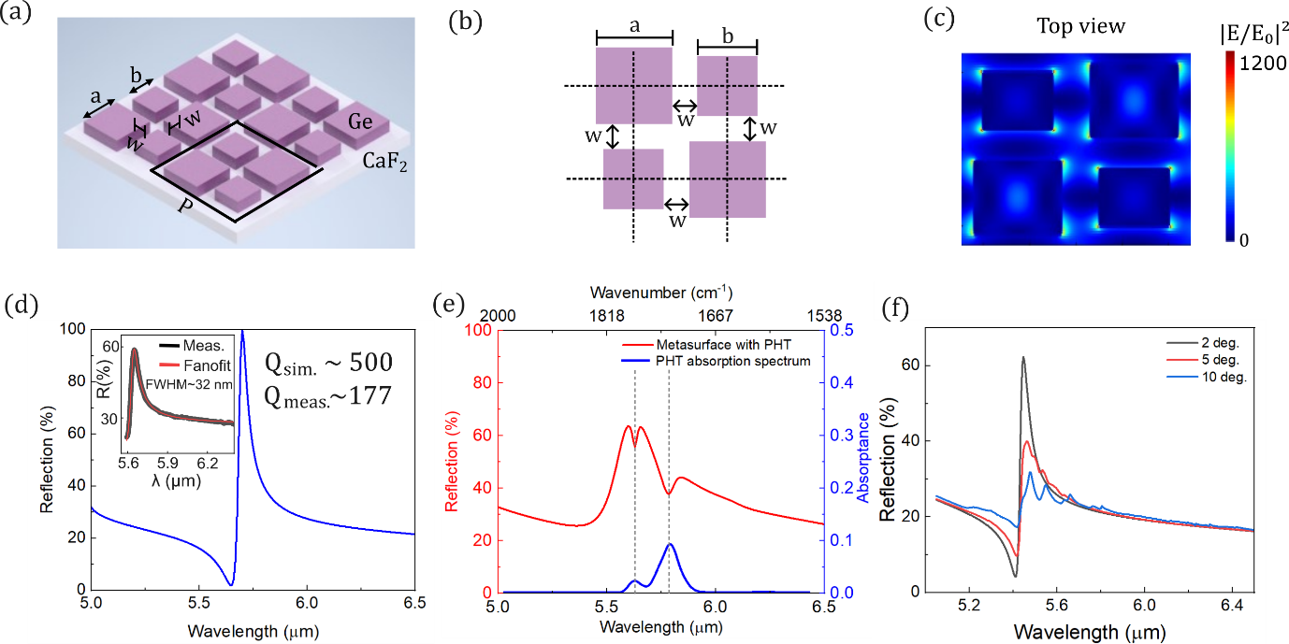
Figure 1. Design of the metasurface and mechanism of molecular absorption enhancement. (a) Schematics of the three-dimensional and (b) two-dimensional unit-cell geometry (top view) of the metasurface. The black solid lines in (a) mark the unit-cell boundaries, consisting of four asymmetric germanium square prisms in Ge on a CaF₂ substrate. The broken symmetry enables the excitation of a guided mode with a high-quality factor even under non-collimated illumination. (c) Simulated electric-field distribution at the half-height plane of the structure, showing strong field confinement in the corner of the tetramers. |E₀| denotes the incident field amplitude. The measured Q factor is 177, compared to the simulated value of 500 for plane-wave illumination, as shown in (d) and the inset. (e) The red curve represents the simulated reflection spectrum assuming a 1 μm thick phenytoin layer (PHT) on the surface. The blue curve represents the absorption spectrum of 1 mg/ml PHT in dried condition measured by ATR-FTIR, the grey dashed lines indicating that the PHT absorption bands align with the resonance dips. (f) Simulated resonance response of the metasurface with a Gaussian beam illumination, with divergence half angles between 2° and 10°.
Fig. 2 illustrates the fabricated metasurface. The SEM micrographs in Fig. 2b, c show the unit cell size of 5.4 μm, with w $≈$ 1 μm gaps between adjacent squares. For the measurement, samples were prepared in a dried state to eliminate the background interference from water. To study the molecular loading, SEM micrographs of dried PHT solution (in ethyl acetate) are shown in Fig. 2e and f, revealing that PHT molecules accumulate and crystallize within the grooves of the structures around the region where the E-field enhancement is strongest. This accumulation ensures a good spatial overlap with the optical mode in addition to the spectral overlap between the resonance and the molecular absorption line, which together yield significant absorption enhancement. For comparison, a PHT droplet dried on a flat Ge substrate forms random shapes (Fig. 2d). An SEM micrograph with a larger field of view comparing PHT dried on flat Ge and on a metasurface is shown in Fig. S4 (section 4, SI).
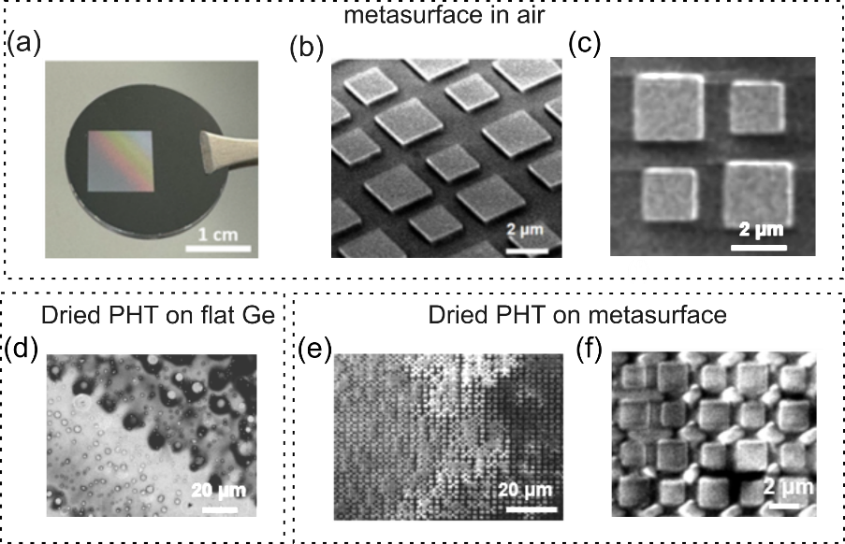
Figure 2. Fabricated metasurface and dried PHT sample. (a) Photograph of the fabricated metasurface. (b) SEM micrograph of the metasurface as fabricated, and (c) top view of one unit-cell. (d) SEM micrograph of the dried PHT on a flat Ge surface and (e, f) the metasurface after PHT crystallisation, showing the PHT molecules accumulating in the corners and grooves of the metasurface.

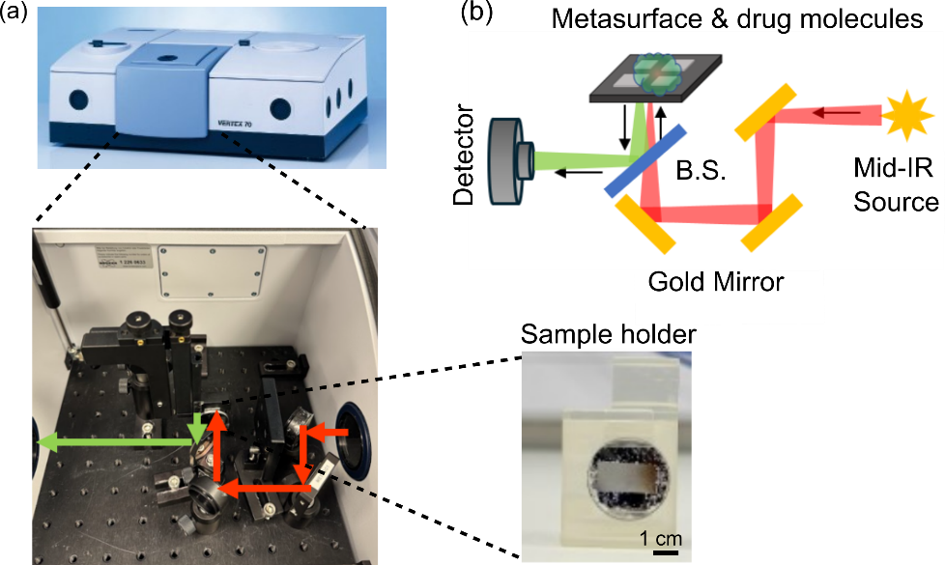
Figure 3. Metasurface implementation in a commercial FTIR spectrometer. (a) Experimental setup with the metasurface integrated into a commercial FTIR system using a custom open-path reflection unit. The unit consists of a mid-IR beamsplitter, gold mirrors, and a 3D printed sample holder for positioning the metasurface, as schematically shown in (b).
To experimentally validate the enhancement, we built an open-path reflection unit (Fig. 3) that is inserted into a commercial FTIR spectrometer. This arrangement allows us to measure both the metasurface resonance and the enhanced molecular absorption spectrum (detailed descriptions are in the Methods section). In order to quantify the enhancement factor over ATR-FTIR, we compare the LoDs of a PHT spiked serum sample between the two methods.
Starting with ATR-FTIR measurements, PHT was spiked into the processed serum sample using our recently developed protocol¹⁹ with concentrations of 50, 100, and 150 μg/ml. We deposited 10 μl of each solution and dried on the ATR sensor surface (applying excessive volume, e.g. >10 μl, would cause overflow of the ATR sensing area, resulting in non-reproducible measurements, as shown in Fig. S5, section 5, SI). The corresponding absorption spectra are presented in Fig. 4b, where the grey arrow marks the target absorption peak at 5.62 μm, while the purple curve represents the spectrum measured without PHT sample in air. From the graph, the LoD was determined by the concentration that is equal to three times the standard deviation (3σ = 0.00175). While the dried PHT sample with the concentration of 150 μg/ml is clearly distinguishable, the 100 μg/ml sample exhibits a signal slightly above the 3σ threshold, shown by the black dashed line, and the signal for the 50 μg/ml sample remains within the noise level. Hence, the LoD of the ATR-FITR for dried PHT-serum is estimated to be approximately 100 μg/ml.
For the metasurface-based measurements, the sensing area is approximately 30 times larger than that of the ATR sensor; therefore, 300 µl of serum was used to ensure an equivalent molecular coverage per unit area. Besides, this volume provides sufficient surface coverage, strong absorption signals, and relatively short evaporation time. Details are also available in section 5 and 6, SI. The serum samples were processed using the same protocol described previously¹⁹. Briefly, the procedure involves three steps: removal of lipids, removal of small water-soluble molecules, and isolation of proteins. After processing, PHT was spiked into the samples at different concentrations We discussed the reason for this sample preparation strategy and its equivalence to alternative clinical workflows in the Discussion section. Figure 4a shows the PHT solution dried on the metasurface, exhibiting a characteristic coffee-ring effect. Reflection spectra were collected at room temperature under compressed air purged conditions, with measurements taken at ten different locations on each sample to average out nonuniformities caused by drying. The enhanced absorption is quantified by integrating the area between the resonance dip and the refractive-index-matched reference profile, as highlighted in yellow in Fig. 4h. Together, they demonstrate that our method is indeed capable of detecting very low concentrations of PHT in serum. Fig. 4c shows a range of concentrations between 0 and 5 µg/ml, with Fig. 4d-g highlighting the spectra for each specific value. Concentrations below 0.1 μg/ml can be clearly observed, with 0.01 µg/ml detectable just beyond the noise. Fig. 4i summarises the response against concentration. Based on the error bars which represent the standard deviation of the dip area from multiple measurements across repeated dry–wash cycles. From Fig. 4i, a realistic LoD for repeatable measurements using the commonly accepted laboratory rule (defined as three times the standard deviation divided by the slope), results in an LoD of 1.4 μg/ml, which is 10-fold lower than the clinical requirement. For comparison, without the metasurface, the PHT absorption dip cannot be distinguished at all in the reflection measurements. For example, a measurement on a flat Ge-on-CaF₂ substrate with 300 μl 100 μg/ml PHT-spiked serum shows no discernible feature, as presented in Fig. S7 in the SI. Note that our LoD is calculated based on four repeats of measurements. If we only analyse the spectra from a single dry–wash cycle with 10 measurements of the same sample, the σ is 0.056, which corresponds to an LoD of 0.019 μg/ml. This explains why we can clearly distinguish concentrations above 0.01 μg/ml as shown in Fig. 4.

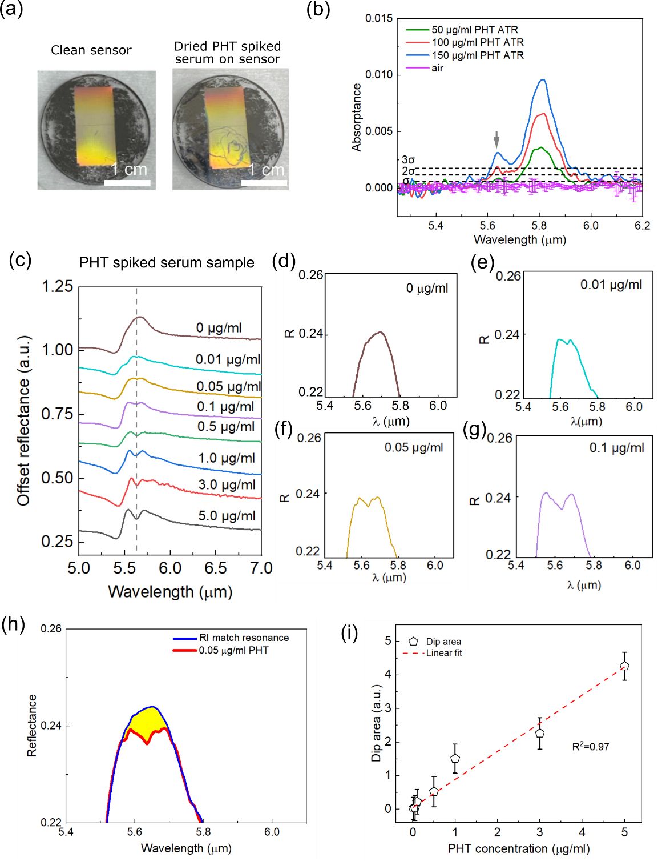
Figure 4. Measurements of PHT in spiked serum. (a) Photographs of the metasurface with and without dried PHT spots. (b) Absorption spectrum of PHT-serum solution dried on an ATR sensor surface. The absorption peak at 5.62 μm is the TDM target peak, indicated by the grey arrow. Blank references are taken as the background spectra, shown with a purple curve with error bars indicating the deviation (σ) at each wavelength, and the black dashed lines represent the σ, 2σ and 3σ at 5.62 μm. The LoD of ATR is determined to be 100 μg/ml from the 3 σ value. (c) Reflection spectrum obtained using the metasurface-enhanced FTIR approach with 0.01-5 μg/mL PHT-serum solution (300 μl dried onto the metasurface). The grey dashed line marks the target PHT absorption line. (d-g) Zoomed-in views of the enhanced absorption area for each specific concentration. (h) Definition of the dip area used for quantification of absorbance enhancement. (i) Sensor response vs concentration to determine the limit of detection (LoD). Each concentration was washed and dried for 4 times, with 10 different scans on each cycle. Samples were carefully checked by photographs, micrographs, and FTIR spectra to confirm clean washing with no crystallized PHT residues (see Fig. S9, SI).

Discussion and Conclusion
We have demonstrated a metasurface-based surface-enhanced infrared absorption (SEIRA) approach that is suitable for bedside therapeutic drug monitoring. We are able to repeatably detect dried serum with a model drug, Phenytoin, at 1.4 μg/ml, and have observed detectable concentrations as low as 0.01 μg/ml. This result is significantly improved compared to other mid-IR spectroscopic techniques; for example, the LoD of dried PHT-serum sample for ATR-FTIR is 100 μg/ml and for IRRAS-FTIR is 5 μg/ml¹⁹. It is also interesting to compare our results to the related technique of surface enhanced Raman scattering (SERS), which does not suffer from water absorption and for which an excellent result of 1.8 μg/ml²⁰ was reported. We note, however, that SERS is known to suffer from quantification issues as minute changes in molecular distribution may change the overlap with the nanoscale hotspots that SERS exploits; our resonant mode is much larger in comparison. Regarding related metasurface work, we note that previous studies have focused on strong absorbers or neat analytes¹⁸, which are considerably easier to detect than the weakly absorbing, clinically relevant drug molecules. Therefore, our approach is able to tackle the much more difficult problem of detecting low concentrations of drug molecules in a serum sample. We explain this improvement with the combination of a relatively high Q-factor, the strong overlap between the resonant mode and the dried analyte, as well as the angular tolerance that is compatible with an FTIR instrument. As a result, we are able to present a significant advancement in infrared molecular sensing and introduce the first approach that offers the real possibility of moving TDM from the laboratory to the bedside.
Metasurface enhanced FTIR (meta-FTIR) spectroscopy offers significant advantages over conventional methods, such as Liquid Chromatography-Tandem Mass Spectrometry (LCMS) in speed, cost, and portability. Meta-FTIR requires a scanning time of less than 1 minute and can be performed on-site, eliminating delays associated with sample transport and laboratory processing, whereas LCMS typically requires more than 10 minutes per measurement and total turnaround times can extend to several days in clinical workflows. Although meta-FTIR sample preparation takes 10-15 minutes compared with 5 minutes for LCMS, this difference is outweighed by the elimination of delays and the need for centralized laboratory infrastructure. In addition, meta-FTIR has a low instrumentation and running cost, it does not require a laser source, and it can be miniaturized, enabling a compact, user-friendly point-of-care platform suitable for bedside or field deployment. By performing well below the clinical concentration range, our method leaves room for practical limitations such as the lack of nitrogen purging, which increases the background noise, or the drug loss during sample preparation. Regarding the latter, the filtration procedure typically results in a 30% drug loss¹⁹ which can be clearly accounted for.
The main source of the variance between measurements that limits more accurate quantification is the uneven distribution of phenytoin across the sample after drying. Future work will focus on improving the homogeneity of the dried film by incorporating a sample well on the sensor surface to confine the evaporation area of the serum sample and ensure that it dries within a defined region. Another issue is the sample preparation protocol, which currently consists of three manual steps; we are working on an integrated microfluidic device that simplifies this process into a single step and can be used by untrained personnel. These improvements will enhance the clinical applicability of metasurface-enhanced FTIR spectroscopy and move the technique even closer towards real-world therapeutic drug monitoring.
Methods
Numerical simulations of the proposed metasurface were carried out using Finite-Difference Time-Domain (FDTD) software developed by Lumerical, while rigorous coupled-wave analysis (RCWA) was employed to model the response under Gaussian beam illumination.
For fabrication, a 400 nm germanium film was deposited onto a CaF₂ wafer by Plasma-enhanced chemical vapor deposition (PECVD) at the University of Southampton. The metasurface pattern was defined using electron-beam lithography (EBL) on AR-P 6200.18 resist (MicroResist GmbH). To mitigate charging effects, a conductive AR-PC layer (Allresist GmbH) was spin-coated on top of the resist. Following exposure, the AR-PC was removed in deionized water, and the sample was developed in xylene for 2 minutes, followed by rinsing in 2-propanol isopropyl (IPA). Reactive ion etching (RIE) was then used to transfer the pattern into the germanium layer using a CHF₃:SF₆ gas mixture (14.5:12.5 sccm). The remaining resist was stripped with remover 1165 (MicroResist GmbH).
Subsequently, a 20 nm-thick Al₂O₃ coating was conformally deposited on the Ge metasurface using atomic layer deposition (ALD) (Picosun Instr.) at 300 °C, with trimethylaluminum (TMA) and H₂O as precursors. The coated sample could survive 5 minutes of Piranha wash without degradation of its resonance position, indicating good protection. Details are shown in Fig. S8, section 8 in SI.
Measurements were performed using a commercial FTIR spectrometer (Bruker Vertex 70), configured as shown in Fig. 3a with a customized perpendicular reflection setup (inset). The schematic optical layout of this setup is illustrated in Fig. 3b. The customized configuration includes a one-inch-diameter beam splitter (BSW510, Thorlabs), three gold mirrors, an x–y translational mount (XYF2/M, Thorlabs), and a 3D-printed sample holder (inset of Fig. 3a). Mid-infrared light generated by the FTIR thermal source enters through the right-hand chamber window, is reflected by the gold mirrors, passes through the beam splitter, and is incident on the metasurface, which is coated with dried drug molecules. The enhanced absorption signal is encoded in the reflected spectrum, which then passes back through the same beam splitter, is directed toward the left chamber window of the FTIR and finally detected by a deuterated L-alanine doped triglycine sulphate (DLaTGS) detector at room temperature.
The ATR measurement was employed with the unit from MIRacle with three-bounce Reflection ATR Plates made of ZnSe, PIKE Technologies, and the unit was inserted into the FTIR spectrometer (Bruker Vertex 70). To evaluate the limit of detection (LoD) of the ATR configuration, ten reference measurements were acquired in compressed air without any sample. Each spectrum was background-corrected to minimize systematic errors. The amplitude variations (standard deviations σ) at each wavelength were then calculated.
In order to calculate the dip area on the reflected resonance, the reference profile was derived from the reflection spectrum of the 0% PHT sample (pure ethyl acetate) and subsequently shifted to match the envelope of each absorption spectrum, thereby compensating for refractive index variations. This correction is necessary because the resonance position of the dielectric metasurface depends on the refractive index of the coating layer; as the PHT concentration changes, the effective refractive index varies, resulting in a resonance shift.
Phenytoin (PHT, Sigma-Aldrich) was dissolved in ethyl acetate (Sigma-Aldrich), and 500 μl of solution was dried on the metasurface in a fume hood within 6 minutes.
Phenytoin was spiked in pre-processed serum samples, the protocol for pre-processing the serum is a three-step process. Firstly, we employ a liquid− liquid extraction with ethyl acetate solution to remove serum proteins and water. Secondly, a combination of magnesium chloride and dextran sulfate sodium has been utilized to remove serum lipids. Thirdly, we use saturated ammonium sulfate to precipitate the albumin following lipid removal. Finally, the phenytoin is spiked into the processed serum samples.

Acknowledgement
The authors thank the support of the EPSRC MISSION Programme Grant (EP/V047663/1).
Conflict of Interest
The authors declare no conflict of interest.
Reference:
(1) Ates, H. C.; Roberts, J. A.; Lipman, J.; Cass, A. E. G.; Urban, G. A.; Dincer, C. On-Site Therapeutic Drug Monitoring. Trends Biotechnol 2020, 38 (11), 1262–1277. DOI: 10.1016/j.tibtech.2020.03.001.
(2) Salman, B.; Al-Khabori, M. Applications and challenges in therapeutic drug monitoring of cancer treatment: A review. J Oncol Pharm Pract 2021, 27 (3), 693–701. DOI: 10.1177/1078155220979048.
(3) Adaway, J. E.; Keevil, B. G. Therapeutic drug monitoring and LC-MS/MS. J Chromatogr B Analyt Technol Biomed Life Sci 2012, 883-884, 33–49. DOI: 10.1016/j.jchromb.2011.09.041 From NLM Medline.
(4) Carrara, S.; Widmer, N.; Rodino, F.; Du, L.; Briki, M.; Decosterd, L. A.; Marzolini, C.; Buclin, T.; Thoma, Y.; Guidi, M. Therapeutic Drug Monitoring and Point-of-Care Technologies: Opportunities and Current Challenges. Ther Drug Monit 2025. DOI: 10.1097/FTD.0000000000001384 From NLM Publisher.
(5) Alvau, M. D.; Tartaggia, S.; Meneghello, A.; Casetta, B.; Calia, G.; Serra, P. A.; Polo, F.; Toffoli, G. Enzyme-Based Electrochemical Biosensor for Therapeutic Drug Monitoring of Anticancer Drug Irinotecan. Anal Chem 2018, 90 (10), 6012–6019. DOI: 10.1021/acs.analchem.7b04357.
(6) Mendelsohn, R.; Mao, G. R.; Flach, C. R. Infrared reflection-absorption spectroscopy: Principles and applications to lipid-protein interaction in Langmuir films. Bba-Biomembranes 2010, 1798 (4), 788–800. DOI: 10.1016/j.bbamem.2009.11.024.
(7) John-Herpin, A.; Tittl, A.; Kühner, L.; Richter, F.; Huang, S. H.; Shvets, G.; Oh, S. H.; Altug, H. Metasurface-Enhanced Infrared Spectroscopy: An Abundance of Materials and Functionalities. Adv Mater 2023, 35 (34). DOI: 10.1002/adma.202110163.
(8) Neubrech, F.; Huck, C.; Weber, K.; Pucci, A.; Giessen, H. Surface-Enhanced Infrared Spectroscopy Using Resonant Nanoantennas. Chem Rev 2017, 117 (7), 5110–5145. DOI: 10.1021/acs.chemrev.6b00743.
(9) Adato, R.; Altug, H. In-situ ultra-sensitive infrared absorption spectroscopy of biomolecule interactions in real time with plasmonic nanoantennas. Nat Commun 2013, 4. DOI: ARTN 2154 10.1038/ncomms3154.
(10) Leitis, A.; Tittl, A.; Liu, M. K.; Lee, B. H.; Gu, M. B.; Kivshar, Y. S.; Altug, H. Angle-multiplexed all-dielectric metasurfaces for broadband molecular fingerprint retrieval. Sci Adv 2019, 5 (5). DOI: 10.1126/sciadv.aaw2871.
(11) Kharratian, S.; Conteduca, D.; Procacci, B.; Shaw, D. J.; Hunt, N. T.; Krauss, T. F. Metasurface-enhanced mid-infrared spectroscopy in the liquid phase. Chem Sci 2022, 13 (43), 12858–12864. DOI: 10.1039/d2sc03927c.
(12) Rosas, S.; Adi, W.; Beisenova, A.; Biswas, S. K.; Kuruoglu, F.; Mei, H. Y.; Kats, M. A.; Czaplewski, D. A.; Kivshar, Y. S.; Yesilkoy, F. Enhanced biochemical sensing with high-Q transmission resonances in free-standing membrane metasurfaces. Optica 2025, 12 (2), 178–189. DOI: 10.1364/Optica.549393.
(13) Bunaciu, A. A.; Aboul-Enein, H. Y.; Fleschin, S. Application of Fourier Transform Infrared Spectrophotometry in Pharmaceutical Drugs Analysis. Appl Spectrosc Rev 2010, 45 (3), 206–219. DOI: 10.1080/00387011003601044.
(14) Barretto, C. T.; Nascimento, M. H. C.; Brun, B. F.; da Silva, T. B.; Dias, P. A. C.; Silva, C. A. B.; Singh, M. N.; Martin, F. L.; Filgueiras, P. R.; Romao, W.; et al. Infrared spectroscopy as a new approach for early fabry disease screening: a pilot study. Orphanet J Rare Dis 2024, 19 (1), 373. DOI: 10.1186/s13023-024-03380-x From NLM Medline.
(15) Chen, X. E.; Zhang, Y.; Cai, G. X.; Zhuo, J. L.; Lai, K. Z.; Ye, L. F. All-dielectric metasurfaces with high Q-factor Fano resonances enabling multi-scenario sensing. Nanophotonics-Berlin 2022, 11 (20), 4537–4549. DOI: 10.1515/nanoph-2022-0394.
(16) Biswas, S. K.; Adi, W.; Beisenova, A.; Rosas, S.; Arvelo, E. R.; Yesilkoy, F. From weak to strong coupling: quasi-BIC metasurfaces for mid-infrared light-matter interactions. Nanophotonics-Berlin 2024, 13 (16), 2937–2949. DOI: 10.1515/nanoph-2024-0043.
(17) Conteduca, D.; Arruda, G. S.; Barth, I.; Wang, Y.; Krauss, T. F.; Martins, E. R. Beyond Q: The Importance of the Resonance Amplitude for Photonic Sensors. Acs Photonics 2022, 9 (5), 1757–1763. DOI: 10.1021/acsphotonics.2c00188.
(18) Tittl, A.; Leitis, A.; Liu, M. K.; Yesilkoy, F.; Choi, D. Y.; Neshev, D. N.; Kivshar, Y. S.; Altug, H. Imaging-based molecular barcoding with pixelated dielectric metasurfaces. Science 2018, 360 (6393), 1105. DOI: 10.1126/science.aas9768.
(19) Dong, P.; Li, K. Z.; Rowe, D. J.; Krauss, T. F.; Wang, Y. Protocol for Therapeutic Drug Monitoring Within the Clinical Range Using Mid-infrared Spectroscopy. Anal Chem 2024, 96 (48), 19021–19028. DOI: 10.1021/acs.analchem.4c03864.
(20) Lee, W. W. Y., McCoy, C. P., Donnelly, R. F., and Bell, S. E. J. Swellable polymer films containing Au nanoparticles for point-of-care therapeutic drug monitoring using surface-enhanced Raman spectroscopy. Analytica Chimica Acta 2017, 912, 111-116. DOI: 10.1016/j.aca.2016.01.023

