Supporting Information
Metasurface-Enhanced Molecular Absorption at Mid-Infrared wavelength for Therapeutic Drug Monitoring
Kezheng Li^{1,*}, Pin Dong¹, Aneesh Vincent Veluthandath², Soheila Kharratian¹, Augusto Martin¹, Ganapathy Senthil Murugan², Yue Wang^{1,*} and Thomas F. Krauss¹
¹ School of Physics, Engineering and technology, University of York, York, U.K.
²Optoelectronics Research Centre, University of Southampton, Southampton, U.K.
*Email: kezheng.li@york.ac.uk; yue.wang@york.ac.uk

- Reflection spectrum of Ge/CaF₂ substrate
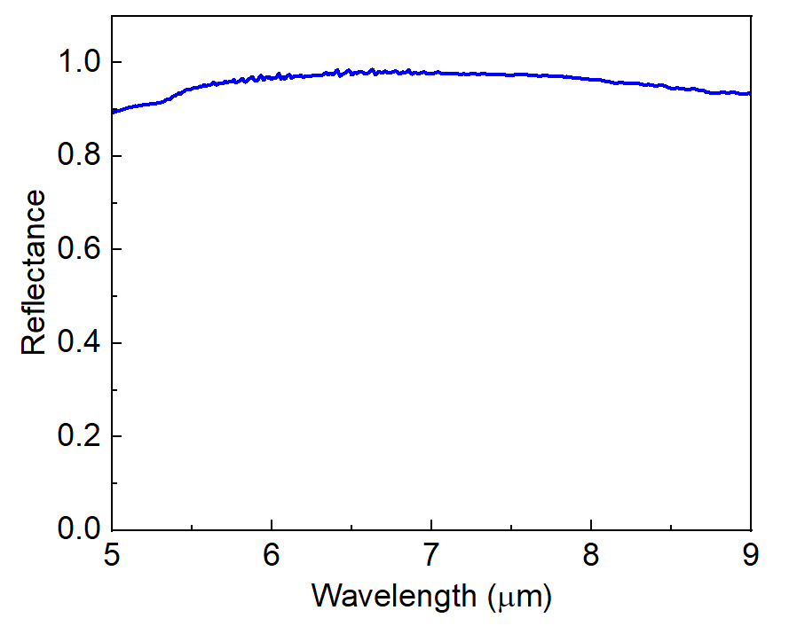
Figure S1 Reflection spectrum of Ge/CaF₂ substrate.
The purpose is to show that the Ge/CaF₂ substrate exhibits high reflection > 90% in the target wavelength range of 5–6 μm. The germanium layer was deposited onto the CaF₂ substrate using Plasma-Enhanced Chemical Vapor Deposition (PECVD).

- Optimisation of the metasurface
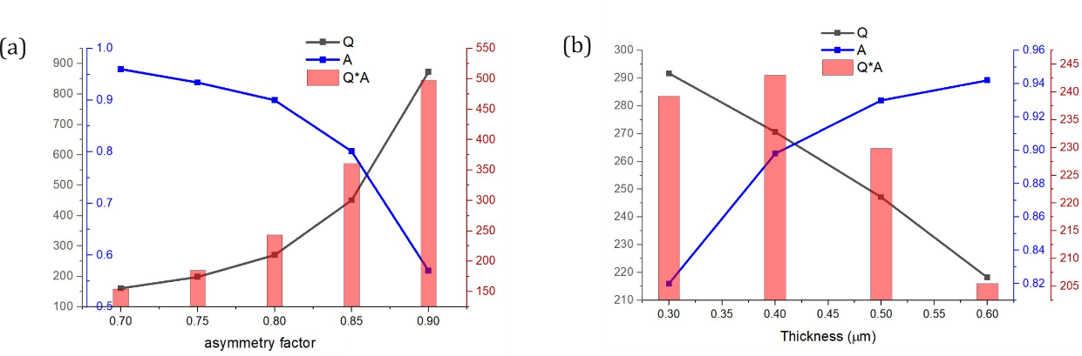
Figure S2. Optimisation of the metasurface. (a) The correlation between asymmetry and the quality factor (Q), amplitude (A), and their product (Q × A) at the thickness of 400 nm. (b) The relationship between germanium thickness and the parameters Q, A, and their product (Q × A). Asymmetry is defined as the ratio of the side length of the smaller square to that of the larger square.

- Absorption spectrum of PHT and Serum
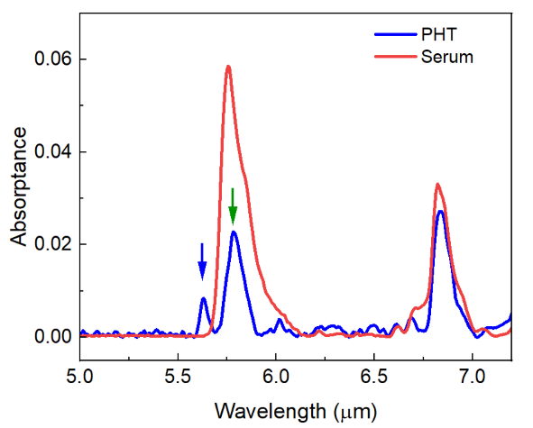
Figure S3 Absorptance spectra of PHT and serum. The main PHT peak at 5.78 μm which is indicated by the green arrow, overlaps with a serum absorption band, whereas the shoulder peak indicated by the blue arrow at 5.62 μm remains distinct and can therefore serve as a target peak for PHT detection.

- Dried spot SEM of PHT on flat Ge surface
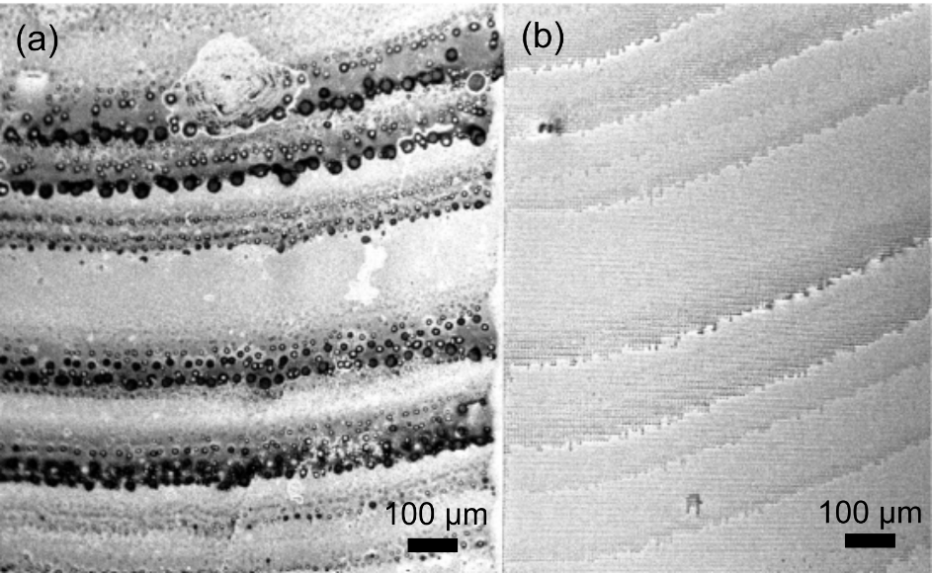
Figure S4. Dried PHT spot on (a) flat Ge surface and (b) metasurface. The coffee ring effect shows differently on each sample. The concentration of PHT ethyl acetate solution is 100 μg/ml.

- PHT solution overflow the ATR sensing area
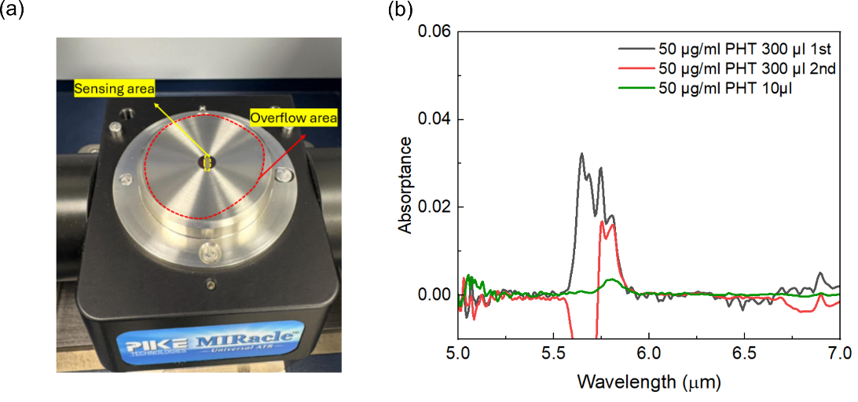
Figure S5 (a) A sample volume of 300 μl PHT solution at 50 μg/ml overflows beyond the ATR sensing area, as indicated by the red dashed curve; the yellow dashed curve outlines the actual ATR sensing region. (b) ATR-measured absorption spectra of PHT solutions at 50 μg/ml with different sample volumes. The black and red curves correspond to 300 μl samples, while the green curve represents a 10 μl sample. When using 300 μl of PHT solution, crystallization does not reliably occur within the sensing region, leading to inconsistent and non-reproducible absorption results. Note that 10 μl is the maximum sample volume that can be loaded onto the ATR; exceeding this amount causes overflow. Therefore, only the results for 10 μl and 300 μl are presented.

- Sample holder and Mid-IR beam scanning on the sample.
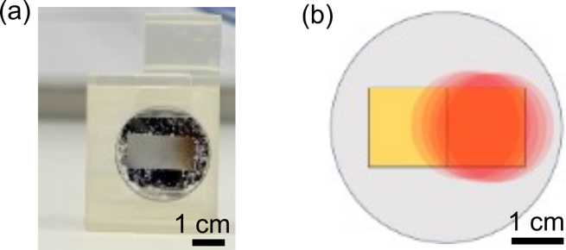
Figure S6 (a) 3D printed sample holder adapted to XY2-M translation mount. (b) Mid-IR beam spot illumination on the metasurface (yellow rectangle), scanning across the sample.

- Reflection spectrum of dried PHT on flat Ge/CaF₂ substrate

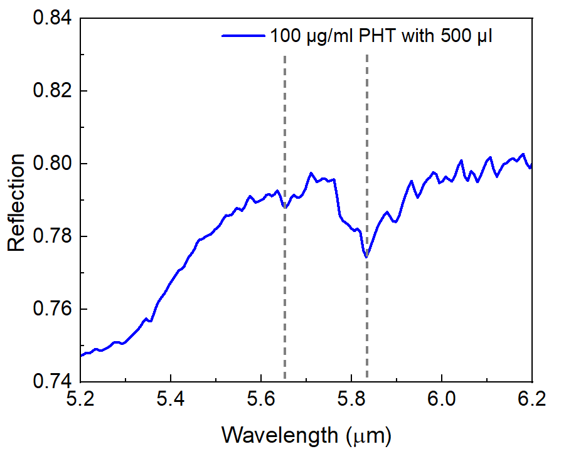
Figure S7. Reflection spectrum of dried PHT on flat Ge/CaF₂ substrate
FTIR reflection spectra of 500 μL of PHT at a concentration of 100 μg/ml, dried on a flat Ge/CaF₂ substrate. The reflection spectrum was obtained by subtracting the background signal of a gold mirror. The reflection spectrum shows a subtle absorption dip at 5.62 μm for the targeted peak of PHT. The depth of this dip is comparable to the noise level, making it indistinguishable from the background. In contrast, as shown in Fig. 4d, the metasurface could easily detect 5 μg/ml with high SNR, exhibiting over 20 times stronger drug absorption compared to the flat Ge surface.

- Atomic layer deposition (ALD) for reusable measurement.
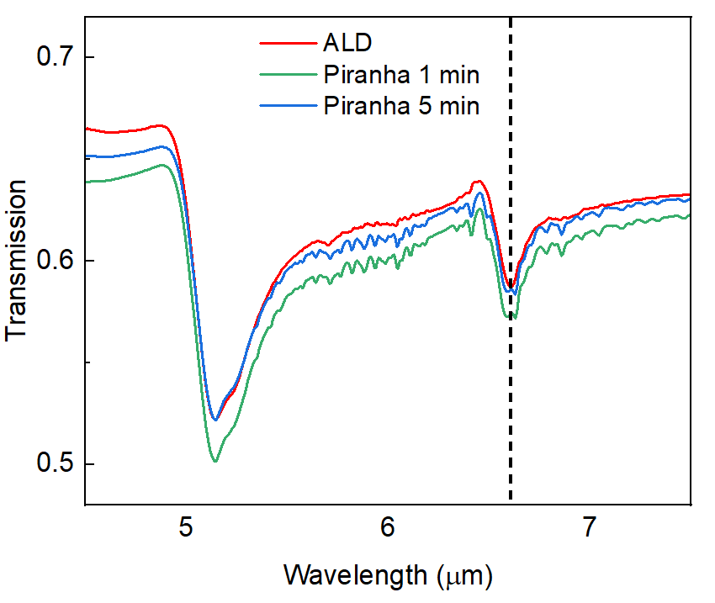
Figure S9. Transmission spectra of the Al₂O₃-coated Ge/CaF₂ metasurface sample were measured before and after the Piranha cleaning process. The absorption dip remains at the same position, confirming that the ALD-deposited Al₂O₃ layer effectively protects the germanium structures from being etched. It should be noted that this measurement used a sample with a larger period, resulting in a resonance position different from those presented in the main manuscript. In FTIR transmission mode, the beam spot size is approximately 2 mm in diameter, requiring only a small metasurface area. In contrast, the reflection setup has a beam spot size of about 10 mm in diameter, requiring a much larger sample to fully cover the beam. Considering these factors, the measurements were performed in transmission mode; however, similar results are expected in reflection mode.

- Photos of the sample before- dried-wash cycle of PHT, and FTIR spectrum of before, dried and wash of PHT crystal
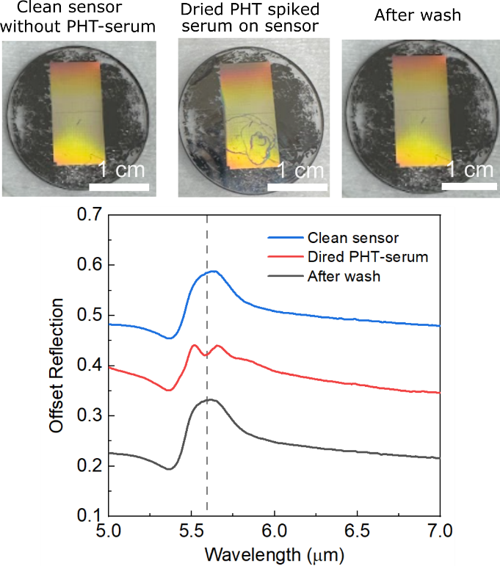
Figure S10. Comparison of sensor photographs taken before and after drying a PHT-serum sample on its surface, alongside the corresponding FTIR reflection spectra. The photos indicate no visible residue remaining after washing. To further verify this, FTIR reflection spectra were recorded, showing that the spectra before and after washing remain unchanged, with no resonance dips observed. In contrast, the presence of dried PHT-serum on the sensor produces a clear dip in the resonance, as illustrated by the red curve. These two complementary methods confirm that no PHT-serum residue remains after the washing step.

